Week 7: Part 1

AiG’s Striking New Christmas Billboard Now in Times Square!

by Ken Ham, AiG–U.S.

November 27, 2013
Layman
- atheism
- christmas
- evolution
- holidays
- worldviews
Last month, Answers in Genesis launched a very successful billboard campaign in California (Hollywood, Los Angeles, and the San Francisco Bay area) and Times Square in New York City. AiG wanted to reach out to people in secularized areas of the country and engage them in a “friendly” way (as a New York Times headline stated)¹ and point them to our website. The result of this campaign was a huge increase in web visitors to our AiG site and a lot of media coverage—and we hope many people considered more carefully the fact of God’s existence. The billboards read, “To all of our atheist friends: Thank God you’re wrong,” which demonstrated our gratefulness that there is a God who offers the free gift of salvation to anyone who will believe.²

The Gospel at Christmas
In an effort to continue reaching out to unbelievers, Answers in Genesis has put up another video board in the heart of Times Square—this time with a Christmas theme. The new billboard went live at 6 AM today and will run through Christmas day.
What’s the message this time in busy Times Square? As always, our heart is to share the gospel with unbelievers because salvation is a gift that lasts forever. In light of that mission, the new billboard shares a message of hope with atheists and others, reading, “To all our atheist friends: All He wants for Christmas is you.” Following that we quote John 3:16. The video below is what people at Times Square can see now through Christmas day:
The Christmas billboard is located in a different part of Times Square than October’s billboard—and it’s on a bigger board! The new billboard measures 50' by 100' (the previous one was a 45' by 90' cube) and is located on Broadway between 46th and 47th Streets, in the “Duffy Square” part of Times Square. Because this board has more space, we have added a verse this time. Here are a couple photos of the actual billboard in Times Square:


Our advertising agency JDA indicated that this new billboard will be viewed by about 45,000,000 people over the next few weeks—more than the last board. What’s even better is that we were able to obtain this prime billboard location at an excellent price, and a number of AiG supporters were so encouraged by the last billboard that they provided special financial support for this new billboard.

Why Run Another Billboard?
Of course, it’s getting close to Christmas, and our new video billboard gives AiG an opportunity to evangelize millions of people as we thank God about the fact that Christ came to earth and we can explain why. But there is another reason to be in Times Square once again, and it relates to an anti-Christmas billboard that appeared last December in Times Square (and similar mocking boards appeared around the country during Christmas 2012). It was just another manifestation of the aggressiveness of atheists in our culture.
Here was the blasphemous atheist billboard that was posted last Christmas in Times Square:

With Christmas in their sights for this year, the organization Freedom from Religion Foundation is planning on posting over 50 billboards around Sacramento, California, urging people to place their belief in mankind over God.³ They want people to follow them in their footsteps and reject the real meaning for Christmas. Here is just one of their billboards they will be posting:

Source: Freedom from Religion Foundation
Over the years, I have observed that more and more atheists have become zealots for their belief system, which is their religion. Yes, atheism is a worldview that, along with its sister belief of evolution, claims to explain everything around us. The “new atheists,” as they are also called, are aggressively going after you and your children. Ultimately, they want to convert you away from your faith to theirs! And over the last few years, one of the atheists’ strategies for spreading their message has been through billboards. Because of the public nature of billboards, numerous people are guaranteed to be exposed to the godless message of atheism.
In the 1960s, atheists got prayer removed from government schools. In more recent decades, they have gotten Nativity scenes taken down from public places, Ten Commandments displays removed, creation pulled out of school curricula, and so on.
Why are the atheists gaining ground? What’s happened in the culture to allow this? As I have been saying for years, there’s been a change in this culture—at a foundational level. Generations have been indoctrinated by the secular education system, museums, and media to build their thinking on human reason, not the Word of God. And at the foundation of this shift has been the issue of creation and evolution.
As the authority of God’s Word and its absolutes have been undermined in America, including inside much of the church, the ideas of secular humanism and its anti-Christian message have gained prominence.
The only reason atheists would even bother to become evangelists for their faith is if they are engaged in a spiritual battle. Otherwise they wouldn’t care. They know in their hearts there is a God, and they are deliberately suppressing that, as the Scripture so clearly tells us in Romans 1.

“Thank God You Are Willing to Take a Stand.”
We were tremendously blessed to hear from Christians who were greatly encouraged in New York and California to see our previous billboards. An AiG supporter in New York City, Joy, was thrilled to see our video board in Times Square. Last month, she was kind enough to travel to Times Square and take photos of our first board, and sent them to us (she also took the two photos above of the new Christmas billboard). One of them is below:

Joy wrote to us at the time: “I live in New York City. Last night I was downtown and thought I would go by and see the AiG billboard. We’re praying very much for this whole campaign, and that God will be glorified.” She added that the digital board was “very well done. Thank God you are willing to take a stand.”
We certainly need to pray for atheists, because they are heading for an eternity separated from God. Indeed, God will give them what they want: separation from Him for eternity. Pray along with me that this new billboard will point atheists to the gospel message and that they will repent before a holy God and receive the free gift of salvation. The Bible teaches, “If you confess with your mouth the Lord Jesus and believe in your heart that God has raised Him from the dead, you will be saved” (Romans 10:9).
For the next few weeks, when you visit the Answers in Genesis homepage, you will be greeted by a powerful video message—specifically addressed to our atheist friends—that is currently playing on a prominent billboard in Times Square. Along with this video is a “Get Answers” button that links to our main article “What Is Christmas?”

Footnotes
- Marc Santora, “In Times Square, a Friendly Jab at Atheists,” New York Times,http://www.nytimes.com/2013/10/08/nyregion/in-times-square-a-friendly-jab-at-atheists.html. Back
- “Billboards Engaging Atheists Up in Times Square and San Francisco,” Answers in Genesis,http://www.answersingenesis.org/articles/2013/10/07/billboards-engaging-atheists. Back
- Karl de Vries, “Organization promoting religious freedom plans to deploy atheist billboards,” Fox News, http://www.foxnews.com/us/2013/11/26/anti-religion-organization-deploys-billboards-in-sacramento-area/. Back

(下面中文使用谷歌翻译。需要修正和编辑。)

第7周：第1部分
AIG的引人注目的新的圣诞广告牌现在在时代广场！
由肯火腿， AIG
2013年11月27日
外行
•无神论
•圣诞节
•进化
•节假日
•世界观
上个月，答案在创世纪推出的加利福尼亚（好莱坞，洛杉矶和旧金山湾区）和时代广场在纽约市一个非常成功的广告牌宣传活动。 AIG想要接触到的人在该国的世俗化领域，他们参与了“友好”的方式（如纽约时报的标题说明） 1 ，并将其指向我们的网站。这场运动的结果是一个巨大的增加，网站访问者对我们网站的AIG和大量的媒体报道，我们希望很多人更仔细地考虑神的存在的事实。该广告牌写着“为了我们所有的无神论者的朋友：感谢上帝，你错了， ”这表明我们的感激，有一个神谁提供的救恩的恩赐给任何人谁将会believe.2

福音在圣诞节
在努力继续深入到不信，答案在创世纪搭起了另外一个视频板在时代广场，这一次与一个圣诞主题的心脏。新的广告牌今天去现场在上午6点，将通过圣诞节运行。
什么是消息这一次是在繁忙的时代广场？与往常一样，我们的心脏是与非信徒分享福音，因为救恩是一个礼物，永恒。鉴于这一使命，新的广告牌股份的希望与无神论者和其他人的邮件，阅读， “为了我们所有的无神论者朋友：所有他想要的圣诞是你”之后，我们引用约翰福音3:16 。下面的视频是什么人在时代广场现在可以看穿圣诞节：
圣诞广告牌位于时代广场的其他部分比十月份的广告牌，它是在一个更大的板！新的广告牌面积为50 ' 100 ' （前一个是45' 90 “立方体） ，位于百老汇第46和第47街之间，在纽约时代广场的”达菲广场“的一部分。因为这款主板拥有更多的空间，我们增加了一节经文这个时候。这里有一对夫妇的照片在纽约时代广场的广告牌实际的：

我们的广告代理防卫厅表示，这一新的广告牌将增加约45,000,000人在未来数周，多于上届董事会进行查看。有什么更好的是，我们能够以优异的价格获得此黄金位置的广告牌，以及一些AIG的支持者是如此鼓舞的是，他们提供的这种新的广告牌专项资金支持的最后一个广告牌。

为什么运行另一个广告牌？
当然，它越来越接近圣诞节，我们的新的视频广告牌给AIG有机会传福音千百万人，我们感谢上帝有关的事实，基督来到世上，我们可以解释为什么。但还有另外一个原因是在时代广场再次，它涉及一种抗圣诞节的广告牌，去年12月出现在时代广场（以及类似的嘲讽板出现在全国各地的圣诞节在2012年） 。这是无神论者在我们的文化侵略性的另一种表现形式。
这里是被张贴去年圣诞节在纽约时代广场的亵渎神明的无神论者广告牌：

随着圣诞节在他们的目光，今年，从宗教基金会组织自由正计划发布萨克拉门托，加利福尼亚州各地的50多个广告牌，呼吁人们把自己的信仰，在人类过度God.3他们希望人们跟随他们在他们的脚步并拒绝真正意义上的圣诞节。这里是他们的广告牌，他们将发布的只是一个：

资料来源：免于宗教基金会
多年来，我观察到，越来越多的无神论者已成为狂热者对他们的信仰体系，这是他们的宗教。是的，无神论是一种世界观，随着进化的它的姊妹的信仰，声称来解释我们周围的一切。 “新无神论者”，因为他们也被称为，正积极在您和您的孩子去。最终，他们希望你转换远离你的信仰他们的了！并在过去的几年里，无神论者'为传播他们的信息战略之一，已经通过广告牌。因为广告牌的公共性质，很多人都保证会接触到无神论的不信神的消息。
在20世纪60年代，无神论者祈祷得到了来自政府学校中移除。在最近的几十年，他们已经开始从公共场所撤下耶稣诞生的场景，删除十诫显示，创建拉出学校课程，等等。
为什么无神论者抬头？发生了什么事在文化允许这样做？正如我一直说了多年，有过这种文化，在一个基础水平的变化。几代人被灌输的世俗教育体系，博物馆，和媒体建立自己的思维在人的理性，而不是神的话语。而在这种转变的基础已经建立和发展的问题。
作为神的话语和绝对的权威已经削弱了美国，里面包括了很多教会，世俗人文主义和反基督教的消息的理念更加突出。
无神论者甚至会不屑于成为传道者为他们的信仰的唯一原因是，如果他们从事属灵的争战。否则，他们也不会关心。他们知道在他们的心中有一个神，他们是故意压制的，就如经上如此明确地告诉我们，在罗马书1 。

“感谢上帝，你愿意采取的立场。 ”
我们是极大的祝福基督徒谁是极大的鼓舞在纽约和加州，看看我们以前的广告牌听的。 AIG的支持者在纽约市，喜悦，兴奋极了，看看我们的视频板在时代广场。上个月，她还跟前往时代广场和拍照，我们的第一板，并将其发送给我们（她还拿了两张照片上的新的圣诞广告牌） 。其中之一是如下：

欢乐写信给我们的时候： “我住在纽约市。昨天晚上我闹，我想我会去的，看到了AIG的广告牌。我们祈祷非常多的这整个战役，神会得荣耀。 “她补充说，数字板”非常出色。感谢上帝，你愿意采取的立场。 “
当然，我们需要祈求无神论者，因为他们正朝着与神分离的永恒。事实上，上帝会给予他们想要的东西：他分离的永恒。和我一起祈祷，这种新的广告牌将指向无神论者的福音，他们将一个圣洁的神面前悔改，接受救恩的恩赐。圣经的教导， “如果你承认你的嘴主耶稣，并相信在你的心脏，神已经从死里复活，就必得救” （罗马书10:9 ） 。
在接下来的几个星期，当您访问的答案在创世纪的主页，你会被一个强大的视频问候消息，专门针对我们的无神论者的朋友 - 当前播放在时代广场的一个突出的广告牌。随着这个视频是一个“获取答案”按钮，链接到我们的主的文章“什么是圣诞节吗？ ”

脚注
1 。马克Santora谈， “在时代广场，友好的戳刺在无神论者，”纽约时报http://www.nytimes.com/2013/10/08/nyregion/in-times-square-a-friendly-jab-at - atheists.html 。后面
2 。 “广告牌从事无神论者Up在时代广场和旧金山， ”创世纪答案， http://www.answersingenesis.org/articles/2013/10/07/billboards-engaging-atheists 。后面
3 。卡尔·德弗里斯， “组织促进宗教自由计划部署无神论者广告牌， ”福克斯新闻，后面
Week 7: Part 2

Answers Research Journal 6 (2013): 409-466.
www.answersingenesis.org/articles/arj/v6/n1/avian-ark-kinds

An Initial Estimate of Avian Ark Kinds

by Jean K. Lightner

November 27, 2013
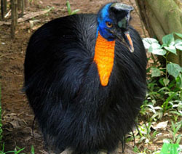

Abstract
Creationists recognize that animals were created according to their kinds, but there has been no comprehensive list of what those kinds are. As part of the Answers in Genesis Ark Encounter project, research was initiated in an attempt to more clearly identify and enumerate vertebrate kinds that were present on the Ark. In this paper, using methods previously described, 196 putative bird kinds are identified. Due to the limited information available and the fact that avian taxonomic classifications shift, this should be considered only a rough estimate.

Keywords: Ark, kinds, created kinds, baraminology, birds

Introduction
As part of the Ark Encounter project, Answers in Genesis initiated and funded research in an attempt to more clearly identify and enumerate the vertebrate kinds that were present on the Ark. In an initial paper, the concept of biblical kinds was discussed and a strategy to identify them was outlined (Lightner et al. 2011). Some of the key points are noted below.
There is tremendous variety seen today in animal life as creatures have multiplied and filled the earth since the Flood (Genesis 8:17). In order to identify which modern species are related, being descendants of a single kind, interspecific hybrid data is utilized. When hybrid data is lacking, a cognitum approach is preferred; this identifies natural groupings based on human cognitive senses. Generally the cognitum at the family level (which is usually fairly strong) is preferred when hybrid data is lacking, though obvious cognita surrounding this level are noted.
Another method that has been used to identify baramins (created kinds) is statistical baraminology. The methods of baraminic distance correlation (BDC) and multidimensional scaling (MDS) are discussed in more detail elsewhere (Wood 2008). Though they are important tools, Lightner et al. (2011) did not consider them as reliable as hybrid data and a cognitum approach on extant species. Results from statistical baraminology studies will be noted here where applicable.
Previous research has provided an initial estimation of mammal and amphibian kinds (Hennigan 2013a; Hennigan 2013b; Lightner 2012). This paper will focus on identifying extant bird kinds. There are over 10,000 living species of birds, making them the most speciose class of vertebrates descended from those preserved on the Ark. There is a large amount of hybrid data available for birds (McCarthy 2006). There are several examples in well-studied species where hybrid data connects several large, diverse families (within the orders Galliformes, Charadriiformes, and Passeriformes).
As in mammals and amphibians, the state of avian taxonomy is in flux. Despite the ideal of neatly nested hierarchies in taxonomy, it seems groups of birds are repeatedly “changing nests.” This is partially because where an animal is placed depends on which characteristics one chooses to consider. While many had thought that molecular data would resolve these issues, in some cases it has exacerbated them. For this estimate of the avian Ark kinds, the taxonomic scheme presented online by the International Ornithologists’ Union (IOU) was used (Gill and Donsker 2012a, 2012b and 2013). This list includes information on extant and some recently extinct species. Any birds known only from the fossil record will not be included in this analysis.

Order Tinamiformes
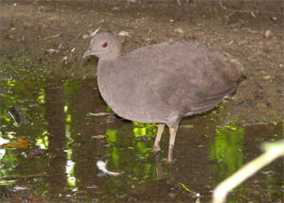
Source: Wikipedia http://www.en.wikipedia.org.
Fig. 1. Crypturellus cinereus.

Tinamidae (The Tinamous kind)
This single family order comprises nine genera and 47 species. Superficially they appear chicken-like. It is debated whether they are more closely related to chickens (Galliformes) or large flightless birds known as ratites (Howard 2003a). They have a palaeognathous palate, as do ratites. However, unlike ratites, they have a keel on the sternum and fully developed wings so they can fly (Handbook of the Birds of the World Alive). Considering this controversy, the family/order seems a natural place to postulate the level of the kind.

Order Struthioniformes

Struthionidae (The Ostrich kind)
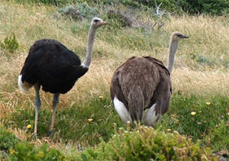
Source: Wikipedia http://www.en.wikipedia.org.
Fig. 2. Struthio camelus.
This family contains a single genus with two species (Gill and Donsker 2012a). They are the largest living birds. Although flightless, they are good runners and once inhabited open areas all over Africa and in the Middle East (Roberson 2012). From a cognitum standpoint, ostriches fit in with other ratite birds such as rheas and emus. These physical similarities were the basis of earlier taxonomists grouping ratities together. Later work suggested they were not as closely related, so many similarities were attributed to convergent evolution (Handbook of the Birds of the World Alive). The only hybrid data are from crosses between the two species of ostrich (McCarthy 2006). Since other ratites currently occupy different orders in the IOU classification scheme and there is no hybrid data linking these orders, the level of the kind will be considered the family/order for now.

Order Rheiformes

Rheidae (The Rhea kind)
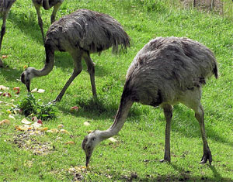
Source: Wikipedia http://www.en.wikipedia.org.
Fig. 3. Rhea americana.
This family also contains a single genus with two species (Gill and Donsker 2012a). These tall, long-legged, flightless birds are excellent runners. They live in South America, usually in open grasslands (Cholewiak 2003a). Despite the fact that they group with other ratites from a cognitum perspective, they are not combined with them here. The only hybrid data is between the two species of rhea (McCarthy 2006). Sibley and Monroe (1990) place rheas in an infraorder beside the ostrich based on DNA-DNA hybridization studies, which give an estimate of DNA similarity between species. Casuariiformes is reduced to a suborder beside these two groups, and Tinamiformes is kept in a separate order beside these in their taxonomy. So there is a fair amount of similarity among these first four orders on the DNA level too. Since we don’t know how to assess DNA similarity in a way that is helpful to identify kinds, the estimate is kept at the family/order level.

Order Casuariiformes

Casuariidae (The Cassowary kind)
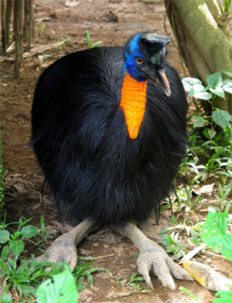
Source: Wikipedia http://www.en.wikipedia.org.
Fig. 4. Casuarius unappendiculatus.
A single genus with three species is recognized in this family (Gill and Donsker 2012a). These large ratites are found in the Australo-Papuan region. They live in the rainforest. They are considered closely related to emus, and are sometimes classified in the same family. They are relatively common in the fossil record. There is a fossil believed to be intermediate between cassowaries and emus (Cholewiak 2003b). Given this, the level of the kind could actually be higher, at the order or possibly above. Since hybrid data is lacking, the kind will be considered at the family level to avoid a bias that will underestimate the number of kinds on the Ark.

Dromaiidae (The Emu kind)
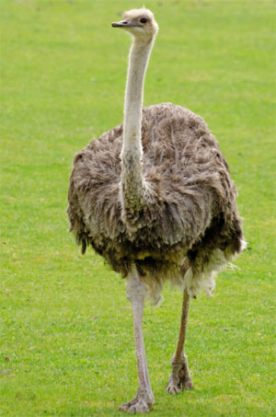
Source: http://www.publicdomainpictures.net/
Fig. 5. Dromaius novaehollandiae.
This family is monotypic, comprised of a single species (Gill and Donsker 2012a). This large ratite is native to Australia. It inhabits grassy areas or open forests. These shaggy birds spend most of their time foraging, consuming grass and plants. They will also eat large quantities of insects when they are available (Roberson 2012). This family is represented in the fossil record and several species went extinct in the early nineteenth century (Handbook of the Birds of the World Alive).

Order Apterygiformes

Apterygidae (The Kiwi kind)
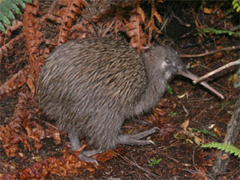
Source: Wikipedia http://www.en.wikipedia.org.
Fig. 6. Apteryx australis.
This family is comprised of a single genus with five species (Gill and Donsker 2012a). There is hybrid data linking three of these species (McCarthy 2006). Kiwis are unusual flightless birds which live in New Zealand. These nocturnal birds stay in a burrow during the day, and come out to forage at night (Roberson 2012). These ratities are believed to be more closely related to the extinct moas (Handbook of the Birds of the World Alive).

Order Galliformes

(The Landfowl kind)
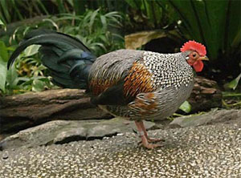
Source: Wikipedia http://www.en.wikipedia.org.
Fig. 7. Gallus sonneratii.
Landfowl, which include chickens, turkeys, and pheasants, are comprised of five families with 299 species (Gill and Donsker 2012a). Four of these families (Cracidae, Numididae, Odontophoridae, and Phasianidae) are united by hybrid data (McCarthy 2006). The fifth family, Megapodidae, has long been considered more closely allied with Cracidae than either of these two families are with the other three families (Wetmore 1930). In fact, Sibley and Monroe (1990) list Megapodidae and Cracidae in a separate order from the others based on DNA-DNA hybridization studies. Thus, with Cracidae being united with the other three families, it appears that all five families were derived from a single created kind.
Using statistical baraminology techniques, a large data set of mostly osteologic characters was analyzed to assess the level of the kind within this order. The results suggested that there were four distinct groups (i.e. potential baramins): Megapodidae, Cracidae, Numididae, and the remaining species grouped in the superfamily Phasianoidea (McConnachie and Brophy 2008). This discrepancy between hybrid data and the results of statistical baraminology techniques is an important reminder that the latter, though valuable in helping to estimate the level of the kind, should be considered tentative.

Order Anseriformes

Anhimidae (The Screamer kind)
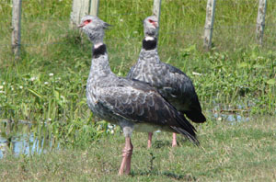
Source: http://tolweb.org.
Fig. 8. Chauna torquata.
This family comprises two genera and three species. Overall the body is goose-like, but the neck is short and topped with a rather small chicken-like head. The webbing in the feet is shallow. Historically there has been some dispute over where to place this group (Howard 2003b). There is hybrid data between the two species in the genus Chauna, but none between this family and any others (McCarthy 2006). Thus it seems best to tentatively consider the kind at the family level.

Anseranatidae (The Magpie Goose kind)
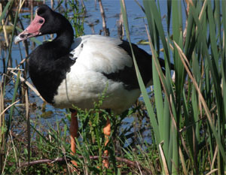
Source: Wikipedia http://www.en.wikipedia.org.
Fig. 9. Anseranas semipalmata.
There is a single species in this family. The magpie goose is found in Australia and New Guinea. They swim and wade in the wet grasslands and swamps by the coast. Their feet are only partially webbed (Wilber 2008). The magpie goose has some features that seem intermediate between screamers and the family Anatidae (Roberson 2012). In the past it had been classified with Anatidae (Wetmore 1930). Sibley and Monroe (1990) place the family closer to Anhimidae based on their DNA studies. Although they seem to fit in the same cognitum as ducks, geese, and swans, they are considered separate here so as to avoid possibly underestimating the kinds on the Ark.

Anatidae (The Duck kind)
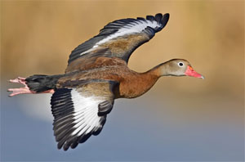
Source: Wikipedia http://www.en.wikipedia.org.
Fig. 10. Dendrocygna autumnalis.
This family comprises 49 genera and 172 species (Gill and Donsker 2012a). In addition to a diverse array of ducks, this family includes geese and swans. Previous statistical baraminologic analysis seemed to indicate three groups within this family. Though this was clearly seen in the BDC analysis, the tetrahedral shape of the MDS calls this into question (Wood 2008). There has been debate about the relationship of taxa within this group (Howard 2003c). However, there is hybrid data that connects all subfamilies (McCarthy 2006). Therefore the level of the kind appears to be at least at the family level.

Order Gaviiformes

Gaviidae (The Loon kind)
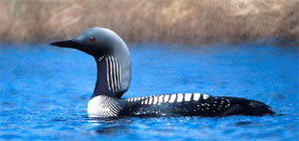
Source: Wikipedia http://www.en.wikipedia.org.
Fig. 11. Gavia pacifica.
The five species of loons all belong to a single genus (Gill and Donsker 2012a). They appear similar to ducks as they swim on the water, except for their dagger-like bill. They are specialized fish eaters. On land they are clumsy because their feet are set so far back on their body (Roberson 2012). Natural hybridization has been reported between four of these species; there is an inferred hybrid involving the fifth species (McCarthy 2006).

Order Spenisciformes

Spheniscidae (The Penguin kind)
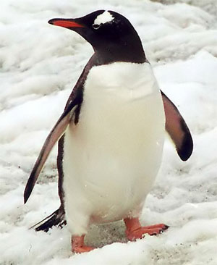
Source: Wikipedia http://www.en.wikipedia.org.
Fig. 12. Pygoscelis papua.
This family comprises 18 species in six genera (Gill and Donsker 2012a). There are a number of extinct genera and species of penguins which show a greater diversity in size and shape than those alive today. Penguins are unique in being both flightless and aquatic (Roberson 2012). Natural hybridization has been recorded between several different species with others in the same genus (McCarthy 2006). There is a strong cognitum at the family level and previous statistical baraminology studies strongly suggest all extant penguins belong to the same kind (Wood 2008).

Order Procellariiformes
A strong cognitum appears at this level. Based on their DNA-DNA hybridization studies, Sibley and Monroe (1990) place this order as a family with the following families grouped into three subfamilies. The diving petrels are placed in the petrels. In their scheme loons (Gaviidae), penguins (Spheniscidae) and frigatebirds (Fregatidae) are placed nearby. In other taxonomies frigatebirds are not placed near these families (Alderfer 2005; Gill and Donsker 2012a) and penguins seem to fall in their own cognitum, strongly suggesting these latter two groups are distinct kinds. Despite these hints that the level of the kind may be at the order Procellariiformes, it will be placed below this at the family level to avoid possibly underestimating the number of kinds.

Diomedeidae (The Albatross kind)
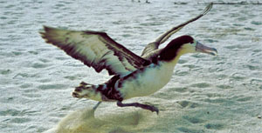
Source: Wikipedia http://www.en.wikipedia.org.
Fig. 13. Phoebastria albatrus.
There are four genera and 21 species of albatrossses (Gill and Donsker 2012a). The albatross has a thick body with long narrow wings. They have large webbed feet and spend much time soaring in the open ocean (Alderfer 2005). Two of the genera have some interspecific hybrid data (McCarthy 2006).

Procellariidae (The Petrel kind)
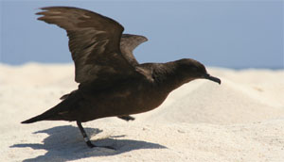
Source: Wikipedia http://www.en.wikipedia.org.
Fig. 14. Puffinus nativitatis.
This family is comprised of 14 genera and 90 species (Gill and Donsker 2012a). Petrels and shearwaters are similar in many was to the albatross. They also have heavy bodies, long narrow wings, and webbed feet. They are also generally found out at sea. They differ from the albatross in having a single tube on the upper ridge of their bill (culmen). The albatross has a single tube on each side of its culmen (Alderfer 2005). They certainly seem to be in the same cognitum as the albatross. Interspecific hybrid data is found within some genera, and hybrids have been inferred between some genera. However, no hybrid data links this family with the albatrosses (McCarthy 2006).

Hydrobatidae (The Storm Petrel kind)
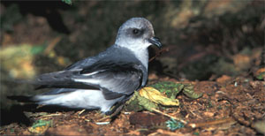
Source: Wikipedia http://www.en.wikipedia.org.
Fig. 15. Oceanodroma furcata.
There are seven genera and 24 species of storm petrels (Gill and Donsker 2012a). Storm petrels are smaller aerial seabirds. Like other members of this order, they have special tubes on their bills which remove the salt from the seawater they drink. They are proportioned a bit differently than the previous two families (Roberson 2012).

Pelecanoididae (The Diving Petrel kind)
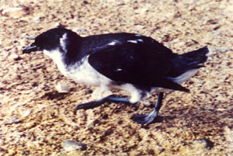
Source: Wikipedia http://www.en.wikipedia.org.
Fig. 16. Pelecanoides garnotii.
This monogeneric family has four species (Gill and Donsker 2012a). They are small stocky seabirds with short wings that excel in swimming and diving, rather than in soaring. In some ways they resemble the unrelated auks (Charadriiformes: Alcidae). This is attributed to convergent evolution (Roberson 2012).

Order Podicipedidae

Podicipedidae (The Grebe kind)
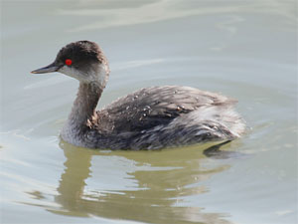
Source: Wikipedia http://www.en.wikipedia.org.
Fig. 17. Podiceps nigricollis.
There are six genera and 23 species of grebes (Gill and Donsker 2012a). Grebes are well represented in the fossil record and are not considered closely related to other birds. They are excellent divers with lobed toes on legs set far back on the body. They are clumsy on land and are rarely seen out of the water (Roberson 2012). There is some hybrid data including an intergeneric cross between Podilymbus podiceps and Tachybaptus ruficollis (McCarthy 2006).

Order Phoenicopteriformes

Phoenicopteridae (The Flamingo kind)
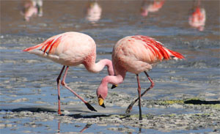
Source: Wikipedia http://www.en.wikipedia.org.
Fig. 18. Phoenicopterus ruber.
There are six species of flamingos in one genus (Gill and Donsker 2012a). They are very distinctive with their proportionally long legs and neck as well as their pink plumage. They also have a distinctive bill that is bent in the center and used to strain algae, diatoms, and aquatic invertebrates (Alderfer 2005). There is hybrid data connecting five of the six species (McCarthy 2006).

Order Phaethonitiformes

Phaethontidae (The Tropicbird kind)
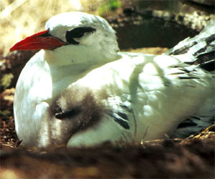
Source: Wikipedia http://www.en.wikipedia.org.
Fig. 19. Phaethon rubricauda.
This family comprises three species in a single genus (Gill and Donsker 2012a). They live out at sea, have a distinctive long central tail streamer as adults, and dive for fish and other prey. The feet are webbed and the legs are far back on the body, making them clumsy when walking. They rarely glide, but fly with rapid wing beats (Alderfer 2005).

Order Ciconiiformes

Ciconiidae (The Stork kind)
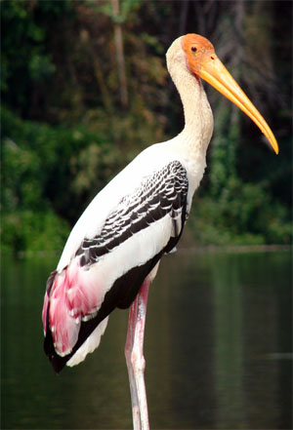
Source: Wikipedia http://www.en.wikipedia.org.
Fig. 20. Mycteria leucocephala.
This family has 19 species in six genera (Gill and Donsker 2012a). Storks are large wading birds. Though superficially similar to some other wading birds, some recent taxonomists suggest they are more closely related to New World vultures (Cathartidae). Hybrids have been reported within the large genus Ciconia as well as between Leptoptilos javanicus and Mycteria leucocephala(McCarthy 2006). The species involved in the intergeneric cross are from two different tribes (Roberson 2012). Given all these factors, the order/family level seems to be the level of the kind.

Order Pelecaniformes

Threskiornithidae (The Ibis kind)
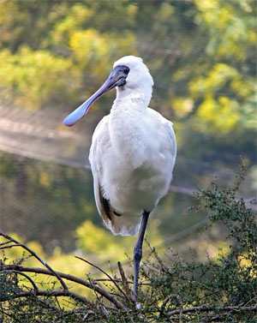
Source: Wikipedia http://www.en.wikipedia.org.
Fig. 21. Platalea regia.
This family is comprised of 13 genera and 35 species (Gill and Donsker 2012a). Ibises and spoonbills are wading birds that can be easily distinguished from each other by bill shape, coloration, and foraging patterns. Despite the distinctiveness of each, the intergeneric hybrid data, which links four of the genera in this family, clearly shows they are related (McCarthy 2006).

Ardeidae (The Heron kind)
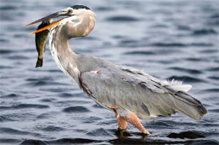
Source: Wikipedia http://www.en.wikipedia.org.
Fig. 22. Ardea herodias.
There are 72 species in 19 genera in this family (Gill and Donsker 2012a). These distinctive birds, which include egrets and bitterns, have a fossil record going back to the lower Eocene. Most are adapted to wading and preying on fish (Alderfer 2005; Roberson 2012). A statistical baraminologic analysis was done and revealed two groups. The bittern subfamily, Botaurinae, formed one group. The remaining herons and the outgroup formed the second. Members of the outgroup are largely from the ibis family (Threskiornithidae) and stork family (Ciconiidae), although the flamingo was included too. Two possible interpretations were suggested. Either bitterns make up a holobaramin (entire created kind) or the level of the kind appears to be above the level of the order (Wood 2008).
At one time bitterns were in one subfamily and all other species were in another. However, now four subfamilies are recognized, and none is considered more closely related to another than to the remaining ones. Further, it is not uncommon for the ibis and the heron to be placed in the same order as storks. Sometimes even the flamingo has been considered to be in the same order (McKilligan 2005). Thus a higher level for the kind may not be that implausible. Nevertheless, herons have some distinctive features so there is a strong cognitum at the family level. Therefore the level of the kind is placed here to be conservative.

Scopidae (The Hamerkop kind)
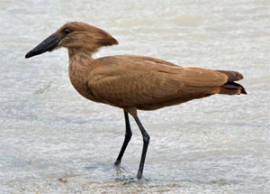
Source: Wikipedia http://www.en.wikipedia.org.
Fig. 23. Scopus umbretta.
The single species in this family lives in sub-Saharan Africa and has unique habits and behavior. It has a few features reminiscent of herons. It has an odd mix of other characters which are similar to the shoebill, flamingos, and storks. It has ectoparasites that are otherwise found only in plovers. Given this, its origin and relationship to other birds are considered unclear (Roberson 2012), so it is considered here to belong to its own kind.

Balaenicipitidae (The Shoebill kind)
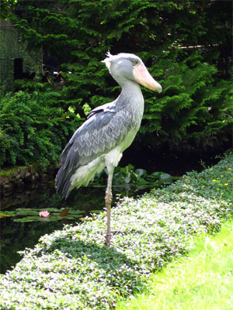
Source: Wikipedia http://www.en.wikipedia.org.
Fig. 24. Balaeniceps rex.
This single species is also found in sub-Saharan Africa. It has been called the Whale-headed stork, though it flies with its neck retracted like a heron. There is skeletal and biochemical evidence suggesting it is more closely related to pelicans (Roberson 2012). Sibley and Monroe (1990) list it as a subfamily in Pelecanidae. Here it is considered to belong to a unique created kind since it is currently placed as a distinct family.

Pelecanidae (The Pelican kind)
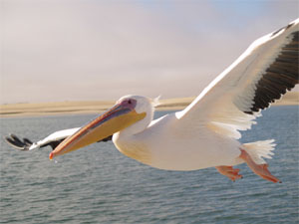
Source: Wikipedia http://www.en.wikipedia.org.
Fig. 25. Pelecanus onocrotalus.
All eight species of pelicans belong to a single genus (Gill and Donsker 2012b). They are distinctive birds with their long, hooked bills and large gular pouches (Alderfer 2005). They fill their beaks with huge gulps of water, strain out the liquid, and eat the remaining fish or squid. They are represented in the fossil record (Roberson 2012). The strong cognitum makes the family a natural place to infer the level of the kind.

Order Suliformes

Fregatidae (The Frigatebird kind)
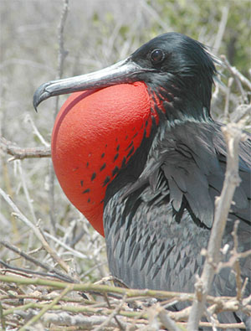
Source: Wikipedia http://www.en.wikipedia.org.
Fig. 26. Fregata magnificens.
There are five species in a single genus in this family (Gill and Donsker 2012b). Frigatebirds are excellent aerialists. They have a light build, long, angular wings and a long, deeply forked tail. These tropical seabirds can glide for great distances over the water. Their long bill is deeply hooked at the tip. The males can greatly inflate their red gular pouch during courtship (Alderfer 2005). There is a strong cognitum at this level, suggesting that this is the level of the kind.

Phalacrocoracidae (The Cormorant kind)
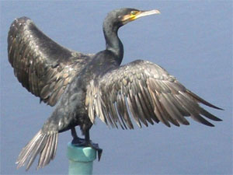
Source: Wikipedia http://www.en.wikipedia.org.
Fig. 27. Phalacrocorax carbo.
This family comprises three genera and 41 species (Gill and Donsker 2012b). Some authors list all species in a single genus. These long-necked diving birds have long, heavy bodies, stiff tails, and long bills which are hooked at the tip. They lack the waterproofing oil of some birds, and so must perch with their wings spread after a diving bout (Alderfer 2005; Roberson 2012). For convenience, the level of the kind is defaulted to the family.

Anhingidae (The Anhinga kind)
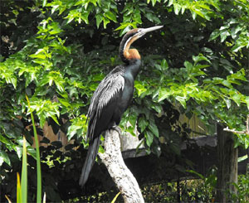
Source: Wikipedia http://www.en.wikipedia.org.
Fig. 28. Anhinga rufa.
This family comprises four species in a single genus (Gill and Donsker 2012b). They resemble slender, long-tailed cormorants and are considered closely related to them. The bill is pointed. The neck is kinked back much like a heron, which allows for quick strikes on prey. They have short legs and large webbed feet. Since they lack hybrid data uniting them with cormorants, the level of the kind is left at the family level.

Order Accipitriformes

Cathartidae (The New World Vulture kind)
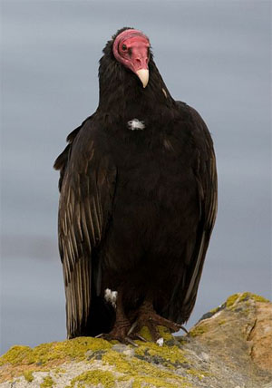
Source: Wikipedia http://www.en.wikipedia.org.
Fig. 29. Carthartes aura.
This family is comprised of seven species in three genera (Gill and Donsker 2012b). Like their Old World counterparts, they have hooked bills, naked heads and feed on carrion. In fact, there is such a strong cognitum among vultures that it would be very natural to group them together in the same kind. However, detailed anatomical comparisons, as well as some behavioral similarities suggest the New World vultures have much in common with storks. DNA hybridization studies also seem to support this. Therefore, these similarities among Old and New World vultures are now attributed to convergent evolution (Alderfer 2005; Handbook of the Birds of the World Alive; Roberson 2012).
This brings up an important point, both the cognitum and statistical baraminology assume that kinds have retained their distinctiveness as creatures have reproduced and filled the earth. There is no biblical basis for asserting that this must be true. Convergent evolution can be a reasonable explanation for similarities in the creation model. It involves similar adaptive changes to a particular environmental niche, either within a kind (as different populations adapted in the same basic way) or between members of different kinds. In fact, convergent evolution fits a bit better in the creation model. Evolution (in the molecules-to-man sense) is supposed to be the result of chance processes, so there is no reason to suspect that creatures would adapt in the same ways. This would be especially true as they diverged, since previous changes should limit future options for change. With a Creator who intends for the earth to be inhabited, it is not unreasonable to postulate that creatures were designed to be able to change. This provides a logical basis for why the same types of changes can occur, whether two creatures belong to the same kind or not.
It is also notable that there is no consensus on how members of Accipitriformes and Falconiformes are related to other birds. In fact, the fossil record fails to support common ancestry of the different families in these orders, leaving evolutionists open to the possibility of separate ancestry with similarities attributable to convergent evolution (Handbook of the Birds of the World Alive). With regard to vultures, given the current information, it appears that New World vultures are distinct from Old World vultures. They also don’t share a strong enough cognitum with storks to place the level of the kind above the family level. Therefore the family seems best place to designate the kind for now.

Sagittariidae (The Secretarybird kind)
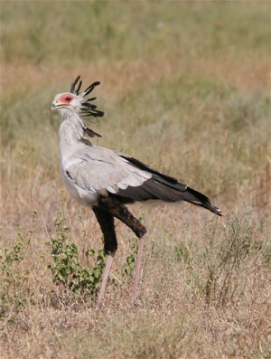
Source: Wikipedia http://www.en.wikipedia.org.
Fig. 30. Sagittarius serpentarius.
There is a single extant species in this family. This distinctive bird of the African plains has always been placed in its own family, and sometimes in its own order. It shares some features with birds of prey, and thus is classified near them in the IOU taxonomy. In other respects the secretarybird is similar to storks. Some have suggested a relationship with cranes or other members of Gruiformes. The secretarybird is nearly four feet tall. It has powerful legs, the top portion of which is covered with black feathers, giving it the appearance of wearing breeches (Roberson 2012, Handbook of the Birds of the World Alive). Based on its unique features and the fact that there is no other group it is clearly related to, the level of the kind is placed at the family.

Pandionidae (The Osprey kind)
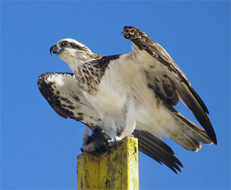
Source: Wikipedia http://www.en.wikipedia.org.
Fig. 31. Pandion haliaetus.
There are two species of osprey which are both in a single genus (Gill and Donsker 2012b). They are sometimes referred to a “fish hawks” as they eat almost exclusively fish. They are distinctive in a number of ways. They have a reversible outer toe, spiny foot pads to help grip slippery fish, and nasal valves that close underwater. They also are well represented in the fossil record (Roberson 2012). It has been suggested that this family has undergone little speciation because they are long distance migrants, which allows for more interbreeding between populations. Thus they don’t experience the isolation that is thought to contribute to speciation (Handbook of the Birds of the World Alive).

Accipitridae (The Hawk kind)
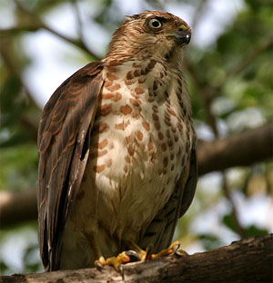
Source: Wikipedia http://www.en.wikipedia.org.
Fig. 32. Accipiter badius.
This large family is comprised of 256 species in 65 genera. It not only includes hawks, but also kites, harriers, eagles, and Old World vultures (Gill and Donsker 2012b). These birds have excellent eyesight, strong feet with curved talons to grab prey, and a hooked beak. Some species have long, wide rounded wings and excel at soaring. Others have narrower wings and longer tails for maneuverability (Alderfer 2005). The Old World vultures can be argued to have a different cognitum than others in this family. However, taxonomically there are no subfamilies in Accipitridae, implying that the birds are considered closely related. Therefore, despite the large size of the family, they are considered a single kind here.

Order Falconiformes

Falconidae (The Falcon kind)
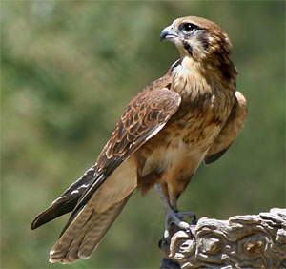
Source: Wikipedia http://www.en.wikipedia.org.
Fig. 33. Falco berigora.
Falcons and caracaras comprise 67 species in 11 genera (Gill and Donsker 2012b). Despite the varied morphology and lifestyles of these birds, the family seems clearly defined by six or more morphological characteristics. There is considerable difference of opinion on how birds within the family are related to each other (Handbook of the Birds of the World Alive). Since this is a single family order, it seems a reasonable place to designate the kind. Statistical baraminology analysis of this group involved a dataset that only used characters of the syrinx. Members of one subfamily grouped together strongly. The other subfamily was more ambiguous and some members grouped more strongly with outgroup birds. It was thus concluded that the dataset revealed more about the structure of the syrinx in these birds rather than their baraminic status (Wood 2008).

Order Otidiformes

Otididae (The Bustard kind)
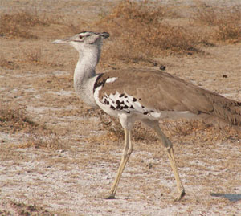
Source: Wikipedia http://www.en.wikipedia.org.
Fig. 34. Ardeotis kori.
This family comprises 11 genera and 26 species (Gill and Donsker 2012b). They have a distinctive shape and are believed to be distantly related to cranes (Gruiformes). They inhabit grasslands and other open areas. Most species live in Africa. They fly very little and never land in trees. They lack the hind toe that most birds have to allow them to perch (Roberson 2012). Since this family is unique enough to occupy its own order, it seems the level of the kind is best placed here.

Order Mesitornithiformes

Mesitornithidae (The Mesite kind)
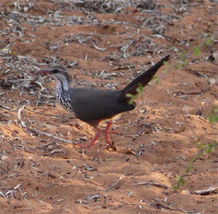
Source: Wikipedia http://www.en.wikipedia.org.
Fig. 35. Monias benschi.
There are three species of mesites placed in two genera (Gill and Donsker 2012b). These ground dwelling birds will typically run when frightened. Though they are believed to be ancient, they are not known from the fossil record (Roberson 2012). Again, this family is unique enough to occupy its own order, so it seems a natural place to consider the level of the kind.

Order Cariamiformes

Cariamidae (The Seriema kind)
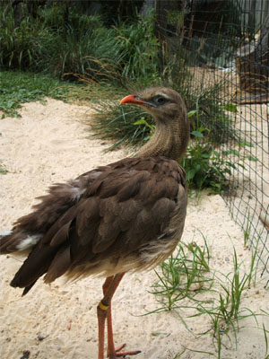
Source: Wikipedia http://www.en.wikipedia.org.
Fig. 36. Cariama cristata.
There are only two species of seriema, each in their own genus (Gill and Donsker 2012b). These birds are not well known; they run and hunt in semi-open drier regions in southern South America. There is controversy over how the seriema is related to other birds (Roberson 2012), suggesting the level of the kind is best placed here.

Order Eurypygiformes

Rhynochetidae (The Kagu kind)
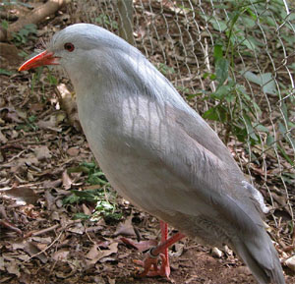
Source: Wikipedia http://www.en.wikipedia.org.
Fig. 37. Rhynochetos jubatus.
The single species in this family inhabits New Caledonia, an island in the South Pacific. It has long legs and a grayish body. The bill and feet are a remarkable reddish-orange. They are flightless and consume various invertebrates found on the forest floor (Roberson 2012). DNA hybridization studies place the kagu near the seriema (Cariamidae) within a rather large order Gruiformes (Sibley and Monroe 1990). However, there is no hybrid evidence to support combining what are different orders in the IOU taxonomic scheme.

Eurypygidae (The Sunbittern kind)
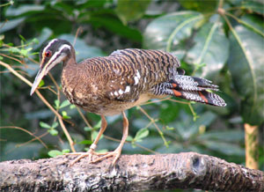
Source: Wikipedia http://www.en.wikipedia.org.
Fig. 38. Eurypyga helias.
The single species of sunbittern inhabits water-edge habitat in Central and South America. The taxonomic position of these birds is uncertain, though they have certain morphologic and behavioral similarities to the kagu. For example, there are similarities in the protein of the egg white and there are showy patterns on the wings that can be displayed (Roberson 2012). However, DNA hybridization studies place them in a separate infraorder in Gruiformes (Sibley and Monroe 1990), suggesting they may actually be a separate kind.

Order Gruiformes

Sarothruridae (The Flufftail kind)
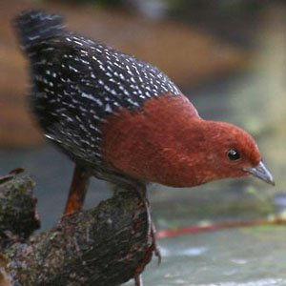
Source: Wikipedia http://www.en.wikipedia.org.
Fig. 39. Sarothrura rufa.
The nine species of flufftails are in a single genus. They are considered a sister taxon to finfoots (Heliornithidae; Gill and Donsker 2012b). They inhabit various regions in Africa. Based on DNA hybridization, Sibley and Monroe (1990) place them in Rallidae, suggesting the level of the kind could actually be higher than indicated here. However, since there is a cognitum at the family and no hybrid data suggesting they are related beyond this, the level of kind is assigned to this default level; that is, the family.

Heliornithidae (The Finfoot kind)
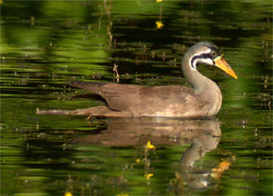
Source: Wikipedia http://www.en.wikipedia.org.
Fig. 40. Heliopais personatus.
There are three species, each placed in the own genus (Gill and Donsker 2012b). The sungrebe and finfoots are unusual aquatic birds that inhabit the tropics. They have lobed feet for swimming and eat mostly while in the water (Roberson 2012). Sibley and Monroe (1990) place finfoots in with the limpkin (Aramidae) based on data from one of the three species. However, since these birds are generally not well studied, the level of kind is left at the family for now.

Rallidae (The Rail kind)
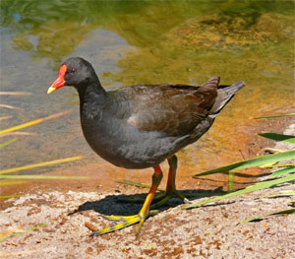
Source: Wikipedia http://www.en.wikipedia.org.
Fig. 41. Gallinula tenebrosa.
The 151 species are placed in 38 genera, though a few of these are now believed to be extinct (Gill and Donsker 2012b). This diverse group includes the rails, crakes, gallinules, and coots. Most are small to medium ground dwellers with relatively short wings and tails. They have strong feet and legs. Many are found in close association with water, with the duck-like coots being the most aquatic (Roberson 2012). Hybrid data connects two relatively large genera, Fulica and Gallinula (McCarthy 2006).

Psophiidae (The Trumpeter kind)
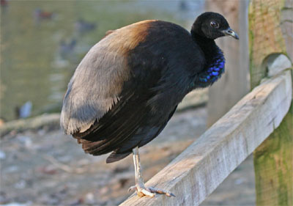
Source: Wikipedia http://www.en.wikipedia.org.
Fig. 42. Psophia crepitans.
The three species of trumpeters are found in a single genus (Gill and Donsker 2012b). They are elusive ground dwellers that live in small groups. They are about the size of a chicken and live in lowland forests in northern South America (Roberson 2012). Taxonomists agree they belong together, but disagree in how they are related to other birds. The various suggestions are from different orders (Handbook of the Birds of the World Alive). This difficulty in determining relationship may be because they are not actually related to any of them, so the level of the kind is placed here.

Gruidae (The Crane kind)
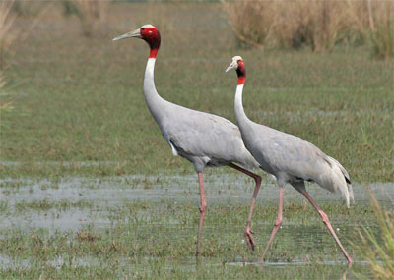
Source: Wikipedia http://www.en.wikipedia.org.
Fig. 43. Grus antigone antigone.
The 15 species of cranes are placed in two genera (Gill and Donsker 2012b). There is hybrid data connecting these two genera (McCarthy 2006). Cranes are large with blue heron-like body proportions. They generally mate for life. They are found in open regions. Many are migratory; they fly with their neck extended forward (unlike a blue heron) and feet extended behind them (Roberson 2012). It has been proposed that they are closely related to the limpkin (Aramidae), trumpters (Psophiidae), and bustards (Otididae) based on various features. In some schemes these families are all in the same order, Gruiformes (Handbook of the Birds of the World Alive). This certainly leaves open the possibility that the level of the kind is higher, but there is enough ambiguity that the level of the kind will be left at the family.

Aramidae (The Limpkin kind)
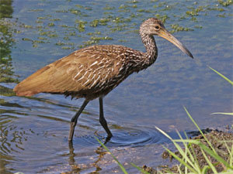
Source: Wikipedia http://www.en.wikipedia.org.
Fig. 44. Aramus guarauna.
There is a single species of limpkin (Gill and Donsker 2012b). They inhabit marshes of the New World tropics. While they superficially appear somewhat like an ibis, they are anatomically more similar to cranes and behaviorally share similarities with rails. DNA comparisons have found high similarity to the family Heliornithidae, the sungrebes and finfoots (Roberson 2012). This all suggests that the kind may actually be above the family level. However, it will be left here for this study since no hybrid data is available to support this possibility.

Order Charadriiformes

(The Shorebird kind)
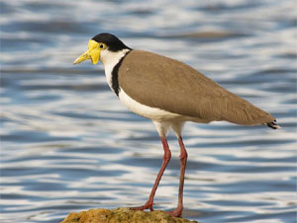
Source: Wikipedia http://www.en.wikipedia.org.
Fig. 45. Vanellus miles.
Hybrid data connects the ruff (Philomachus pugnax) and the crowned lapwing (Vanellus coronatus; McCarthy 2006). They are members of the sandpiper (Scolopacidae) and plover (Charadriidae) families respectively. These two families are the largest in this order apart from the gulls (Laridae). Other smaller families fit easily within this cognitum, particularly ones bearing plover as part of their common name.
Based on DNA-DNA hybridization studies, Sibley and Monroe (1990) place Scolopacidae and Charadriidae in separate parvorders (level below infraorder and above superfamily). Combining these two groups means 18 of the 19 families that Gill and Donsker (2013) place in this order would be considered from a single created kind. This includes 368 species, some of which are now extinct.
This is not entirely unexpected. Many of the smaller families have species which exhibit traits reminiscent of several other families in this grouping. For example, the Magellanic plover inhabits the southern tip of South America and was once placed in the plover family (Charadriidae). However, it behaves more like a turnstone (Scolopacidae) and has anatomical traits like the sheathbill (Chionidae). It is now usually placed in its own monotypic family (Pluvianellidae). Similarly, the crab plover (Dromadidae) is the sole member of its family. It has a pied appearance like avocets (Recurvirostridae), and a heavy bill and feeding habits like one genus of thick-knees (Burhinidae). It digs burrows for nesting like auks (Alcidae), and its tarsal scutellation and the color pattern of down on the chicks most closely resembles gulls (Laridae; Roberson 2012). Other families in this order include Haematopodidae, Ibidorhynchidae, Rostratulidae, Jacanidae, Pedionomidae, Thinocoridae, Glareolidae, and Stercorariidae.
Statistical analysis was performed on a dataset that included only Alcidae. It appeared to divide the family, with one of the five tribes showing strong correlation within the group and weak discontinuity with some of the other tribes. This was not completely compatible with previous molecular analysis (Wood 2008). Since there is no indication of how this family relates to outgroups, the statistical analysis was not deemed helpful in determining its baraminic status. Since Sibley and Monroe (1990) place Turnicidae in a separate order based on their DNA studies, it will be considered a separate kind here.

Turnicidae (The Buttonquail kind)
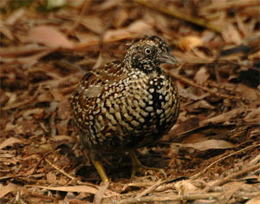
Source: Wikipedia http://www.en.wikipedia.org.
Fig. 46. Turnix melanogaster.
There are 17 species in this family, all but one of which are in a single genus (Gill and Donsker 2013). These small, ground-dwelling birds appear superficially similar to quail, but they are considered unrelated. They differ from quail in that they lack a hind toe and crop. Females have an enlarged trachea and an inflatable region of the esophagus which they use to produce their booming call. Determining to which taxon they are most closely related has proved to be a conundrum. Suggestions have been made that they were allied with a number of divergent taxa (Handbook of the Birds of the World Alive). Given this ambiguity, it may well indicate they are not truly related to another taxon, but are instead a created kind.

Order Pterocliformes

Pteroclidae (The Sandgrouse kind)
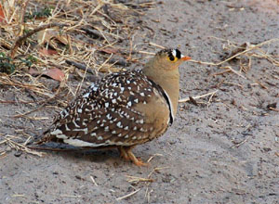
Source: Wikipedia http://www.en.wikipedia.org.
Fig. 47. Pterocles bicinctus.
There are 16 species placed in two genera (Gill and Donsker 2013). Though it is readily agreed that members of this family are closely related to each other, it is hotly debated how the family is related to other birds. Linnaeus originally placed them in the same genus as the European grouse. Later it was pointed out that they had similarities to doves. Then it was suggested they were more closely related to shorebirds. DNA and other biochemical evidence reveal significant similarity between them and the waders of Charadriiformes (Roberson 2012). Given that the taxa they are postulated as being related to are so diverse, it may indicate they are actually a distinct kind.

Order Columbiformes

Columbidae (The Dove kind)
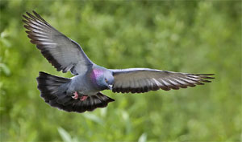
Source: Wikipedia http://www.en.wikipedia.org.
Fig. 48. Columba livia.
Gill and Donsker (2013) list 335 species in 45 genera, a few of which are now extinct. This distinctive family is distributed worldwide and easily recognized by most people. Thirteen genera are connected by hybrid data and two other genera have hybridized with each other (McCarthy 2006). Given the strong cognitum, it seems the level of the kind is here.

Order Psittaciformes

(The Parrot kind)
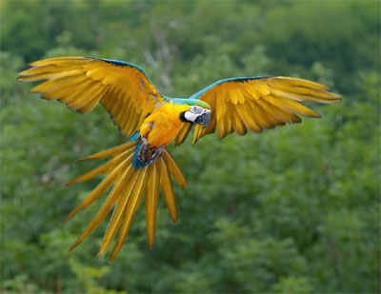
Source: Wikipedia http://www.en.wikipedia.org.
Fig. 49. Ara ararauna.
Three families are recognized in this order: Strigopidae (New Zealand parrots), Cacatuidae (cockatoos) and Psittacidae (parrots). The first two are small, comprising four and 21 species respectively. There are 363 species of parrots, a few of which are now extinct (Gill and Donsker 2013). There are a number of genera within Psittacidae which are linked by hybrid data. One documented cross between Galah and Eastern Rosella resulted in fertile eggs, which unites the family Psittacidae with Cacatuidae (McCarthy 2006). This provides the basis for combining the three families. Sibley and Monroe (1990) place all these species in a single family as well.

Order Opisthocomiformes

Opisthocomidae (The Hoatzin kind)
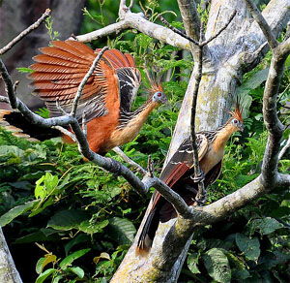
Source: Wikipedia http://www.en.wikipedia.org.
Fig. 50. Opisthocomus hoazin.
The Hoatzin is an unusual bird whose relationship to other birds has been debated. It inhabits the lowland swamps of South America. Its diet consists of leaves, fruits, and flowers. It digests its food by foregut fermentation, which is highly unusual for a bird. Its chicks have two claws on each budding wing which can be used to grip objects as they move about. Like most birds they have anisodactyl feet, with three forward pointing toes and one toe that points back (Roberson 2012). Given its distinct characteristics and unclear relationship to other birds, the family/order seems the logical place for the kind.

Order Musophagiformes

Musophagidae (The Turaco kind)
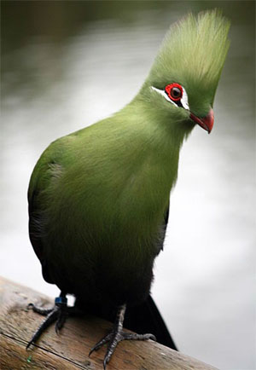
Source: Wikipedia http://www.en.wikipedia.org.
Fig. 51 Tauraco persa.
This family is comprised of 23 species in six genera (Gill and Donsker 2013). These African birds have a semi-zygodactylous toe formation. The fourth toe can be held next to the third, or moved around to point backwards. This unique flexibility allows them to move along branches and through vegetation with great agility. They also have two copper pigments that are unknown in other birds (Handbook of the Birds of the World Alive). As with so many of the single family orders, it seems the level of the kind should be here.

Order Cuculiformes

Cuculidae (The Cuckoo kind)
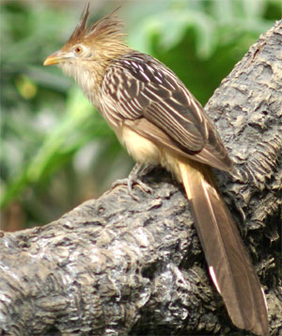
Source: Wikipedia http://www.en.wikipedia.org.
Fig. 52. Guira guira.
This family comprises nearly 150 species in over 30 genera (Gill and Donsker 2013). It is a diverse family that has been identified as including seven distinct subgroups. They are unusual in having zygodactyl feet, with two toes pointing forward and two pointing rearward. Most species are insectivorous. The roadrunner is probably the best known member of this family (Roberson 2012).

Order Strigiformes

Tytonidae (The Barn Owl kind)
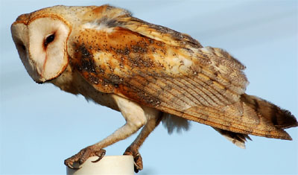
Source: Wikipedia http://www.en.wikipedia.org.
Fig. 53. Tyto alba.
This family comprises 18 species placed in two genera (Gill and Donsker 2013). These owls have a hearted-shaped facial disk and a long, compressed bill. Their eyes are proportionally smaller than those of typical owls. They have features of their feet and sternum that differ as well (Cholewiak 2003c). Fertile eggs have been reported from a cross between the two genera (McCarthy 2006).

Strigidae (The Owl kind)
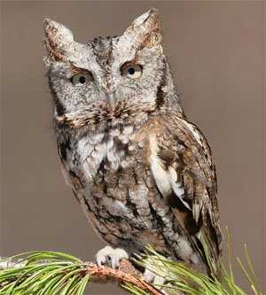
Source: Wikipedia http://www.en.wikipedia.org.
Fig. 54. Megascops asio.
Typical owls are comprised of 211 species in about 25 genera (Gill and Donsker 2013). Hybrids are considered to be rare in owls. There are two intergeneric crosses that have been observed in captivity: Athene with Speotyto and Bubo with Strix. McCarthy (2006) points out that many species of owls are hard to identify clearly, resulting in confusion regarding species and generic limits. This obviously makes the identification of hybrids more difficult when even the parents are difficult to identify. Further, due to their nocturnal behavior and sometimes inaccessible habitats, owls are relatively poorly studied. Therefore, any hybridization which is occurring is less likely to be identified compared to other, better studied groups of birds.

Order Caprimulgiformes
Members of this order are also nocturnal and not as well studied as most other birds. Many types are very similar, yet treated as separate species, creating the same problems with identifying hybrids as mentioned for owls. Most caprimulgids are not bred in captivity, and all interspecific hybrids are intrageneric (McCarthy 2006).

Podargidae (The Frogmouth kind)
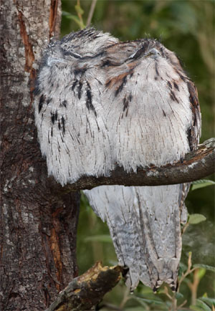
Source: Wikipedia http://www.en.wikipedia.org.
Fig. 55. Podargus strigoides.
Gill and Donsker (2013) identify 16 species placed in three genera. They are characterized by a very wide, strong bill from which they derive their name. Based on various characteristics, including DNA-DNA hybridization, they appear to be related to other families in this order, particularly the nightjars (Caprimulgidae; Handbook of the Birds of the World Alive). However, the level of the kind is kept at the family due to lack of sufficient data, especially hybrid data, to placing it higher.

Steatornithidae (The Oilbird kind)
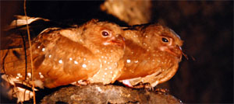
Source: Wikipedia http://www.en.wikipedia.org.
Fig. 56. Steatornis caripensis.
There is only a single species of this strange, large, fruit-eating nightbird. It breeds and roosts in caves. It uses echolocation in the caves like bats, but it also has huge eyes and excellent night vision. It can fly fast, slow, or hover. This bird is represented in the fossil record in the Green River formation (Roberson 2012). Until more information comes available, the level of the kind is placed at the family.

Nyctibiidae (The Potoo kind)
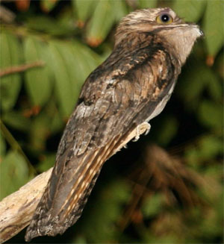
Source: Wikipedia http://www.en.wikipedia.org.
Fig. 57. Nyctibius jamaicensis.
The seven species belong to a single genus (Gill and Donsker 2013). There are various morphological and behavioral features that distinguish them from other families in this order, such as lack the bristles around the mouth and a “toothed” beak. Yet they have various features similar to several of the other families in this order. They are usually considered most closely related to nightjars (Handbook of the Birds of the World Alive). Since the various families they are postulated as being related to are in the same order, it is possible that the level of the kind is higher. However, this order is not as well studied as many others and hybrid evidence is lacking. Thus, for now, the level of the kind is placed at the family.

Caprimulgidae (The Nightjar kind)
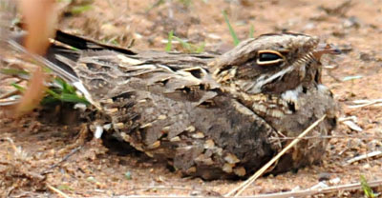
Source: Wikipedia http://www.en.wikipedia.org.
Fig. 58. Caprimulgus asiasticus.
The 95 species of this family are placed in 21 genera (Gill and Donsker 2013). They are found in a variety of habitats around the world except for the Polar Regions. Their family name is literally goat-suckers based on the belief that they suckled goats at night. In reality these nocturnal birds are mostly insectivorous. They have strange calls and a small bill which opens a cavernous mouth that collects their prey (Alderfer 2005).

Order Apodiformes

Aegothelidae (The Owlet-nightjar kind)
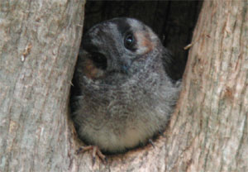
Source: Wikipedia http://www.en.wikipedia.org.
Fig. 59. Aegotheles cristatus.
This family is comprised of ten species in a single genus (Gill and Donsker 2013). Sibley and Monroe (1990) place this family and members of Caprimulgiformes in the same order as owls. This alternative grouping based on DNA-DNA hybridization studies also is consistent with their common name. These nocturnal birds are not well studied and no hybrid data is available for them (McCarthy 2006). Given the ambiguity and lack of hybrid data, the level of the kind is left at the family.

Hemiprocnidae (The Treeswift kind)
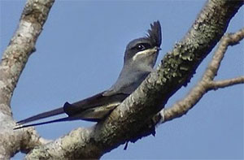
Source: Wikipedia http://www.en.wikipedia.org.
Fig. 60. Hemiprocne coronata.
This family is comprised of four species in a single genus (Gill and Donsker 2013). These insectivorous birds live in forests of the Malay Peninsula and islands of that region. Though considered to be closely related to swifts, they differ in several anatomic features (Roberson 2012). While the similarities may suggest the level of the kind is higher, it is left at the level of the family for now for want of hybrid data.

Apodidae (The Swift kind)
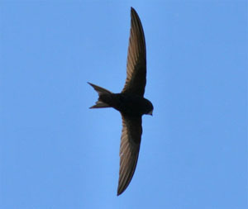
Source: Wikipedia http://www.en.wikipedia.org.
Fig. 61. Apus apus.
The 105 species in this family are divided among 19 genera (Gill and Donsker 2013). They were once thought to be closely related to swallows because of some superficial similarities, but are no longer believed to be so. They are the most aerial of all birds, and generally only perch near their nests. They have strong claws which enable them to perch on vertical surfaces. They have a small bill, but a large gape for feeding on aerial arthropods (Alderfer 2005). McCarthy (2006) only reports intrageneric hybrids.

Trochilidae (The hummingbird kind)
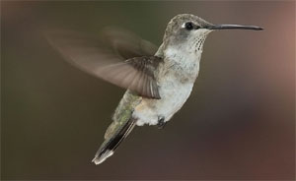
Source: Wikipedia http://www.en.wikipedia.org.
Fig. 62. Archilochus alexandri.
Gill and Donsker (2013) recognize 342 species in over 100 genera. These tiny birds beat their wings incredibly fast and, by rotating their wings, can even fly backwards. Hybrid data connects at least 26 of the genera. In addition, there are several more isolated crosses that connect two genera which are unconnected with any others (McCarthy 2006). The cognitum is also very strong for these birds, suggesting the level of the family is a good place to consider the level of the kind.

Order Coliiformes

Coliidae (The Mousebird kind)
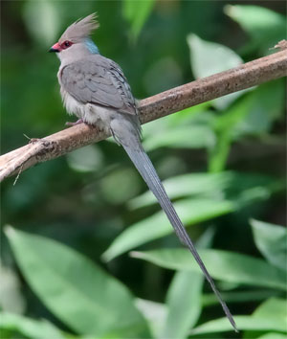
Source: Wikipedia http://www.en.wikipedia.org.
Fig. 63. Urocolius macrourus.
There are six species of mousebirds placed in two genera (Gill and Donsker 2013). Sometimes referred to as colies, these unique arboreal birds are found in sub-Saharan Africa. In 1872 it was suggested they should be a separate order based on morphological peculiarities. Molecular studies have confirmed this (Roberson 2012).

Order Trogoniformes

Trogonidae (The Trogon kind)
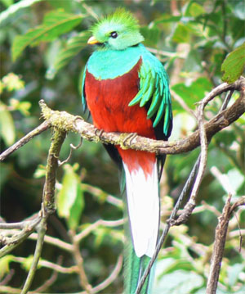
Source: Wikipedia http://www.en.wikipedia.org.
Fig. 64. Pharomachrus mocinno.
This family is comprised of 43 species in seven genera (Gill and Donsker 2013). These birds have brightly colored plumage, particularly in the males. They are well represented in the forests of the Neotropics, while other species are found in Africa and Asia. One genus includes five species of quetzals. The best known is the resplendent quetzal (Pharomachrus mocinno); the male of this species has one of the longest tails known and is featured on the Guatemala flag and coat-of-arms (Roberson 2012). As a single family order, it is convenient to place the level of the kind here.

Order Leptosomiformes

Leptosomidae (The Cuckoo Roller kind)
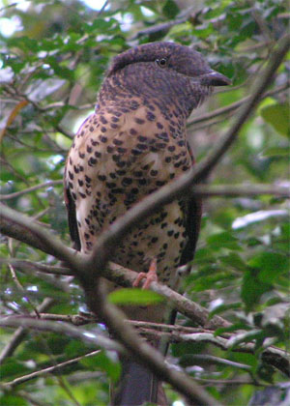
Source: Wikipedia http://www.en.wikipedia.org.
Fig. 65. Leptosomus discolor.
This single species is endemic to the island of Madagascar. Its head seems disproportionately large compared to the rest of its body. They are relatively tame. They often fly in circles and are occasionally mistaken for small hawks because of their short, broad wings. However, their flight pattern differs; they alternate quick wingbeats and glides, resulting in an undulating pattern (Roberson 2012). Although initially thought to be a cuckoo, subsequent studies have consistently found them to be more closely allied with rollers. This may suggest the level of the kind is higher, but it will be left at the family level for this single family order.

Order Coraciiformes

Coraciidae (The Roller kind)
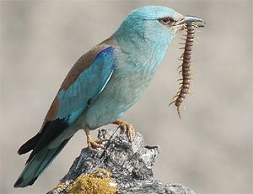
Source: Wikipedia http://www.en.wikipedia.org.
Fig. 66. Coracias garrulus.
This family is comprised of 12 species in two genera (Gill and Donsker 2013). Although these birds are relatively common in much of Africa, and parts of Asia and Australia, they remain relatively poorly studied. They are considered related to cuckoo rollers (Leptosomidae) and ground rollers (Brachypteraciidae). Yet they share features with a number of other families which are now suspected to be from convergent evolution (Handbook of the Birds of the World Alive). So while the level of the kind may be higher, it will be left here until stronger evidence suggests otherwise.

Brachypteraciidae (The Ground Roller kind)
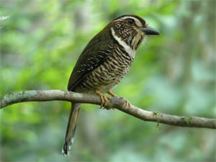
Source: Wikipedia http://www.en.wikipedia.org.
Fig. 67. Brachypteracias leptosomus.
The five species of this family are placed in four different genera (Gill and Donsker 2013). They are found only in Madagascar. Four species inhabit the rain-forest; one inhabits the spiny deserts of the southwest. The latter, the long-tailed ground-roller, has such an interesting mix of characteristics that its specific name is chimaera (Roberson 2012).

Alcedinidae (The Kingfisher kind)
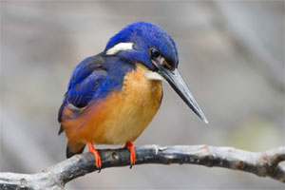
Source: Wikipedia http://www.en.wikipedia.org.
Fig. 68. Alcedo azurea ruficollaris.
This family is comprised of 95 species in 19 genera (Gill and Donsker 2013). Within this family there are three distinct subfamilies which some authors will elevate to the status of family (Roberson 2012). McCarthy (2006) only reports intrageneric hybrids, which could be argued as sufficient reason to place the kind at this lower grouping. However, the cognitum unifying them is strong and they are believed to be closely related. While the size and tail length varies considerably among them, they have large heads sporting a long, strong beak and short legs (Alderfer 2005).

Todidae (The Tody kind)
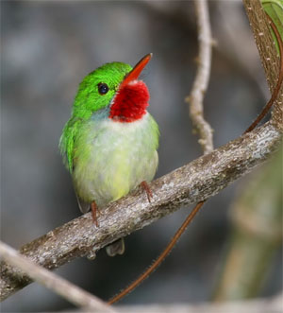
Source: Wikipedia http://www.en.wikipedia.org.
Fig. 69. Todus todus.
The five species in this family are placed in a single genus (Gill and Donsker 2013). These birds are native to the Caribbean and look like miniature kingfishers. Their green color, long, flattened beaks and ability to hover explains why the local people call them colibri, which means hummingbird. They are now usually considered most closely related to motmots of the Neotropics (Handbook of the Birds of the World Alive). While the level of the kind may be higher, there is no hybrid data connecting any families in this order.

Momotidae (The Motmot kind)
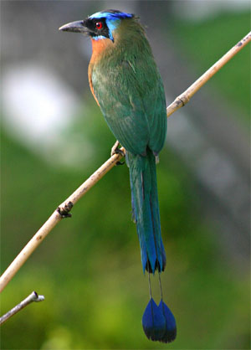
Source: Wikipedia http://www.en.wikipedia.org.
Fig. 70. Momotus momota.
This family is comprised of 14 species in 6 genera (Gill and Donsker 2013). These sit-and-wait hunters inhabit the Neotropics. They will suddenly burst out and snatch their prey, which are generally invertebrates or small vertebrates. A number of the species have a long tail with racquets at the end (Roberson 2012).

Meropidae (The Bee-eater kind)
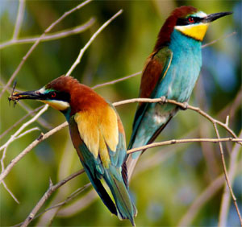
Source: Wikipedia http://www.en.wikipedia.org.
Fig. 71. Merops apiaster.
There are 27 species in this family arranged in three genera (Gill and Donsker 2013). Bee-eaters are attractive birds found in Africa and Asia. As their name implies, bees usually comprise a major part of their diet. They vary from social species of the open country to retiring inhabitants of dense Asian jungles (Roberson 2012).

Order Bucerotiformes

Upupidae (The Hoopoe kind)
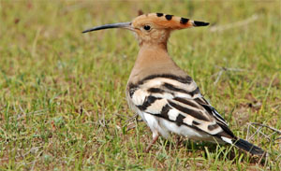
Source: Wikipedia http://www.en.wikipedia.org.
Fig. 72. Upupa epops.
This family comprises three extant species in a single genus (Gill and Donsker 2013). These Old World birds have long, thin, downward curving bills, a chunky body, broad wings, square tails, and impressive crests. They differ from other birds in the order in that they lack an expansor secondarium muscle and their young are not naked, but covered with down upon hatching. They do share a range of characters with the woodhoopoes and are placed near them based on DNA-DNA hybridization (Alderfer 2005; Handbook of the Birds of the World Alive; Roberson 2012). Yet they are distinctive and no hybrid data connects this family with another, so the level of the kind is left here.

Phoeniculidae (The Wood Hoopoe kind)
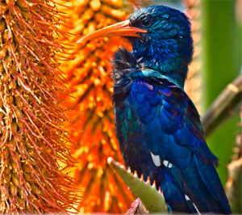
Source: Wikipedia http://www.en.wikipedia.org.
Fig. 73. Phoeniculus purpureus.
Gill and Donsker (2013) list nine species in two genera and recognize this family as a sister taxon to hoopoes (Upupidae). These birds have a long, downward curved bill and share a variety of other characteristics with the hoopoe. The most obvious difference is that they lack the crest (Handbook of the Birds of the World Alive). All this could suggest that the level of the kind is higher than the family. However, based on DNA-DNA hybridization, it was suggested this family be divided, and that wood hoopoes (genus Phoeniculus) and the scimitarbills (genusRhinopomastus) be considered separate, though related, families. This means ignoring the obvious cognitum of this family. In fact, the black wood hoopoe (aka black scimitarbill) was initially named based on morphological similarities to other woodhoopoes (Phoeniculus), but is now classified as scimitarbill (Rhinopomastus) based on genetic similarity. Its bill doesn’t live up to the new name (Handbook of the Birds of the World Alive). For now it seems best to leave the level of the kind at the family.

Bucerotidae (The Hornbill kind)
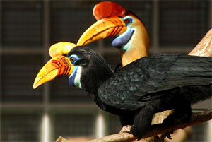
Source: Wikipedia http://www.en.wikipedia.org.
Fig. 74. Aceros cassidix.
This family comprises 59 species divided among 13 genera. They are recognized as a sister taxon to ground hornbills, both of which are considered related to the hoopoes and woodhoopoes (Gill and Donsker 2013). These impressive birds have a large, deep, downward curved bill. They inhabit a variety of habitats in the Old World tropics. When nesting, the female is sealed inside the nest cavity and fed by the male though a tiny slit while she incubates the eggs (Roberson 2012). Despite some hints the level of the kind may be higher, it is kept here as no hybrid data connects these families.

Bucorvidae (The Ground Hornbill kind)
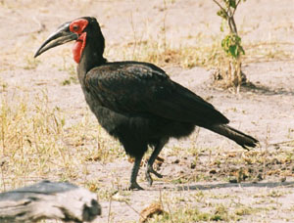
Source: Wikipedia http://www.en.wikipedia.org.
Fig. 75. Bucorvus leadbeateri.
The two species in this family are in a single genus (Gill and Donsker 2013). At one time they were considered a subfamily of hornbills. Unlike hornbills, they do not seal the female inside the nest cavity. They also hop instead of walk, lack a carotid artery (unlike all other birds), and have 15 neck vertebrae instead of 14. They inhabit grasslands and savanna in sub-Saharan Africa (Roberson 2012).

Order Piciformes

Galbulidae (The Jaçamar kind)
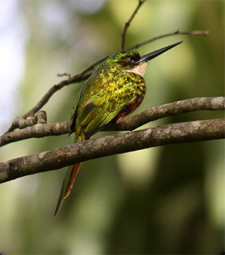
Source: Wikipedia http://www.en.wikipedia.org.
Fig. 76. Galbula ruficauda melanogenia.
Gill and Donsker (2013) report 18 species in five genera. When these birds were first identified centuries ago they were classified as kingfishers. Today convincing evidence has accumulated to establish them as a sister taxon to puffbirds (Bucconidae). Yet despite this perceived close relationship, there are number of traits which distinguish these two families (Handbook of the Birds of the World Alive). Thus, for now, the level of the kind will be designated at the family.

Bucconidae (The Puffbird kind)
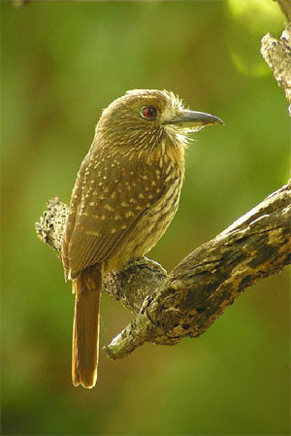
Source: Wikipedia http://www.en.wikipedia.org.
Fig. 77. Malacoptila panamensis.
This family is comprised of 36 species in ten genera (Gill and Donsker 2013). These birds have a relative large head and large eyes, as well as a fairly heavy beak that is swollen at the base. Despite the fact that over half the species have been known for over 150 years, much is still unknown about these difficult-to-study birds (Handbook of the Birds of the World Alive).

Capitonidae (The New World Barbets)
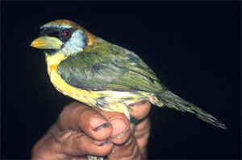
Source: Wikipedia http://www.en.wikipedia.org.
Fig. 78. Eubucco bourcierii.
This family is comprised of 15 species in two genera (Gill and Donsker 2013). Barbets are tropical species which excavate holes to lay eggs and have zygodactyl feet, where two toes point forward and the other two point backward. The New World barbets are considered more closely related to the toucan-barbet and the toucan than to Old World barbets. However, the Old World barbets are ecological counterparts to the New World species (Roberson 2012). No hybrid data connects these families.

Semnornithidae (The Toucan Barbet kind)
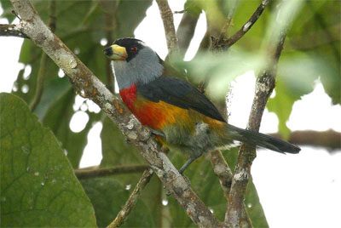
Source: Wikipedia http://www.en.wikipedia.org.
Fig. 79. Semnornis ramphastinus.
Both species in this family are in a single genus (Gill and Donsker 2013). At one time they were placed with New World barbets in the toucan family. There is some controversy over whether they are more closely related to barbets or toucans. These fruit-eating species inhabit the Andes of Colombia and Ecuador (Roberson 2012).

Ramphastidae (The Toucan kind)
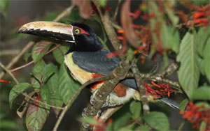
Source: Wikipedia http://www.en.wikipedia.org.
Fig. 80. Pteroglossus torquatus.
Gill and Donsker (2013) list 46 species in five genera. Toucans are distinctive-looking birds of the New World Neotropics which most people can readily recognize. Despite the distinctive appearance, considerable evidence suggests that they are simply large-billed barbets. Most species eat primarily fruit (Roberson 2012). Thus it is quite possible that the level of the kind is above the current family level, but it is kept here because hybrid data is lacking.

Megalaimidae (The Asian Barbet kind)
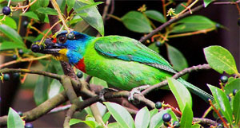
Source: Wikipedia http://www.en.wikipedia.org.
Fig. 81. Megalaima oorti.
This family comprises 30 species in three genera (Gill and Donsker 2013). Most are small to medium sized birds. These chunky birds are often colorful. However, it is often easier to hear them than see them. They make sounds like woodpeckers as they excavate nest holes in rotten wood. Like the woodpecker they have zygodactyl feet for clinging to the side of trees, but they lack the stiff tail. Their calls are also prominent in the forests they inhabit (Roberson 2012).

Lybiidae (The African Barbet kind)
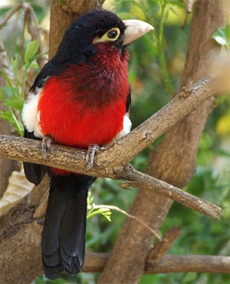
Source: Wikipedia http://www.en.wikipedia.org.
Fig. 82. Lybius bidentatus.
Gill and Donsker (2013) list 42 species in seven genera. They live in a wide range of habitats, from dense jungles to open thornscrub savanna. Like other barbets they nest in holes; in the savanna these are excavated in termite mounds. These latter birds are more insectivores, while most barbets eat primarily fruit (Roberson 2012).

Indicatoridae (The Honeyguide kind)
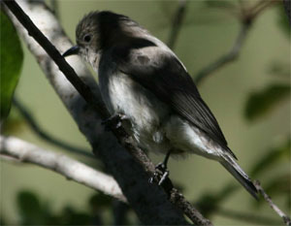
Source: Wikipedia http://www.en.wikipedia.org.
Fig. 83. Prodotiscus regulus.
This family comprises 17 species in four genera (Gill and Donsker 2013). They have dull plumage and lay their eggs in the nests of other birds, especially small barbets and tinkerbirds. These birds eat beeswax and honeycomb, and their name reflects the fact that they can be followed to a source of honey (Roberson 2012).

Picidae (The Woodpecker kind)
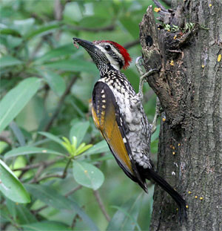
Source: Wikipedia http://www.en.wikipedia.org.
Fig. 84. Dinopium benghalense.
This family comprises 232 species in 30 genera (Gill and Donsker 2013). Two relatively large genera, Colaptes and Melanerpes, are connected by hybrid data. A second intergeneric hybrid has been reported between two other genera, but it is considered doubtful by McCarthy (2006). All woodpeckers have a similar design equipping them for a life of chiseling wood. This includes shock-absorbing head musculature, extremely long tongues, and stiff tail feathers that help them perch upright on the side of trees (Roberson 2012). Thus it seems reasonable that these many different species are part of the same created kind.

Order Passeriformes
The remaining birds are part of a huge order known as Passeriformes, often known as perching birds. This order includes over half the world’s bird species (Gill and Donsker 2013). It is incredibly diverse and includes a number of families that are united by hybridization data (Lightner 2010). As seen below, the taxonomic position of many species has been subject to considerable controversy.

Acanthisittidae (The New Zealand Wren kind)
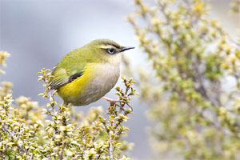
Source: Wikipedia http://www.en.wikipedia.org.
Fig. 85. Xenicus gilviventris.
Gill and Donsker (2013) recognize two extant species each in their own genus. One species, the Rifleman, can be found on North, South, and Stewart Islands in New Zealand. Despite the loss of native habitat, they remain reasonably common. The second species is limited to the South Island. Several other species have become extinct since people have colonized the islands (Roberson 2012).

Eurylaimidae (The Broadbill kind)
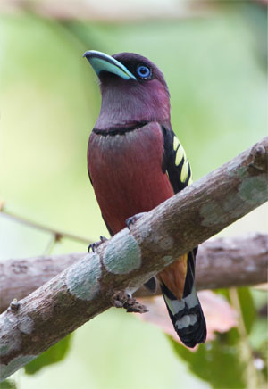
Source: Wikipedia http://www.en.wikipedia.org.
Fig. 86. Eurylaimus javanicus.
Gill and Donsker (2013) list 20 species in 12 genera. This family of largely tropical Asian and African (i.e. paleotropical) birds now includes the asities (formerly Philepittidae) which inhabit Madagascar. The Sapayoa, a New World species, has been added to this family as well. These birds are considered closely related to pittas (Pittidae), but no hybrid data connects these two families (Handbook of the Birds of the World Alive).

Pittidae (The Pitta kind)
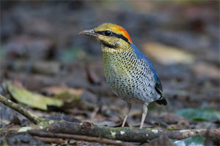
Source: Wikipedia http://www.en.wikipedia.org.
Fig. 87. Pitta cyanea.
This family is comprised of 33 species in three genera (Gill and Donsker 2013). Historically there was debate concerning to which taxa these paleotropical birds are most closely related. Currently they are believed to be most closely related to broadbills (Eurylaimidae), which is supported by multiple lines of evidence including DNA-DNA hybridization (Handbook of the Birds of the World Alive). However, there is no hybrid data connecting this family with another and the cognitum isn’t very informative as there is considerable intrafamilial diversity.

Furnariidae (The Ovenbird kind)
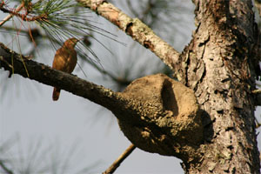
Source: Wikipedia http://www.en.wikipedia.org.
Fig. 88. Furnarius rufus.
This family comprises 307 species in over 70 genera. The woodcreepers, formerly placed in the family Dendrocolaptidae, had always been considered closely related and are now considered phylogenetically embedded in the family (Gill and Donsker 2013). Hybrid data connect the woodcreeper genera Dendrocolaptes and Hylexetastes (McCarthy 2006). These birds range through every habitat in South America with some species extending north as far as Mexico. The name ovenbird comes from oven-shaped mud nest constructed by several species in the genusFurnarius. Most species do not construct this type of nest. The North American oven bird is unrelated, belonging instead to the New World warblers, Parulidae (Handbook of the Birds of the World Alive; Roberson 2012).

Thamnophilidae (The Antbird kind)
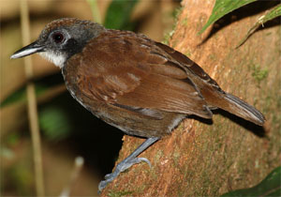
Source: Wikipedia http://www.en.wikipedia.org.
Fig. 89. Gymnopithys leucaspis.
Gill and Donsker (2013) list 228 species in this family. They are confined to the Neotropics, where they predominantly occupy niches in various lowland forests. Unlike some surrounding families, these birds have distinctive features enabling one to more easily identify members of this family, though some would only be obvious to an experienced birder. Despite the many species, they are surprisingly constrained in color combinations and patterns. Most have a similar beak and prey on various invertebrates (Roberson 2012).

Formicariidae (The Antthrush kind)
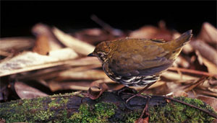
Source: Wikipedia http://www.en.wikipedia.org.
Fig. 90. Chamaeza nobilis.
This family is comprised of 12 species in two genera (Gill and Donsker 2013). These neotropical birds once occupied the same family as the antbirds, but multiple lines of evidence (e.g. syringeal morphology and DNA-DNA hybridization) resulted in their removal. In some schemes the antpittas (Grallariidae) were included in this family, but they now appear more closely related to tapaculos (Rhinocryptidae) based on DNA-DNA hybridization (Handbook of the Birds of the World Alive). While it is possible the level of the kind is higher, there is no hybrid data and no strong cognitum to support it.

Grallariidae (Antpitta kind)
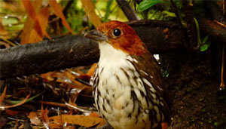
Source: Wikipedia http://www.en.wikipedia.org.
Fig. 91. Grallaria ruficapilla.
Gill and Donsker (2013) recognize 51 species in this family. These birds are also confined to the Neotropics. They generally live on or near the ground. Their relatively drab coloration provides camouflage. They communicate extensively through vocalizations, but are often hard to spot (Roberson 2012).

Conopophagidae (The Gnateater kind)
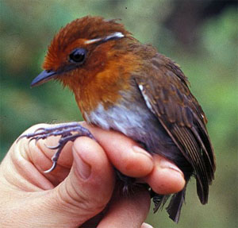
Source: Wikipedia http://www.en.wikipedia.org.
Fig. 92. Conopophaga castaneiceps.
Comprised of 11 species in two genera, these birds are restricted to Central and South America (Gill and Donsker 2013). Their family placement has been controversial. They appear somewhat like small antpittas. Most are sexually dimorphic. The males make a buzzing sound as they fly around their territory at dawn or dusk (Roberson 2012). The level of the kind is left at the family because there is no clear cognitum or hybrid data indicating that it is higher.

Rhinocryptidae (The Tapaculo kind)
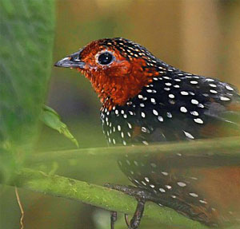
Source: Wikipedia http://www.en.wikipedia.org.
Fig. 93. Acropternis orthonyx.
Gill and Donsker (2013) recognize 56 species. Roberson (2012) calls them “the mice of the avian world” because of the way they scuttle through undergrowth. These birds of the New World tropics were once postulated to be related to the scrub birds or lyrebirds of Australia, but they are more similar genetically to gnateaters and antbirds. Again, this hints that the level of the kind may be higher, but supporting hybrid data is absent and no higher cognitum is obvious.

Melanopareiidae (The Crescentchest kind)
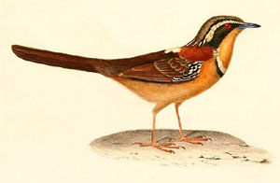
Source: Wikipedia http://www.en.wikipedia.org.
Fig. 94. Melanopareia torquata.
All four species are in a single genus (Gill and Donsker 2013). The colorful birds inhabit the dryer regions of central South America. At one time they had been placed in with the tapaculos. However, they have a relatively long tail and two of them have a white intrascapular patch like many antbirds (Roberson 2012).

Tyrannidae (The Tyrant Flycatcher kind)
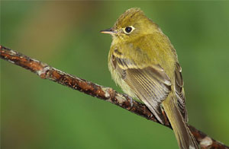
Source: Wikipedia http://www.en.wikipedia.org.
Fig. 95. Empidonax flavescens.
Gill and Donsker (2013) list 421 species. Hybrid data connect the genus Contopus withEmpidonax and Empidonomus with Tyrannus (McCarthy 2006). They inhabit many habitats in North and South America. As their name implies, many eat insects and other arthropods. Some sit patiently until a suitable meal comes nearby. While there are other flycatchers in the Old World, they do not appear to be related to this New World family (Roberson 2012).

Cotingidae (The Cotinga kind)
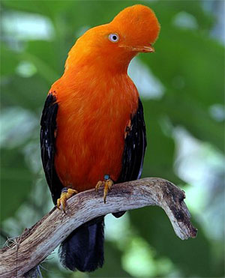
Source: Wikipedia http://www.en.wikipedia.org.
Fig. 96. Rupicola peruviana.
Gill and Donsker (2013) identify 64 species in this family. One other species, the swallow-tailed cotinga, is listed separately (as part of incertae sedis 1, since it is unclear to which family it should be assigned), but it will be included here for this analysis. Tyrant flycatchers, cotingas, manakins, and tityras are all considered to be closely related, and are placed by Sibley and Monroe (1990) in a single family. This suggests the level of the kind is actually higher than recognized here, but no hybrid data is available to support this.

Pipridae (The Manakin)
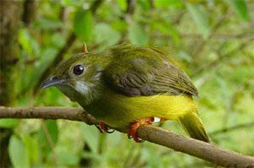
Source: Wikipedia http://www.en.wikipedia.org.
Fig. 97. Manacus candei.
This family is comprised of 52 species in 14 genera (Gill and Donsker 2013). These are tiny birds of the New World tropics (Roberson 2012). Intergeneric hybrids have been reported, forming two groups of three genera each (McCarthy 2006). Wood (2008) analyzed a dataset which appeared to separate out some members of the genus Pipra from the rest of the family. Since all 58 characters related to aspects of syringeal morphology, Wood concluded that wholly syringeal datasets are not informative baraminologically.

Tityridae (The Tityra kind)
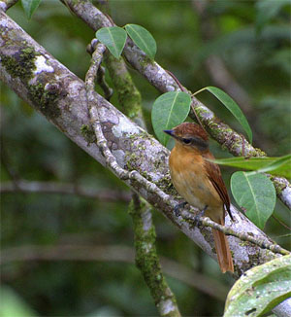
Source: Wikipedia http://www.en.wikipedia.org.
Fig. 98. Pachyramphus castaneus.
This family is comprised of 45 species (Gill and Donsker 2013). Historically it was difficult to find boundaries between the tyrant flycatchers, cotingas, and manakins. Classification was based on the shape of the bill, the scutellation of the tarsus, and whether or not the toes were united, and to what degree. Later molecular evidence was used to create a fourth family, Tityridae. In many of the genera, similarity to members of the other families is attributed to convergent evolution. While this classification scheme resolves numerous difficulties, some still remain (Roberson 2012). Due to the difficulty in finding a clear cognitum in this family and the three preceding it, and the fact that members of these families appear genetically very similar, the level of the kind is probably not really at the family level. For now Philabura and Calyptura, placed in incertae sedis 1 by Gill and Donsker (2003), are absorbed in the above for this assessment. However, more research is necessary to address this uncertainty.

Menuridae (The Lyrebird kind)
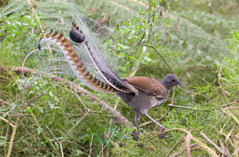
Source: Wikipedia http://www.en.wikipedia.org.
Fig. 99. Menura novaehollandiae.
The two species of lyrebirds are in a single genus (Gill and Donsker 2013). These Australian birds are named for the stunning tail of the male Superb Lyrebird which resembles a Greek lyre. The 16 tail feathers consist of two lyrates, two medians, and 12 filaments. Though normally carried behind the bird, he will fan them forward over his head during a courtship display. Males of the other species lack the two lyrate feathers (Roberson 2012).

Atrichornithidae (The Scrub-bird kind)
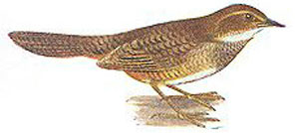
Source: Wikipedia http://www.en.wikipedia.org.
Fig. 100. Atrichornis clamosus.
Scrub-birds also consist of two species in a single genus (Gill and Donsker 2013). These birds are also found in Australia. They live in isolated areas and one species was thought to be extinct until it was rediscovered in 1961. They live in deep leaf litter where they consume invertebrate prey. They are difficult to see, but can often be identified by their singing (Roberson 2012).

Ptilonorhynchidae (The Bowerbird kind)
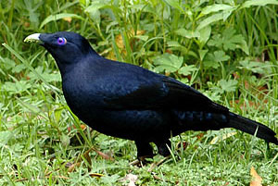
Source: Wikipedia http://www.en.wikipedia.org.
Fig. 101. Ptilonorhynchus violaceus.
Gill and Donsker (2013) identify 20 species in eight genera. Hybrid data connects the genusPtilonorhynchus with Sericulus (Handbook of the Birds of the World Alive). Bowerbirds are found in Australia and New Guinea. Some are colorful, while other species are drab. Most males build bowers to attract a female. These impressive structures may take months to build and are sometimes decorated with colorful objects (Roberson 2012).

Climacteridae (The Australian Treecreeper kind)
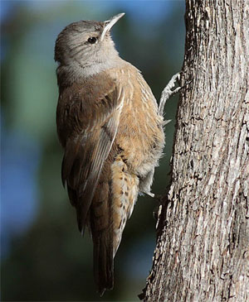
Source: Wikipedia http://www.en.wikipedia.org.
Fig. 102. Climacteris picumnus.
This family is comprised of seven species placed in two genera (Gill and Donsker 2013). One species lives in the mountains of New Guinea while the rest inhabit Australia. As their name implies, they slowly travel up the trunks of trees as they search for insects to feed on. Unlike members of other families that exhibit similar behavior, they do not use their tail to prop themselves up. They are syndactylous with the second and third digit bound together by a membrane that extends to the end of the first toe bone (proximal phalanx) of digit two. Digits three and four are bound together to the base of the third toe bone. This anatomical arrangement appears to help them creep up the tree trunks (Roberson 2012).

Maluridae (The Australasian Wren kind)
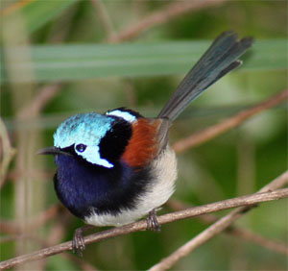
Source: Wikipedia http://www.en.wikipedia.org.
Fig. 103. Malurus elegans.
Gill and Donsker (2013) recognize 29 species in six genera. Four of these are commonly known as fairy-wrens. The other species comprise emu-wrens and grasswrens. Most of these Australasian little birds are active and territorial. They carry their tail in a cocked position and do not migrate. Many also have striking plumage patterns (Roberson 2012).

Meliphagidae (The Honeyeater kind)
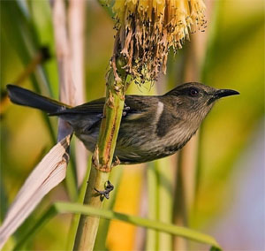
Source: Wikipedia http://www.en.wikipedia.org.
Fig. 104. Phylidonyris pyrrhopterus.
This family is comprised of 184 species (Gill and Donsker 2013). They are essentially restricted to Australasia, but are widespread throughout this region. They are the dominant bird in both Australia and New Guinea. Members of this family have a brush-tipped tongue that collects fluids by capillary action. Most honeyeaters feed on nectar by rapidly extending and retracting their tongue. They also are important pollinators of endemic plants in Australia (Roberson 2012). One intergeneric cross has been reported (McCarthy 2006).

Dasyornithidae (The Bristlebird kind)
This family is comprised of three species in a single genus (Gill and Donsker 2013). They are native to Australia. Not all authors place these birds in their own family (Roberson 2012). Sibley and Monroe (1990) place them and the Australasian warblers in Pardalotidae. Bristlebirds have similarities with scrub-birds (Atrichornithidae) that are believed to be from convergent evolution. Birds from both families excel at moving secretively in dense, low vegetation. They are similar in size and appearance, but have distinct vocalizations (Roberson 2012). The controversy over placement may indicate the level of the kind is higher, since it is among families in the same order. However, there is no hybrid data or obvious cognitum to substantiate this.

Pardalotidae (The Pardalote kind)
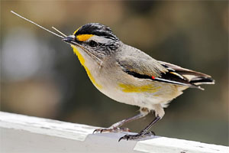
Source: Wikipedia http://www.en.wikipedia.org.
Fig. 105. Pardolatus striatus ornatus.
This family of Australasian birds has four species in a single genus (Gill and Donsker 2013). Though taxonomically unrelated, these birds are somewhat like nuthatches in size, shape, and behavior. However, in addition to foraging on tree trunks and cones, they can be found among the leaves of trees as well. They are often found on Eucalyptus trees where they consume the sweet exudate of psyllids, small plant-sucking insects (Roberson 2012).

Acanthizidae (The Australasian Warbler kind)
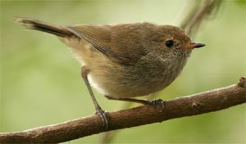
Source: Wikipedia http://www.en.wikipedia.org.
Fig. 106. Acanthiza pusilla.
Gill and Donsker (2013) place 65 species in this family, though one species is now extinct. The family includes thornbills, scrubwrens, gerygones, white-faces, and some unusual ground-dwelling species. Some species of thornbills are quite similar and difficult to differentiate (Roberson 2012).

Family incertae sedis 2 (The Mohoua kind)
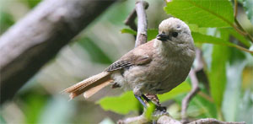
Source: Wikipedia http://www.en.wikipedia.org.
Fig. 107. Mohoua albicilla.
Gill and Donsker (2013) place the genera Mohoua and Finschia separately as their taxonomic position is uncertain. Three species are recognized: the yellowhead, whitehead, and pipipi. Sibley and Monroe (1990) place them in the crow family (Corvidae) based on DNA-DNA hybridization. Given the uncertainty, they will be considered a separate kind here (Roberson 2012). For other species that do not fit neatly into a family, such as those designated incertae sedis 1 and incertae sedis 3 by Gill and Donsker, they are sometimes included in a nearby family for this work if it seems there is sufficient evidence to do so.

Pomatostomidae (The Australasian Babbler kind)
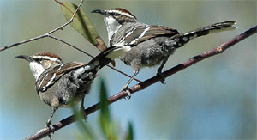
Source: Wikipedia http://www.en.wikipedia.org.
Fig. 108. Pomatostomus ruficeps.
Gill and Donsker (2013) recognize five species in two genera. At one time these birds and logrunners (Orthonychidae) were grouped with other Old World babblers (Roberson 2012). Their removal was largely the result of the work by Sibley and Monroe (1990). Based on the DNA-DNA hybridization work, evolutionists now recognize a great Australasian radiation. The major families in this group were divided between the menurids (Menuridae, Atrichornithidae, Meliphagidae, et al.) and corvids (Corvidae, Paradisaeidae, Cracticidae, et al.). Both Pomatostomidae and Orthonychidae are placed with corvids (Roberson 2012). It remains to be seen if this Australasian radiation seems plausible within the creation model, which does not assume universal common ancestry. So far significant intergeneric hybrid data has not been documented.

Orthonychidae (The Logrunner kind)
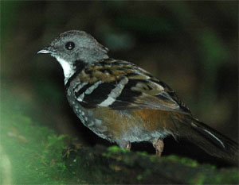
Source: Wikipedia http://www.en.wikipedia.org.
Fig. 109. Orthonyx temminckii.
Gill and Donsker (2013) recognize three species in a single genus. These ground-dwelling birds sometimes forage for berries. More commonly they scratch through the leaf litter on the forest floor for small invertebrates, leaving a characteristic small circular cleared area. Though they were at one time considered related to quail-thrushes and their allies, they are now considered part of a corvid radiation that arose in Australasia (Roberson 2012). The level of the kind is left at the family due to insufficient evidence to place it elsewhere.

Cnemophilidae (The Satinbird kind)
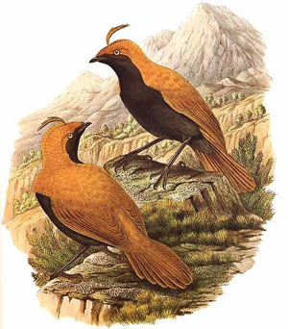
Source: Wikipedia http://www.en.wikipedia.org.
Fig. 110. Cnemophilus macgregorii.
This family is comprised of three species in two genera (Gill and Donsker 2013). They are a poorly studied group of birds native to the uplands of New Guinea. Initially it was thought they were related to bowerbirds (Ptilonorhynchidae) until Ernst Mayr found anatomical evidence suggesting they were more closely related to birds of paradise (Paradisaeidae). Cnemophilidae were removed from the latter family based on DNA evidence suggesting that they and bowerbirds were instead part of the corvid assemblage that arose in Australasia (Roberson 2012). Due to the ambiguity, the level of the kind is left at the family.

Melanocharitidae (The Berrypecker/Longbill kind)
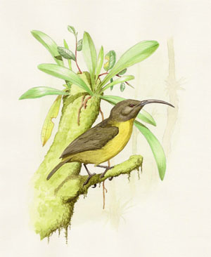
Source: Wikipedia http://www.en.wikipedia.org.
Fig. 111. Toxorhamphus poliopterus.
This family comprises ten species in four genera (Gill and Donsker 2013). This family was only recently identified based on DNA-DNA hybridization. Prior to that members of this family had been classified with flowerpeckers (Dicaeidae), honeyeaters (Meliphagidae), or sunbirds (Nectariniidae). Unsurprisingly, the family is morphologically diverse (Handbook of the Birds of the World Alive). The level of the kind is placed here by default.

Paramythiidae (The Painted Berrypecker kind)
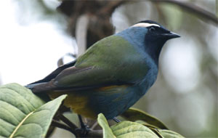
Source: Wikipedia http://www.en.wikipedia.org.
Fig. 112. Paramythia montium montium.
This family is comprised of two species in separate genera (Gill and Donsker 2013). These brightly colored, berry-eating birds inhabit the New Guinea highlands. At one time they were placed with flowerpeckers (Dicaeidae), but they and the typical berrypeckers were removed from that family based on DNA-DNA hybridization evidence. This evidence also supported placing berrypeckers beside painted berrypeckers, but more recent sequencing of nuclear genes may challenge that view (Roberson 2012). For now the level of the kind is left at the family.

Callaeidae (The New Zealand Wattlebird kind)
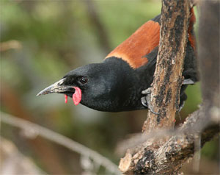
Source: Wikipedia http://www.en.wikipedia.org.
Fig. 113. Philesturnus carunculatus.
Gill and Donsker (2013) list five species in three genera. Two of these species (comprising one genus) are recently extinct. Their extinction is blamed on the introduction of non-native species, particularly brown and black rats. New Zealand wattlebirds are so named because of the fleshy wattles. These are orange in all species except for the North Island Kokako, in which they are blue (Roberson 2012).

Notiomystidae (The Stitchbird kind)
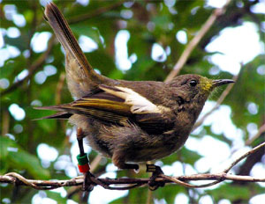
Source: Wikipedia http://www.en.wikipedia.org.
Fig. 114. Notiomystis cincta.
This family is comprised of a single species (Gill and Donsker 2013). The stitchbird was once considered one of three species of honeyeaters endemic to New Zealand. DNA evidence supports the fact that the other two species are honeyeaters, but the stitchbird was found to be more similar to the New Zealand wattlebirds (Callaedae). This forest species inhabits the North Island and surrounding islets (Roberson 2012). Since there is not an obvious cognitum including the stitchbird and the wattlebirds, the level of the kind is kept at the family.

Psophodidae (The Whipbird kind)
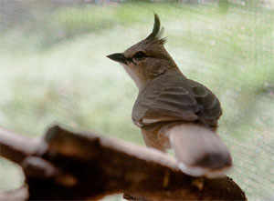
Source: Wikipedia http://www.en.wikipedia.org.
Fig. 115. Psophodes occidentalis.
Gill and Donsker (2013) recognize 16 species in four genera. In this family they include not only whipbirds, but wedgebills, jewel-babblers, and quail-thrush. In the past these species and logrunners were all in the family Orthonychidae. It was the DNA-DNA hybridization evidence that resulted in the removal of the logrunners. In some taxonomic schemes, quail-thrush are also removed to a separate family based on subsequent DNA evidence (Roberson 2012). Sometimes this type of controversy involving closely related families may be from the level of the kind being higher than the family. For now, it is kept at the default level to avoid underestimating the total number of avian kinds.

Platysteiridae (The Batis kind)
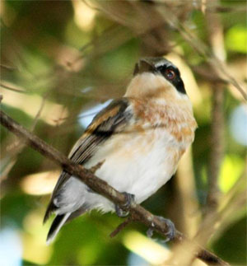
Source: Wikipedia http://www.en.wikipedia.org.
Fig. 116. Batis fratrum.
This family comprises 33 species in five genera (Gill and Donsker 2013). They are medium-sized African birds, over half of which are in the genus Batis. There has been controversy of which species belong in this family, or if this group should even be recognized as a family. Some authors have placed them in with the brush-shrikes (Malaconotidae). Sometimes helmet-shrikes and vangas have been lumped in with them as well. However, more recent biochemical work has resulted in these groups being considered as separate families (Roberson 2012). Again, this type of controversy may suggest the level of the kind is higher. Since no hybrid data supports this, it is left at the family level for now.

Tephrodornithidae (The Woodshrike kind)
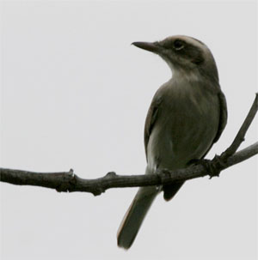
Source: Wikipedia http://www.en.wikipedia.org.
Fig. 117. Tephrodornis pondicerianus.
This family is comprised of eight species in three genera (Gill and Donsker 2013). They are small forest birds of tropical Asia. They had traditionally been placed in with cuckoo-shrikes (Campephagidae). Some authors place them in with vangas (Vangidae; Roberson 2012). Based on recent research, Gill and Donsker (2012b) place Woodshrikes in their own family with flycatcher-shrikes and Philentoma.

Prionopidae (The Helmetshrike kind)
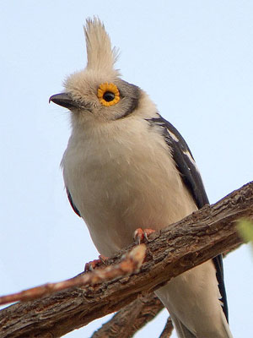
Source: Wikipedia http://www.en.wikipedia.org.
Fig. 118. Prionops plumatus.
This family comprises eight species in a single genus (Gill and Donsker 2013). Some authors place these birds in with vangas (Vangidae). Based on DNA evidence it is now believed that three clades exist among these types of birds. The first is the core bush-shrikes (Malaconotidae). The second is the batises and wattle-eyes (Platysteiridae). The third includes shrike-flycatchers (Tephrodornithidae), helmet-shrikes, and vangas (Roberson 2012). In keeping with Gill and Donsker (2013) the latter three are separated out at the family level here. However, given the longstanding uncertainty, it seems reasonable to postulate that the level of the kind may include all these taxa. However, as with a number of previous taxa, the level of the kind is kept at the family level since hybrid data fails to connect these taxa, it is unclear where the kind would be placed if it is higher, and we want to avoid underestimating the number of kinds on the Ark for this project.

Malaconotidae (The Brushshrike kind)
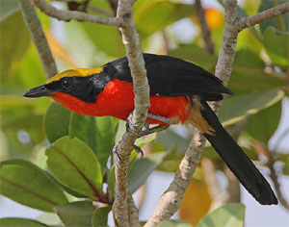
Source: Wikipedia http://www.en.wikipedia.org.
Fig. 119. Laniarius barbarus.
Gill and Donsker (2013) recognize 50 species in this family. They inhabit sub-Saharan Africa and are considered closely related to helmet-shrikes (Prionopidae), vangas (Vangidae), batises and wattle-eyes (Platysteiridae). Most species are loud with distinctive calls, but they are often difficult to see (Roberson 2012).

Machaerirhynchidae (The Boatbill kind)
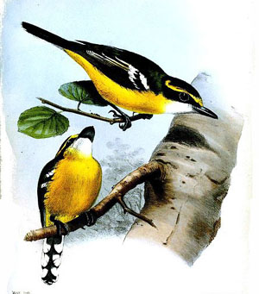
Source: Wikipedia http://www.en.wikipedia.org.
Fig. 120. Macaerirhynchus flaviventer.
This family is comprised of two species in single genus (Gill and Donsker 2013). These Australasian birds had previously been placed in the same family as monarch flycatchers (Monarchidae). They have many behaviors that are similar to flycatchers; however, a few behaviors are quite distinctive. Recent biochemical evidence suggests that they are not closely related, and thus they are now placed in a separate family (Roberson 2012).

Vangidae (The Vanga kind)
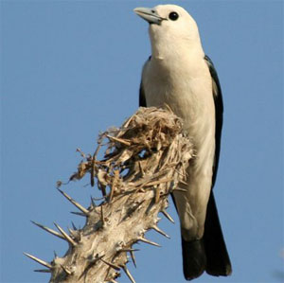
Source: Wikipedia http://www.en.wikipedia.org.
Fig. 121. Artamella viridis.
This family comprises 21 species in 15 genera (Gill and Donsker 2013). This diverse group of woodland birds occupies many niches on the island of Madagascar. From the dry, open, spiny forest to the humid jungle, members of this family generally prey on invertebrates or small vertebrates. Diversification within this family is believed to have arisen rapidly (within the last 10 million years on the evolutionary scale) and rivals that of the Hawaiian honeycreepers and Galapagos finches (Roberson 2012).

Cracticidae (The Butcherbird kind)
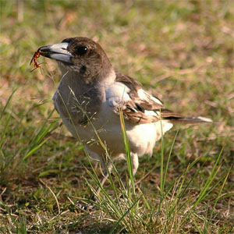
Source: Wikipedia http://www.en.wikipedia.org.
Fig. 122. Cracticus nigrogularis.
This family comprises 12 species in four genera (Gill and Donsker 2013). There is a reported hybrid between the Australian magpie (Gymnorhina tibicen) and the pied butcherbird (Cracticus nigrogularis), connecting two of these genera (McCarthy 2006). Birds of this family typically have large bills and strong legs. They inhabit Australasia and New Guinea and are often found on or near the ground in open areas (Roberson 2012).

Pityriaseidae (The Bristlehead kind)
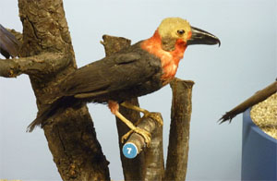
Source: Wikipedia http://www.en.wikipedia.org.
Fig. 123. Pityriasis gymnocephala.
This single species has recently been promoted to its own family. It is an unusual bird that lives in the canopy of lowland forests of Borneo. In the past it had been placed with the wood-shrikes or jays and crows. Biochemical evidence has placed it near woodswallows (Artamidae) and butcherbirds (Cracticidae). This rare and elusive bird is not well studied (Roberson 2012).

Artamidae (The Woodswallow kind)
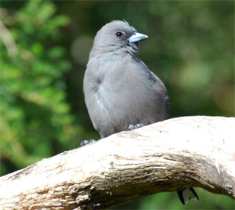
Source: Wikipedia http://www.en.wikipedia.org.
Fig. 124. Artamus cyanopterus.
Gill and Donsker (2013) recognize 11 species in a single genus. Based on their DNA-DNA hybridization work, Sibley and Monroe (1990) place members of Cracticidae, Pityriaseidae, and this family (Artamidae) together in the same tribe as a subfamily beside crows in a greatly expanded Corvidae family. In addition to the genetic similarity, there are morphologic similarities. For example, woodswallows share many distinctive features of skull morphology with two genera in Cracticidae (Handbook of the Birds of the World Alive). Thus it is possible the kind may include all three families, but it is placed here until more substantial information becomes available.

Aegithinidae (The Ioras kind)
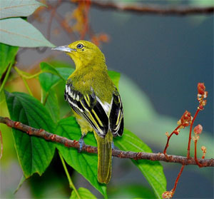
Source: Wikipedia http://www.en.wikipedia.org.
Fig. 125. Aegithina tiphia.
This family comprises four species in a single genus (Gill and Donsker 2013). They are found throughout tropical Asia. They generally forage alone for berries, other fruit, or insects. Though traditionally placed near the babblers (Timaliidae), biochemical studies suggest they are more similar to Muscicapidae. The taxonomic relationship of these families remains controversial (Roberson 2012).

Campephagidae (The Cuckooshrike kind)
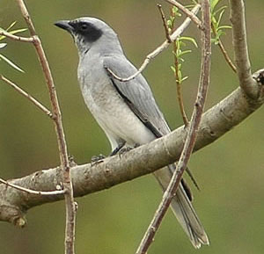
Source: Wikipedia http://www.en.wikipedia.org.
Fig. 126. Coracina novaehollandiae.
This family comprises 92 species in six genera (Gill and Donsker 2013). Traditionally, over half the species were placed in a single genus, Coracina. Based on genetic evidence this genus is believed to actually consist of at least five different groups. These birds are primarily arboreal and found in the Old World, primarily the tropics of Australasia and southeastern Asia (Roberson 2012).

Neosittidae (The Sittella kind)
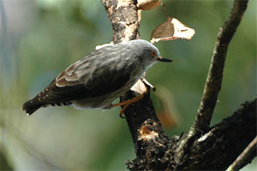
Source: Wikipedia http://www.en.wikipedia.org.
Fig. 127. Daphoenositta chrysoptera.
This family is comprised of three species in a single genus (Gill and Donsker 2013). The members of this small Australasian family appear something like nuthatches, but it has long been known they aren’t related to them (Roberson 2012). They are considered closely related to whistlers (Pachycephalidae). Sibley and Monroe (1990) place these two families in separate tribes within a single subfamily. While not in the same subfamily as crows and jay, they are part of the greatly expanded Corvidae presented by these authors. Again, this suggests the level of the kind may be higher, but it is not clear where similarity based on DNA-DNA hybridization is truly from common ancestry or may be from common design.

Pachycephalidae (The Whistler kind)
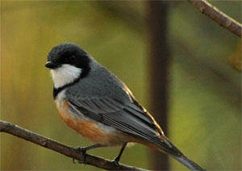
Source: Wikipedia http://www.en.wikipedia.org.
Fig. 128. Pachycephala rufiventris.
Gill and Donsker (2013) recognize 58 species in eight genera. For this analysis the wattled ploughbill, which Gill and Donsker separate as incertae sedis 3, will also be included here. Pachycephalidae is an Australasian family which includes whistlers, shrike-thrushes, and the shrike-tit. The shrike-tit’s status in this family has been questioned, and it was briefly in a separate family with the wattled ploughbill, but has since been returned to this family based on further nuclear DNA evidence (Roberson 2012). Sibley and Monroe (1990) treat the shrike-tit part of a separate tribe within the same subfamily as the rest of these species. The two remaining tribes in that subfamily include the sittellas (Neosittidae) and the genera Mohoua/Finschia(incertae sedis 2). Given that DNA-DNA hybridization evidence was used to place these families together in a single subfamily, the level of the kind might easily be higher than the currently recognized family.
One interesting genus placed in this family by Gill and Donsker (2013) is Pitohui. These birds are known to be toxic. The toxin is acquired by eating poisonous melyrid beetles and is stored in the skin and feathers. It is a powerful neurotoxin similar to that found in poison dart frogs. The people of New Guinea have long known of their toxic effects and avoid eating them. In studying this one genus, some researchers suggested its members really belong to four different families! Roberson (2012) discusses them under Oriolidae where he recognizes the two most toxic pitohuis belong. Again, this evidence seems to suggest that the level of the kind is above the family. Yet the DNA based similarity is not necessarily from common ancestry.

Laniidae (The Shrike kind)
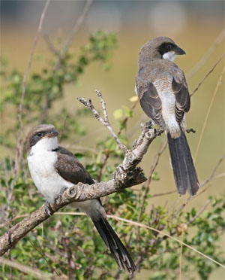
Source: Wikipedia http://www.en.wikipedia.org.
Fig. 129. Lanius cabanisi.
This family comprises 33 species in four genera (Gill and Donsker 2013). All but four species are in a single genus. They are medium-sized, predatory songbirds that have a hooked bill reminiscent of raptors. Though most of their diet consists of invertebrates, they occasionally prey on small vertebrates as well. At one time they were considered close relatives to bush-shrikes (Malaconotidae), helmet-shrikes (Prionopidae), vangas (Vangidae) and batises (Platysteiridae). More recently evidence supports the close relationship of the aforementioned four families, but Laniidae was placed closer to crows (Roberson 2012).

Vireonidae (The Vireo kind)
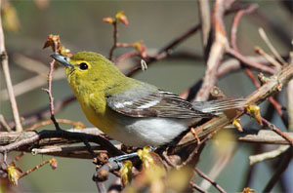
Source: Wikipedia http://www.en.wikipedia.org.
Fig. 130. Vireo flavifrons.
This family comprises 63 species in six genera. This was a strictly New World family with the largest genus containing the vireos. The three other genera include greenlets, peppershrikes, and shrike-vireos. Recent research has added two Old World genera to this family: the shrike-babblers (Pteruthius) and Erpornis (Gill and Donsker 2013).

Oriolidae (The Old World Oriole kind)
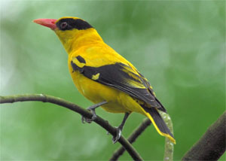
Source: Wikipedia http://www.en.wikipedia.org.
Fig. 131. Oriolus chinensis.
Gill and Donsker (2013) identify 34 species in three genera, but one genus with two species is now extinct. The smaller of the two extant genera contains figbirds. This family is comprised of medium-sized, highly arboreal birds which inhabit warmer regions of the Old World. They are not to be confused with New World species of orioles, which belong to the genus Icterus in the blackbird family, Icteridae (Roberson 2012). Sibley and Monroe (1990) place Old World orioles and cuckooshrikes (Campephagidae) together in one tribe under the same subfamily as that including crows. This placement is due to significant DNA similarity and suggests that the level of the kind could be higher. However, there is no way to know for sure that the similarity is due to common ancestry.

Dicruridae (The Drongo kind)
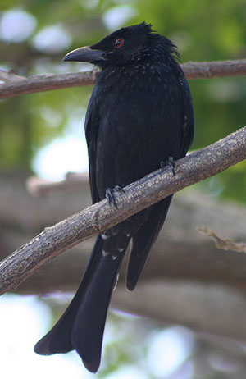
Source: Wikipedia http://www.en.wikipedia.org.
Fig. 132. Dicrurus bracteatus.
Gill and Donsker (2013) list 26 species in two genera. One genus is monotypic and that species,Chaetorhynchus papuensis, is thought to possibly be a whistler (Pachycephalidae). Roberson (2012) instead considers it to be a member of Rhipiduridae. Drongos are mostly black and somewhat crow-like in appearance. They eat insects much like flycatchers and many have forked tails. Some have tails that are curled on the end, while others have racquets (Roberson 2012).

Rhipiduridae (The Fantail kind)
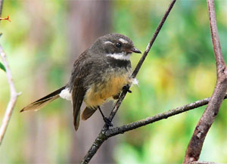
Source: Wikipedia http://www.en.wikipedia.org.
Fig. 133. Rhipidura albiscapa.
This family is comprised of 49 species in two genera. One genus is monotypic and was previously placed in the Monarchidae (Gill and Donsker 2013). Fantails are distinctive Old World flycatchers that range from India to Australia and some Pacific Islands. Most swish their splayed open tails up and down as they flit through the forest, making it obvious where they got their common name (Roberson 2012). Sibley and Monroe (1990) place them in the same subfamily as drongos and monarchs, suggesting they may be related. There is no hybrid data to corroborate this, so the families are listed as separate kinds here.

Monarchidae (The Monarch kind)
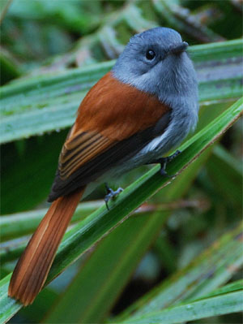
Source: Wikipedia http://www.en.wikipedia.org.
Fig. 134. Terpsiphone bourbonnensis.
This family comprises 98 species in 16 genera (Gill and Donsker 2013). This is a predominantly Old World family of birds which behave as flycatchers, darting out from their perches after flying insects. They are not believed to be related to either Old World flycatchers (Muscicapidae) or New World flycatchers (Tyrannidae). Some species have colorful bare patches encircling their eyes. Many species are colorful and the paradise-flycatchers are known for magnificent long tails in the adult male (Roberson 2012).

Corvidae (The Crow kind)
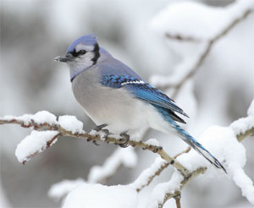
Source: Wikipedia http://www.en.wikipedia.org.
Fig. 135. Cyanocitta cristata.
This family is comprised of 130 species (Gill and Donsker 2013). Several of the numerous genera are linked by hybrid data. Crows and ravens are linked to one of the magpie genera (Corvus andPica). There are also a number of genera of jays linked by hybrid data (Aphelocoma, Calocitta,Cyanocitta, Cyanocorax, and Psilorhinus; McCarthy 2006). Birds in this family are known for their intelligence and are the largest “songbirds” extant today (Roberson 2012).

Corcoracidae (The Australian Mudnester kind)
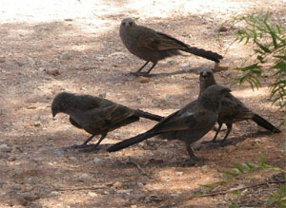
Source: Wikipedia http://www.en.wikipedia.org.
Fig. 136. Struthidea cinerea.
This family comprises two species each in its own genus (Gill and Donsker 2013). The apostlebird and the white-winged chough were at one time placed in a family with other birds that build mud nests, but are now considered unrelated to them (Roberson 2012). Sibley and Monroe (1990) place these two birds in their own subfamily within an expanded Corvidae family.

Family incertae sedis 4 (The Melampitta kind)
There are three species in two genera that are placed here because their taxonomic status is uncertain. The blue-capped ifrit is now considered possibly related to Monarchs (Gill and Donsker 2013). The two species of melampitta superficially resemble pittas, but the syringeal anatomy is significantly different. Morphological and genetic data haven’t always suggested the same placement of these birds that are confined to New Guinea. It is quite probable these two genera are not actually closely related to each other, though they have bounced around in families containing other Australo-Papuan songbirds (Handbook of the Birds of the World Alive). So the level of the kind could be above or below this, but it is placed here so these species are at least considered in this analysis.

Paradisaeidae (The Bird-of-paradise kind)
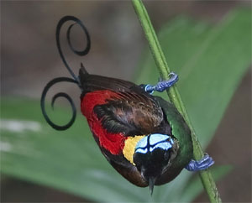
Source: Wikipedia http://www.en.wikipedia.org.
Fig. 137. Cicinnurus respublica.
This family comprises 41 species in 16 genera (Gill and Donsker 2013). It has long been known that extensive natural hybridization occurs in this family; at least nine of the currently recognized genera are connected by hybrid data (McCarthy 2006). Sibley and Monroe (1990) classify them as a tribe within the subfamily containing crows and jays. Their noisy cries are certainly reminiscent of crows, but males in this family sport an amazing variety of colorful plumes, shields, streamers, wires, and plumage (Roberson 2012).

Petroicidae (The Australasian Robin kind)
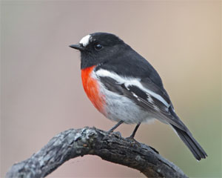
Source: Wikipedia http://www.en.wikipedia.org.
Fig. 138. Petroica boodang.
This family comprises 46 species in 14 genera (Gill and Donsker 2013). They are not related to robins from other regions of the world. They are small birds characterized by a big head, thick neck, fat body, and short tail. They fill a niche in Australasia similar to the niche filled by New World flycatchers and Old World flycatchers (Roberson 2012).

Picathartidae (The Rockfowl kind)
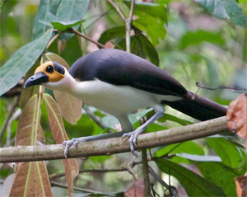
Source: Wikipedia http://www.en.wikipedia.org.
Fig. 139. Picathartes gymnocephalus.
This family is comprised of two species in a single genus (Gill and Donsker 2013). These unusual large African birds roost and nest in caves. They have bare, brightly colored heads. They forage on the forest floor. Though at one time they were lumped in with the babblers, evidence suggests they are actually more similar to rockjumpers and rail-babblers (Roberson 2012). Since it is unclear if this similarity is indicative of common ancestry, the level of the kind is left at the family level.

Chaetopidae (The Rockjumper kind)
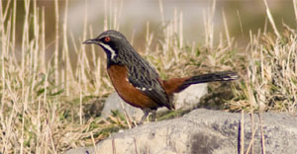
Source: Wikipedia http://www.en.wikipedia.org.
Fig. 140. Chaetops frenatus.
This family is also comprised of two species in a single genus (Gill and Donsker 2013). This family is restricted to two African countries: South Africa and Lesotho. They live in rocky regions, as their name suggests. They run, maneuvering on their rocky habitat with great agility. They are sexually dimorphic with colorful males (Roberson 2012).

Eupetidae (The Rail-babbler kind)
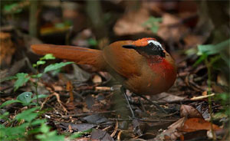
Source: Wikipedia http://www.en.wikipedia.org.
Fig. 141. Eupetes macrocerus.
This family now comprises a single species (Gill and Donsker 2013). It is also a ground-dwelling species and inhabits lowland forests in Thailand, peninsular Malaysia, and the islands of Sumatra and Borneo. At one time this elusive bird was placed in with the babblers, hence its name. More often it was placed with other secretive forest dwelling birds of Australasia, such as logrunners (Orthonychidae), quail-thrush, whipbirds, and jewel-babblers (Psophodidae). Some morphologic similarities had been noted between rail-babblers and the two previous African families; more recent DNA evidence showed similarity as well, hence they are now considered sister taxa (Roberson 2012). This may suggest this species is related to other extant birds, but there is enough ambiguity that the level of the kind is placed at the default level, the family, for now.

Bombycillidae (The Waxwing kind)
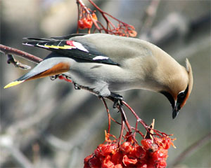
Source: Wikipedia http://www.en.wikipedia.org.
Fig. 142. Bombycilla cedrorum.
This family is comprised of three species in a single genus (Gill and Donsker 2013). They are named for the waxy spots on their wings. They also sport a distinctive soft crest. The taxonomic relationships of this family are controversial (Roberson 2012). Sibley and Monroe (1990) place the palmchat and silky-flycatchers in the same family, which is placed in the same superfamily as Old World flycatchers, starlings, and mockingbirds.

Ptilogonatidae (The Silky-flycatcher kind)
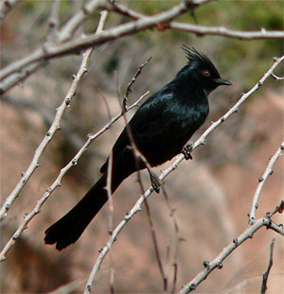
Source: Wikipedia http://www.en.wikipedia.org.
Fig. 143. Phainopepla nitens.
This family comprises four species in three genera (Gill and Donsker 2013). These long-tailed, thrush-sized birds range from the southwestern United States through the forests in the western mountains of Panama. As their name implies, they eat insects and have a silky appearance to their plumage. Three of the four species have crests (Roberson 2012).

Hypocoliidae (The Hypocolius kind)
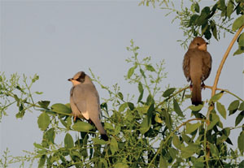
Source: Wikipedia http://www.en.wikipedia.org.
Fig. 144. Hypocolius ampelinus.
This family is comprised of a single species (Gill and Donsker 2013). This elusive bird winters in Saudi Arabia. It breeds in Iraq, Iran, and eastern Pakistan. Due to the difficulty in studying it, its relationships have long been uncertain. It had traditionally been considered related to the waxwings and silky-flycatchers, and recent research appears to confirm this (Roberson 2012). For now the level of the kind is left at the family until more information becomes available.

Dulidae (The Palmchat kind)
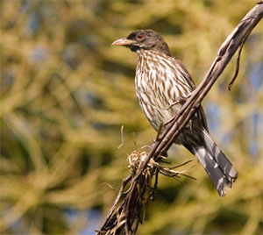
Source: Wikipedia http://www.en.wikipedia.org.
Fig. 145. Dulus dominicus.
This family is also comprised of a single species (Gill and Donsker 2013). The palmchat lives in Hispaniola, the island comprised of Haiti and the Dominican Republic. It is an odd bird which is very common on the island. These gregarious, vocal birds are fond of Royal palms. They build large communal nests (Roberson 2012).

Mohoidae (The Oo kind)
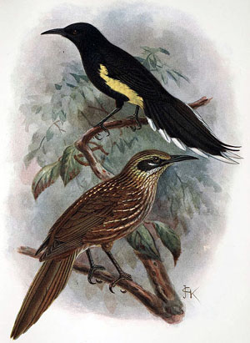
Source: Wikipedia http://www.en.wikipedia.org.
Fig. 146. Moho apicalis.
This family was comprised of five species in two genera, but all are now considered extinct. They inhabited the Hawaiian Islands and were once considered related to honeyeaters (Meliphagidae). More recent work suggests instead that they are more similar to waxwings (Bombycillidae) thus explaining their placement closer to the latter family (Gill and Donsker 2013). While most extinct birds are not considered here, this recently extinct family is included because it was listed on the IOU list.

Hylocitreidae (The Hylocitrea kind)
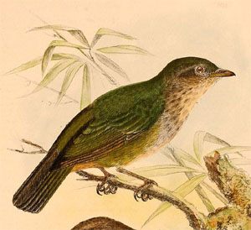
Source: Wikipedia http://www.en.wikipedia.org.
Fig. 147. Hylocitrea bonensis.
This family is comprised of a single species (Gill and Donsker 2013). This bird inhabits the moss forests at higher elevations in Sulawesi, an island in Indonesia. It is often referred to as the olive-flanked whistler, but recent molecular analysis indicates that it is not really a whistler. Instead, it is believed to be related to waxwings, and it has been suggested that it should have the rank of subfamily within an expanded Bombycillidae (Roberson 2012). The level of the kind is left here until further information is found substantiating this relationship.

Stenostiridae (The Fairy Flycatcher kind)
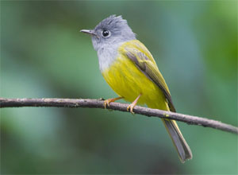
Source: Wikipedia http://www.en.wikipedia.org.
Fig. 148. Culicicapa ceylonensis.
This family comprises nine species in four genera (Gill and Donsker 2013). They inhabit tropical areas in Africa and Asia. Many behave as fantails, spreading their tail feathers while twitching their tails up and down. These were once placed in Monarchidae as were the fantails which have now been moved to Rhipiduridae. Other members of this family were once considered related to the Old World flycatchers (Muscicapidae). This family is identified based on molecular data; there is no morphological character that clearly defines this family (Roberson 2012). This, of course, means that this family lacks a clear cognitum. The level of the kind is here by default.

Paridae (The Tit kind)
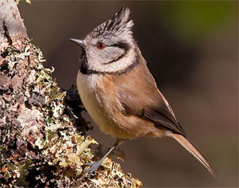
Source: Wikipedia http://www.en.wikipedia.org.
Fig. 149. Lophophanes cristatus.
This family comprises 59 species in eight genera. It includes tits, titmice, and chickadees (Gill and Donsker 2013). This homogeneous family of small, lively birds is easy to identify; at one time most were placed in a single genus: Parus. They are agile birds found in forests around the world. Though Sibley and Monroe (1990) enlarged this family to include Remizidae, most taxonomies place the family level here (Roberson 2012). Since these relatively familiar birds can be identified to family fairly easily, the level of the kind is left here until a stronger case can be made to place it elsewhere.

Remizidae (The Penduline Tit kind)
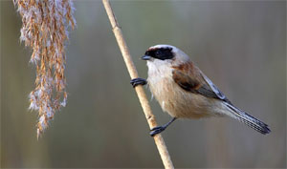
Source: Wikipedia http://www.en.wikipedia.org.
Fig. 150. Remiz pendulinus.
This family comprises 12 species in four genera (Gill and Donsker 2013). These tiny birds inhabit open and scrubby woodlands around the world, particularly in Eurasia and Africa. They are considered to be related to both tits (Paridae) and fairy flycatchers (Stenostiridae). Given their common names, close association with the tits is unsurprising, but due to biochemical distinctiveness they are kept as a separate family (Roberson 2012).

Panuridae (The Bearded Reedling kind)
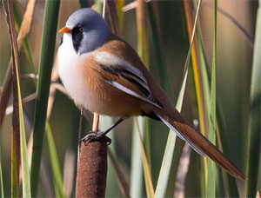
Source: Wikipedia http://www.en.wikipedia.org.
Fig. 151. Panurus biarmicus.
This family is currently comprised of a single species (Gill and Donsker 2013). This species inhabits reedy marshes of the Old World. Outside the breeding season they are gregarious and can form large flocks as the nesting season ends. Previously they were placed in a family with parrotbills (Roberson 2012).

Nicatoridae (The Nicator kind)
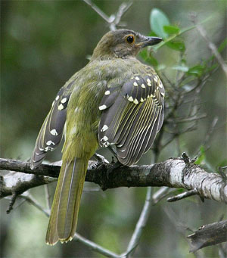
Source: Wikipedia http://www.en.wikipedia.org.
Fig. 152. Nicator gularis.
This African family is comprised of three species in a single genus (Gill and Donsker 2013). At various times historically they have been thought to be related to shrikes (Laniidae), bush-shrikes (Malaconotidae), or bulbuls (Pycnonotidae). Due to these uncertainties, they were classified asincertae sedis until they were recently given a full family status (Roberson 2012).

Alaudidae (The Lark kind)
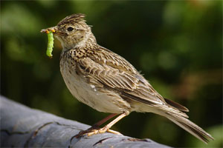
Source: Wikipedia http://www.en.wikipedia.org.
Fig. 153. Alauda arvensis.
This family is comprised of 98 species in just over 20 genera (Gill and Donsker 2013). Larks are ground-dwelling birds which are found primarily in the Old World, especially Africa. Most have drab plumage, but many have incredible songs. Over one-third of larks are in the genus Mirafra. Roberson (2012) reports they are related to bulbuls in the Sylvioidea superfamily which also contains swallows, babblers, and many Old World warblers. Sibley and Monroe (1990) place them in the superfamily Passeroidea.

Pycnonotidae (The Bulbul kind)
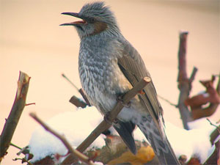
Source: Wikipedia http://www.en.wikipedia.org.
Fig. 154. Hypsipetes amaurotis.
This family comprises 151 species (Gill and Donsker 2013). They are medium-sized songbirds that are classified near swallows, babblers, and many Old World warblers. They are morphologically and ecologically homogeneous, yet they are comprised of two lineages: the Asian clade and the African clade. Most of the African clade are green or olive in color, and are sometimes referred to as greenbuls. Birds in the Asian clade are often gray and white, or brown and white. Some of the Asian species have expanded westward and now inhabit parts of Africa (Roberson 2012).

Hirundinidae (The Swallow kind)
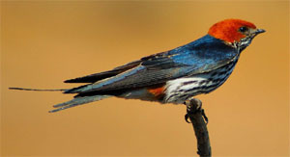
Source: Wikipedia http://www.en.wikipedia.org.
Fig. 155. Hirundo abyssinica.
This family is comprised of 88 species (Gill and Donsker 2013). Four of the numerous genera are connected by hybrid data (Delichon, Hirundo, Riparia, Tachycineta; McCarthy 2006). They are distinctive birds with streamlined bodies. They consume insects. They often nest close to people, even sometimes within their homes (Roberson 2012).

Pnoepygidae (The Cupwing kind)
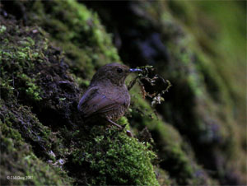
Source: Wikipedia http://www.en.wikipedia.org.
Fig. 156. Pnoepyga albiventer.
This family is comprised of four species in a single genus (Gill and Donsker 2013). They had been previously referred to as wren babblers, but DNA analysis suggests that they are unrelated to either of the babbler families (Timaliidae and Sylviidae). These tiny birds of tropical Asia have a short tail, slender bill, and reduced front claws. They are semiterrestrial and move by hopping in the tangled undergrowth. They have distinctive warbler-like songs (Roberson 2012).

Macrosphenidae (The African Warbler kind)
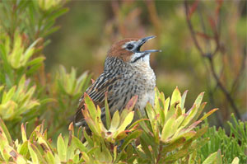
Source: Wikipedia http://www.en.wikipedia.org.
Fig. 157. Sphenoeacus afer.
This family comprises 18 species in six genera. Once placed in the Old World warblers (Sylviidae), this is one of many groups which have now been removed and given their own family status based on recent research. The eclectic composition of this family was not predicted based on traditional classification. It includes the grass warbler (Melocichla), the grassbird (Sphenoeacus), the rockrunner (Achaetops), five species of longbills (Macrosphenus), nine species of Crombec (Sylvietta), and Victorin’s warbler (Cryptillas). One species previously considered a longbill is actually a bulbul (Roberson 2012 ; Gill and Donsker 2013).

Cettidae (The Cettia Bush Warbler kind)
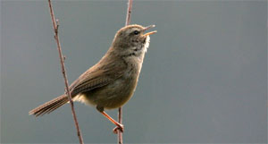
Source: Wikipedia http://www.en.wikipedia.org.
Fig. 158. Cettia fortipes.
This family is comprised of 32 species in seven genera (Gill and Donsker 2013). It is another eclectic family of birds that had previously been placed in Sylviidae. It includes diverse warblers from Eurasia and some tailorbirds from the Orient. While about half the species are known as bush-warblers, there are other bush-warblers in the family Locustellidae. Though now occupying two separate families, the bush-warblers of tropical Asia were thought to have been related based on their dull plumage and reclusive behavior. Now those similarities are attributed to convergent evolution (Roberson 2012).

Scotocercidae (The Streaked Scrub Warbler kind)
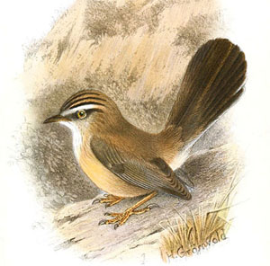
Source: Wikipedia http://www.en.wikipedia.org.
Fig. 159. Scotocerca inquieta.
This family is comprised of a single species. It was incertae sedis, of uncertain affinity, but now is considered a sister group to Cettidae. Thus it was elevated to the rank of family. The various subspecies are found in Europe, northern Africa, and parts of Asia (Gill and Donsker 2013).

Erythrocercidae (The Yellow Flycatcher kind)
This family comprises three species in a single genus (Gill and Donsker 2013). These African flycatchers dwell in the lowland forests. Traditionally they were placed with the monarch flycatchers, though some authors noted a few morphological and behavioral peculiarities. Genetic evidence suggests they are unrelated to any of the other flycatchers, but instead group withCettia and related warblers. In some taxonomic schemes, the yellow flycatchers and streaked scrub warbler are placed in the family Cettidae (Roberson 2012).

Family incertae sedis 5 (The Hylia kind)
Gill and Donsker (2013) place three species, each in their own genus, in this fifth group of uncertain affinities. Two species are commonly known as hylias, while the third is known as Grauer’s warbler. They have been placed in a number of different families over the years, and the recent evidence suggests they are related to Aegithalidae. More research is needed to clarify where they will finally land taxonomically (Roberson 2012).

Aegithalidae (The Bushtit kind)
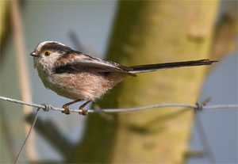
Source: Wikipedia http://www.en.wikipedia.org.
Fig. 160. Aegithalos caudatus.
This family is comprised of 13 species in four genera (Gill and Donsker 2013). Referred to as long-tailed tits by Roberson (2012), most of these species are found Eurasia, particularly in the Himalayas or mountains of China. There is also one North American species and one in the mountains of Java. These tiny birds are very vocal and move through trees and bushes in small family groups.

Phylloscopidae (Leaf Warbler kind)
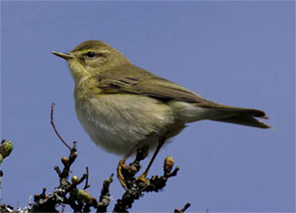
Source: Wikipedia http://www.en.wikipedia.org.
Fig. 161. Phylloscopus trochilus.
This family comprises 77 species in two genera (Gill and Donsker 2013). This is another of around a dozen families that have been extracted from the previously huge Sylviidae. For the most part they are small arboreal warblers which forage on insects on the leaves in the canopy or sub-canopy. Many are known to migrate great distances. They are often difficult for birders to identify to species (Roberson 2012).

Acrocephalidae (The Reed Warbler kind)
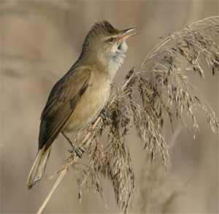
Source: Wikipedia http://www.en.wikipedia.org.
Fig. 162. Acrocephalus arundinaceus.
This family is comprised of five genera with 61 species, some of which are now extinct (Gill and Donsker 2013). This family is another that has originated from the fracturing of Sylviidae. Most reed warblers breed in large Old World marshes. Many are secretive and difficult to see unless they are singing. They can be very difficult to identify to species (Roberson 2012).

Locustellidae (The Grassbird kind)
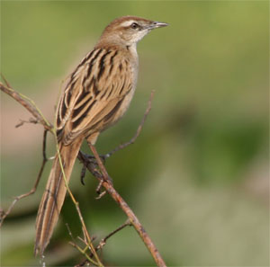
Source: Wikipedia http://www.en.wikipedia.org.
Fig. 163. Megalurus palustris.
This family is comprised of 57 species in nine genera (Gill and Donsker 2013). They are often difficult to see as they skulk through grass or thickets. Based on recent studies, there has been some shifting of species between the various genera. This family is viewed as a sister group to the Malagasy warblers. These two families are considered a sister group to reed warblers, hence their placement here (Roberson 2012). There is no hybrid data indicating that these families are indeed related, so the level of the kind is left at the family for now.

Donacobiidae (The Black-capped Donacobius kind)
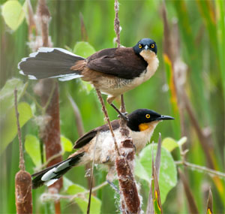
Source: Wikipedia http://www.en.wikipedia.org.
Fig. 164. Donacobius atricapilla.
This family is comprised of a single species (Gill and Donsker 2013). This unusual bird inhabits marshes and grassy regions of Panama and South America. They are conspicuous with a blackish back and a buff colored underside. Breeding pairs display and sing duets in their territories by the water’s edge. Once called the black-capped mockingbird, they were considered members of Mimidae. Later, they were declared to be a wren. More recent DNA-based research suggests they are neither, and are more closely related to various Old World species (Roberson 2012).

Bernieridae (The Malagasy Warbler kind)
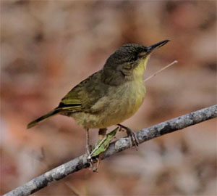
Source: Wikipedia http://www.en.wikipedia.org.
Fig. 165. Bernieria madagascariensis.
This family comprises 11 species in eight genera (Gill and Donsker 2013). Endemic to Madagascar, these birds had previously been placed in a variety of different families. Several were previously placed in Sylviidae, a couple had been considered babblers, and still others bulbuls. Recent molecular evidence indicates that their conventional placement is incorrect and that, instead, they form a distinct group (Roberson 2012).

Cisticolidae (The Cisticola kind)
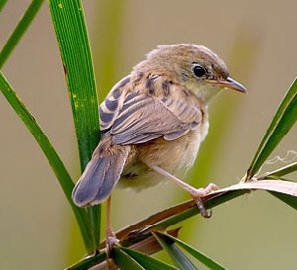
Source: Wikipedia http://www.en.wikipedia.org.
Fig. 166. Cisticola exilis.
This family is comprised of 160 species in nearly 30 genera. Most species are limited to Africa, but some are found in Asia, Europe or Australia. Many African species closely resemble each other and are often best distinguished by their song. These birds were removed from Sylviidae over two decades ago based on DNA-DNA hybridization studies. However there is still much to learn about them and their relationship to other birds (Gill and Donsker 2013; Roberson 2012).

Timaliidae (The Babbler kind)
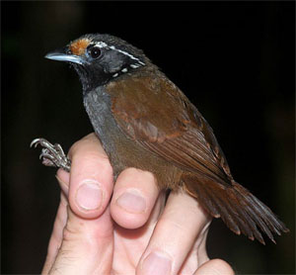
Source: Wikipedia http://www.en.wikipedia.org.
Fig. 167. Stachyris leucotis.
This family comprises 56 species in ten genera (Gill and Donsker 2013). Babblers were part of the very large Sylviidae, but by the mid-2000s studies suggested they should be split. There has been some controversy over how many families they comprise (Roberson 2012). Here they comprise five families: tree and scimitar babblers (Timaliidae), fulvettas and ground babblers (Pellorneidae), laughing thrushes (Leiothrichidae), sylvid babblers and parrotbills (Sylviidae), and white-eyes (Zosteropidae) in conformity with Gill and Donsker (2013). Roberson (2012) places the first three as separate subfamilies within Timaliidae and retains the last two as distinct families based on recommendations by Moyle et al. (2012).

Pellorneidae (The Fulvetta/Ground Babbler kind)
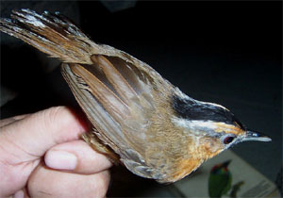
Source: Wikipedia http://www.en.wikipedia.org.
Fig. 168. Pellorneum capistratum.
Gill and Donsker (2013) provisionally recognize this family to be comprised of 71 species. Most are found in China and Southeast Asia, though two genera are restricted to Africa. Several species are known as wren babblers. While previously grouped together, wren babblers in Pnoepygidae were found to be unrelated and were placed in a separate family (Roberson 2012).

Leiothrichidae (The Laughingthrush kind)
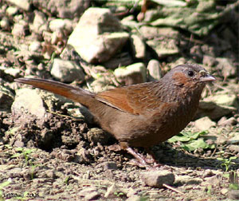
Source: Wikipedia http://www.en.wikipedia.org.
Fig. 169. Garrulax lineatus.
Gill and Donsker (2013) provisionally recognize this family, identifying 133 species in just over a dozen genera. Hybridization has occurred between two of these genera (McCarthy 2006). These birds are recognized as a major clade of babblers. They are found in Europe, Africa and Asia (Gill and Donsker 2013). They are a diverse family ranging from cheerfully colored birds to drab colored ones and they occupy a number of niches (Roberson 2012).

Sylviidae (The Sylviid Babbler kind)
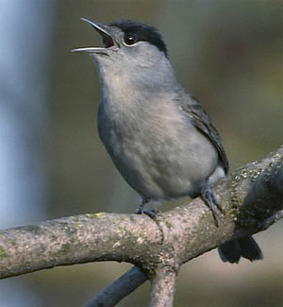
Source: Wikipedia http://www.en.wikipedia.org.
Fig. 170. Sylvia atricapilla.
This family is now comprised of 70 species (Gill and Donsker 2013). At one time it included around 400 species which were known as Old World warblers. Following research using molecular data, it became evident they were not a single unified group. Thus the family was fractured into about a dozen families. The core genus in this family, Sylvia, is found mostly in Europe, northern Africa, and the Middle East. Currently members of this family are believed to be more closely related to babblers (Timaliidae). Thus the name Sylviid babblers is used to describe the group, or sometimes just the term sylvids (Roberson 2012). There is no hybrid data linking this family with others.

Zosteropidae (The White-eye kind)
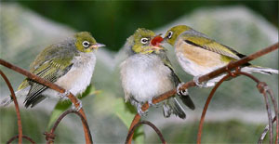
Source: Wikipedia http://www.en.wikipedia.org.
Fig. 171. Zosterops lateralis.
This family comprises 128 species (Gill and Donsker 2013). The name white-eye refers to a white ring around the eye of traditional members of this family. With the advent of molecular data this family has experienced its share of upheaval. It was discovered they were similar to babblers, so they were grouped by some with the Sylviid babblers. Others proposed they be placed in the babbler family Timaliidae. As that family broke up into several others, the white-eyes became a family again. However, the composition is not the same as before; some other species are now included. The majority of white-eyes are in a single genus Zosterops. They are found throughout the Old World, with a large proportion being specialists on various islands (Roberson 2012).
Again, this shifting among families suggests that the level of the kind may be higher, but it is unclear where it should be. The only hybrid data involving this family links it with Fringillidae via an alleged cross between a domestic canary (Serinus domesticus) and a green white-eye (Zosterops virens). McCarthy (2006) documents this report but considers it doubtful since these species are taxonomically far apart within Passeriformes. So it needs confirmation before it would be accepted as evidence that two different large superfamilies should be considered from a single created kind.

Arcanatoridae (The Dapple-throat kind)
This family is comprised of three species each in its own genus. They are found in the east African nations of Tanzania, Mozambique, and Malawi. Evolutionists now believe that Arcanatoridae and Promeropidae are basal branches, each of which go further back in time than almost any other extant lineage in the Passerida. They are treated as separate families with the expectation that evidence will establish a sister relationship (Gill and Donsker 2013). Generally speaking, extant species that are considered basal are ones that evolutionists have had trouble classifying; they are birds that do not fit well into the “tree.”

Promeropidae (The Sugarbird kind)
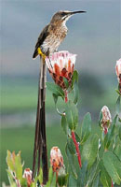
Source: Wikipedia http://www.en.wikipedia.org.
Fig. 172. Promerops cafer.
This family is comprised of two species in a single genus (Gill and Donsker 2013). They have been known to hybridize with each other in a particular region of South Africa. Unfortunately, there is no intergeneric hybrid data to link these to another family. This genus has been variously placed in Meliphagidae, Sturnidae, and Nectariniidae in the past (McCarthy 2006).

Irenidae (The Fairy-bluebird kind)
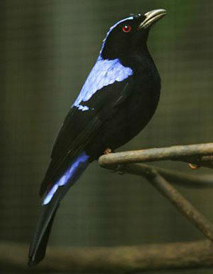
Source: Wikipedia http://www.en.wikipedia.org.
Fig. 173. Irena puella.
This family comprises two species in a single genus (Gill and Donsker 2013). They are tree-dwelling birds of tropical Asia. They are relatively large fruit-eating birds that live in lowland rainforests. Their relationship with other birds has been controversial. Some recent evidence suggests a close relationship with leafbirds (Chloropseidae; Roberson 2012). For now the level of the kind is kept at the family.

Regulidae (The Goldcrest/Kinglet kind)
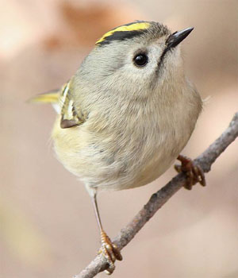
Source: Wikipedia http://www.en.wikipedia.org.
Fig. 174. Regulus regulus japonensis.
This family comprises six species in a single genus (Gill and Donsker 2013). These tiny arboreal birds inhabit the Northern Hemisphere in both the Old and New World. They are easy to recognize. They consume insects in coniferous forests and are known for the colorful markings on their crown. Their taxonomic position has been much less easy to discern (Roberson 2012). Thus the level of the kind is left at the family.

Hyliotidae (The Hyliota kind)
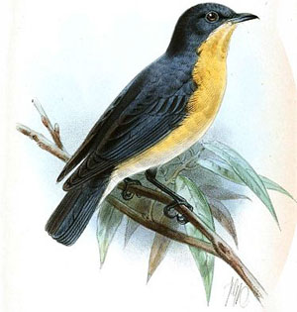
Source: Wikipedia http://www.en.wikipedia.org.
Fig. 175. Hyliota nehrkorni.
This family comprises four species in a single genus (Gill and Donsker 2013). As with so many of these smaller families, they have been variously placed in other families. This genus has previously been placed in Muscicapidae, Monarchidae, Platysteiridae, or Sylviidae, prior to the breakup of that family. They are mostly found in western and central Africa. They consume insects, sometimes in flycatcher style, but often times they meticulously search through the canopy for their prey, even sometimes hanging upside-down as they search under leaves or branches (Roberson 2012).

Troglodytidae (The Wren kind)
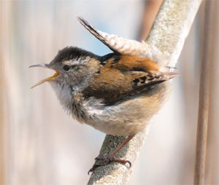
Source: Wikipedia http://www.en.wikipedia.org.
Fig. 176. Cistothorus palustris.
This family is comprised of 83 species in 19 genera (Gill and Donsker 2013). Two of these genera are connected by hybrid data (McCarthy 2006). Nearly all species are endemic to the New World. A fair number are adapted to desert habitats, while others skulk in undergrowth thickets in humid lowland rainforests of the Neotropics. They are often difficult to locate unless they are singing, and many are known for their distinctive vocalizations (Roberson 2012).

Polioptilidae (The Gnatcatcher kind)
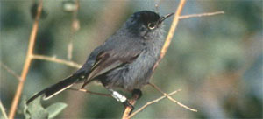
Source: Wikipedia http://www.en.wikipedia.org.
Fig. 177. Polioptila californica.
This family comprises 17 species in 3 genera (Gill and Donsker 2013). There is a strong cognitum at the family level of these New World birds. Fourteen species are called gnatcatchers and are placed in the genus Polioptila. The three remaining species are known as gnatwrens. Gnatcatchers are gray and white, have long tails and thin bills, and sometimes black caps. As with many other small families, there has been considerable controversy over where to place these species taxonomically. They have been placed in various families over the years, but now occupy their own and are considered closely related to wrens (Roberson 2012). So despite the clear cognitum, the level of the kind could be higher. Still, no hybrids have been documented that support this possibility.

Sittidae (The Nuthatch kind)
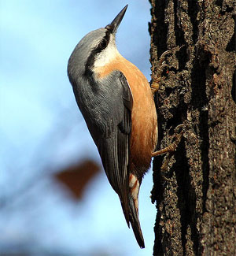
Source: Wikipedia http://www.en.wikipedia.org.
Fig. 178. Sitta europaea.
This family is comprised of 28 species in a single genus (Gill and Donsker 2013). These small birds with short tails and thin bills are easy to identify to family. They are known to travel headfirst down tree trucks in search of insects or grubs. They also eat seeds. They inhabit northern continents throughout the world. They are cavity nesters, generally finding holes in trees (Roberson 2012).

Tichodromidae (The Wallcreeper kind)
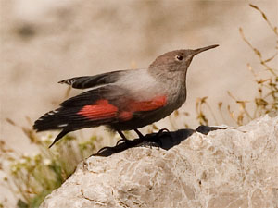
Source: Wikipedia http://www.en.wikipedia.org.
Fig. 179. Tichodroma muraria.
This family is comprised of a single species. It is distributed from southern Europe to central China (Gill and Donsker 2013). It has anatomic and behavioral similarities to the nuthatch, though it climbs rocks in search of insects rather than trees (Roberson 2012). Sibley and Monroe (1990) place it as a subfamily in the nuthatch family. So it is tempting to place the level of the kind higher, but no hybrid data supports this.

Certhiidae (The Treecreeper kind)
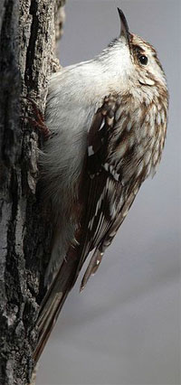
Source: Wikipedia http://www.en.wikipedia.org.
Fig. 180. Certhia americana.
This family is comprised of 11 species in two genera (Gill and Donsker 2013). They had historically been associated with the nuthatches, and these two families in turn to the tits and long-tailed tits. DNA-DNA hybridizations studies suggest a closer association with gnatcatchers and gnatwrens (Handbook of the Birds of the World Alive). It is difficult to interpret this situation. On one hand, the level of the kind could be high enough that it includes all these families and perhaps others. On the other hand, the ambiguity may suggest they are not related to other families. So the level of the kind is left at the family for now.

Mimidae (The Mockingbird kind)
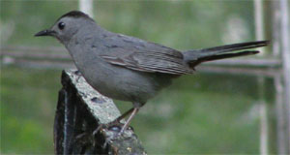
Source: Wikipedia http://www.en.wikipedia.org.
Fig. 181. Dumetella carolinensis.
This family comprises 34 species in ten genera (Gill and Donsker 2013). It includes thrashers, mockingbirds, and catbirds. The two largest genera, Mimus and Toxostoma, which include most of the mockingbirds and thrashers respectively, are connected by hybrid data (McCarthy 2006). These New World birds are well known for their ability to mimic other birds and sounds (Roberson 2012).

Sturnidae (The Starling kind)
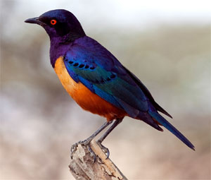
Source: Wikipedia http://www.en.wikipedia.org.
Fig. 182. Lamprotornis hildebrandti.
Gill and Donsker (2013) list 123 species, some of which are now extinct. These are birds of the Old World, though the common starling has been introduced worldwide. McCarthy (2006) identifies six genera (Acridotheres, Cosmopsarus, Lamprotornis, Onychognathus, Spreo, andSturnus) that are united by hybrid data. However, a major shifting of genera took place based on works published in 2008, so two of these genera (Cosmopsarus and Spreo) have been assimilated in the others. Unsurprisingly, the four remaining are the largest of the 33 genera listed by Gill and Donsker (2013).

Buphagidae (The Oxpecker kind)
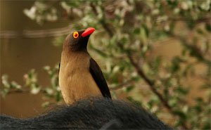
Source: Wikipedia http://www.en.wikipedia.org.
Fig. 183. Buphagus erythrorhynchus.
This family comprises two species in a single genus (Gill and Donsker 2013). They live in sub-Saharan Africa on large mammals, especially ungulates. They feed on flies, ticks, and fleas. This benefits the host, making it a predominantly mutual commensal relationship. However, they also consume tissues from wounds, blood and other secretions, and are thus considered semi-parasitic. Some authors consider them a subgroup of starlings (Sturnidae). They have significant morphologic and biochemical similarities with starlings (Roberson 2012). Further study should be done to see if the level of the kind should be elevated about the family level.

Turdidae (The Thrush kind)
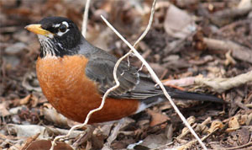
Source: Wikipedia http://www.en.wikipedia.org.
Fig. 184. Turdus migratorius.
This family is comprised of 185 species (Gill and Donsker 2013). These small to medium-sized songbirds have a distinctive protrusion from the syrinx known as the “turdine thumb.” Many are impressive singers. The family has decreased in size significantly since many of the original 365 were moved to Muscicapidae. It is recognized that some further changes are likely. The largest genus, Turdus, includes birds native to all continents except Australia and Antarctica. The familiar American robin belongs to this genus (Roberson 2012).

Muscicapidae (The Chat/Old World Flycatcher kind)
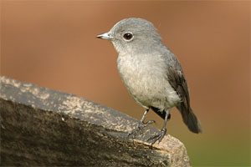
Source: Wikipedia http://www.en.wikipedia.org.
Fig. 185. Melaenornis fischeri.
This family comprises 298 species (Gill and Donsker 2013). They are relatively small birds that inhabit the Old World, with a couple of exceptions that can be found in Alaska. As with many other birds, they have hopped nests in the taxonomic nested hierarchies. Once considered part of a huge group that included thrushes, Old World warblers, babblers and others, they were later divided out in a somewhat smaller group. Based on DNA-DNA hybridization, they were placed together beside thrushes in this large family. There is still some controversy over the precise limits of the group (Roberson 2012).

Cinclidae (The Dipper kind)
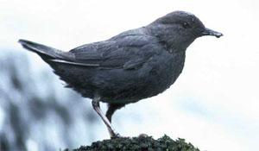
Source: Wikipedia http://www.en.wikipedia.org.
Fig. 186. Cinclus mexicanus.
This family comprises five species in a single genus (Gill and Donsker 2013). These birds are found worldwide near fresh water pools, waterfalls, rivers, and streams. They dive into the water after a variety of underwater prey, including small fish and aquatic invertebrates. They have a number of adaptations possessed by other aquatic birds. They often nest behind waterfalls or under bridges (Roberson 2012).

Chloropseidae (The Leafbird kind)
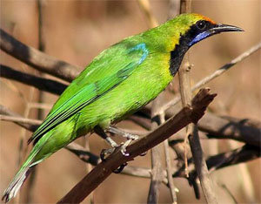
Source: Wikipedia http://www.en.wikipedia.org.
Fig. 187. Chloropsis aurifrons.
This family is comprised of 11 species in a single genus (Gill and Donsker 2013). They are tree-dwelling birds found in tropical Asia. They are generally a combination of green or yellow, and sometimes a little blue. They eat berries, fruit and insects. At one time they were considered related to the bulbuls (Pycnonotidae). They have some characters of drongos (Dicruridae) or cuckoo-shrikes (Campephagidae). They were considered closely related to the Ioras (Aegithinidae), and were sometimes placed in the same family as recently as 2000. However, DNA studies suggest they are more closely related to bush-shrikes, helmet-shrikes, and vangas (Roberson 2012). Further study should be done to see if the level of the kind is really at the family.

Dicaeidae (The Flowerpecker kind)
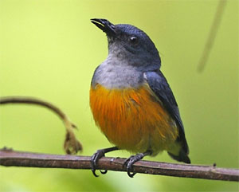
Source: Wikipedia http://www.en.wikipedia.org.
Fig. 188. Dicaeum trigonostigma.
This family is comprised of 48 species in two genera (Gill and Donsker 2013). It has long been debated which genera belong in this family, and how these birds are related to other families. For example, based on bill form and their nine long primary feathers, flowerpeckers were grouped with Zosterops (Zosteropidae), some neotropical honeycreepers from Thraupidae, New World Warblers (Parulidae), and Pardalotus (Pardalotidae). Later it was proposed they were part of Fringilliformes along with an unlikely assortment of other taxa. Others proposed they were related to nectariniid sunbirds. Even with the advent of DNA-DNA hybridization data the affinities of this family are still considered uncertain (Handbook of the Birds of the World Alive). Thus the level of the kind is left at the family.

Nectariniidae (The Sunbird kind)
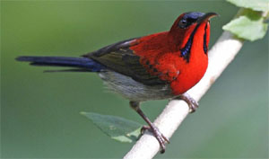
Source: Wikipedia http://www.en.wikipedia.org.
Fig. 189. Aethopyga siparaja.
This family comprises 139 species in 16 genera (Gill and Donsker 2013). Sunbirds are small, often colorful birds of the Old World tropics. They have long, downward-curved bills and feed on nectar like hummingbirds. One genus in this family, Arachnothera, is composed of 13 species of spiderhunters. They are generally not as colorful and feed instead on arachnids and insects (Roberson 2012).

Passeroidea (The Sparrow/Finch kind)
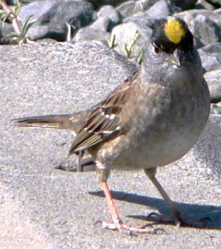
Source: Wikipedia http://www.en.wikipedia.org.
Fig. 190. Zonotrichia atricapilla.
Passeroidea is a superfamily designation for the Old World sparrows (Passeridae) and other families that are considered related to them. In Sibley and Monroe (1990) it includes a number of families already listed here separately. It is used in this work to include the families listed from Passeridae through Cardinalidae in the current IOC World Bird List (Gill and Donsker 2013). Sibley and Monroe (1990) have these listed in two expanded families: Passeridae and Fringillidae.
Wood (2008) used statistical baraminology methods on two datasets focusing on different subfamilies of Fringillidae. In the analysis he noted that there was a failure to detect discontinuity with the outgroups, which were from Passeridae and Estrildidae. He suggested two possibilities: that there was a true lack of discontinuity because all three families were part of a larger holobaramin, or there had been spurious character sampling. He noted that the dataset with a broader sampling of characters (craniomandibular, postcranial, and plumage/integumentary) failed to show positive correlation between ingroup and outgroup. On the other hand, the dataset deemed less holistic showed extensive positive correlation.
There is extensive hybridization data between genera and families in these familiar birds (McCarthy 2006). Based on this data, a large monobaramin (group belonging to one created kind) was identified (Lightner 2010). It includes Old World sparrows and snowfinches (Passeridae), weaver finches (Ploceidae), waxbills, munias and allies (Estrildidae), finches (Fringillidae), oropendolas, orioles, and blackbirds (Icteridae), buntings, New World sparrows and allies (Emberizidae), tanagers and allies (Thraupidae), and cardinals, grosbeaks and allies (Cardinalidae). In these families alone there are 1241 species! So Wood’s (2008) initial suggestion appears to be the case.
When the other families in this range are included, the total number of species rises to 1471. It is logical to include these families because they are considered related to the birds that have hybridized. Based on the taxonomy of Sibley and Monroe (1990), the hybrids span two families. From a creationist standpoint that is evidence that all members of those families would be related, that is, considered a monobaramin. In the IOC World Bird List (Gill and Donsker 2013) these other families appear between the families connected by hybrid data. Again, their position there suggests they are related.

Analysis of Interesting Patterns
In identifying the putative Ark kinds, the cognitum approach proved to be very difficult to use at times, especially in the huge order Passeriformes. This probably should have been anticipated given that bird taxonomy is often controversial and has experienced considerable upheaval since molecular data has become available. Often similar traits appear in unrelated taxa and are explained by convergent evolution.
There are several groups of well-studied birds where considerable hybrid data is available. Three are particularly notable: Anatidae, Galliformes, and the Passeroidea. Anatidae comprises 172 species of ducks, geese, and swans. This family is familiar to many people and provides the average person a glimpse of the amount of diversity that has arisen within an avian kind.
The order Galliformes, which includes chickens, turkeys, quail, and pheasants, is even more impressive. Here the hybrid data connects a whole order with nearly 300 species! Even more surprising is the fact that Sibley and Monroe (1990) place these species in two separate orders based on DNA-DNA hybridization studies! This certainly indicates that a tremendous amount of diversity, both in physical appearance and genetics, has arisen in this kind.
However, perhaps the most astounding group identified based on interspecific hybrid data is Passeroidea. Encompassing Old and New World sparrows, various finches and related birds, this represents an amazing amount of variety in the nearly 1500 species. It is clear that this diversity didn’t arise since the Flood by the standard naturalistic explanations of neo-Darwinism, that is, chance mutations and natural selection (Lightner 2013)!
Each of these three groups (Anatidae, Galliformes and Passeroidea) has a global distribution (Gill and Donsker 2013). This is remarkably consistent with the blessing God pronounced on birds the day they were created (Genesis 1:20–23). We certainly see that they have reproduced and filled the earth. What an awesome testimony to our Creator who provides for His creatures!
It seems as though the diversity within bird kinds may generally be much greater than that within mammals. Perhaps the reason for this is suggested in the Flood account. Two of each kind of land and flying animal were to be taken on the Ark (Genesis 6:19–20). Yet in the case of clean animals, more were taken (Genesis 7:2). The statement in Genesis 7:3 may hint that most birds were clean; meaning a greater amount of genetic diversity may have been present among them on the Ark. Discussion of clean and unclean animals seems consistent with this. Clean animals consist of ruminants; a small group of mammals. In contrast, unclean birds are specifically mentioned in a short list (Leviticus 11; Deuteronomy 14), thus suggesting there were fewer unclean birds relative to clean ones.
The patterns seen do not fit well in the neo-Darwinian tree of life. Instead, there are an enormous number of traits that must be considered the result of convergent evolution rather than common ancestry. According to the neo-Darwinian model, morphologic, physiologic, and molecular traits should be consistent in where they suggest the bird is placed. Unfortunately for the evolutionist, this is often not the case. It is a little harder to predict what we should expect in the creation model. We recognize that similarities and differences may also have been designed. This is in addition to similarity sometimes being from common ancestry (within a kind) or changes producing similar results (aka convergent evolution).
Within a biblical framework, there are many details to sort out. How reliable is the cognitum approach when you have Malagasy warblers (Bernieridae) which includes genera that were initially placed in different families? It is only the advent of molecular data that produced evidence that they belong together? Then again, how valuable is the molecular data in determining relationships? In Sibley and Monroe (1990) the taxonomic level was related to the indirect measurement of DNA similarity. In a biblical framework, do we want to assume that genetic diversity is essentially equivalent within each of the created kinds? Perhaps not.
The idea that the family is the typical level of the kind is challenged by some of the findings here. Perhaps it is higher in even more cases than the hybrid data indicates. If so, this may explain the conundrum with the Malagasy warblers. Perhaps they are also related to the other families these species were once allied with. Yet there needs to be more evidence to support such a conjecture. Considerable research needs to be done to evaluate the types of diversity typical within kinds and suggest the type of differences that may help delimit the boundaries of a kind. The field of baraminology is ripe for harvest. Pray that we would have researchers raised up for the task.

Conclusions
In this survey, 196 “kinds” of birds were identified. While hybrid data was used where it was available, and the cognitum and other data were considered, many kinds were identified by equating the currently recognized family with a kind. This is overly simplistic. Further, bird taxonomy is still in a state of flux, so this should be considered only a rough, conservative estimate.
There are many unanswered questions at this point. We still need to further assess diversity within kinds identified by hybrid data. This will help us understand what characteristics God designed to vary to enable birds to fill the earth. Hopefully this will suggest parameters for delimiting the kinds. Thus there is plenty of room for more exciting research to better understand how our magnificent Creator designed and provides for His Creation.

References
Alderfer, J., ed. 2005. National Geographic Complete Birds of North America. Washington, DC: National Geographic.
Cholewiak, D. 2003a. Rheidae. Animal diversity web. Retrieved from http://animaldiversity.ummz.umich.edu/site/accounts/information/Rheidae.html on August 29, 2012.
Cholewiak, D. 2003b. Casuariidae. Animal diversity web. Retrieved from http://animaldiversity.ummz.umich.edu/site/accounts/information/Casuariidae.html on August 29, 2012.
Cholewiak, D. 2003c. Tytonidae. Animal diversity web. Retrieved from http://animaldiversity.ummz.umich.edu/accounts/Tytonidae/ on March 5, 2013.
Gill, F. and D. Donsker, eds. 2012a. IOC world bird names (v 3.1). Retrieved from http://www.worldbirdnames.org on August 22, 2012 through September 15, 2012.
Gill, F. and D. Donsker, eds. 2012b. IOC world bird names (v 3.2). Retrieved from http://www.worldbirdnames.org on October 18, 2012 through January 28, 2013].
Gill, F. and D Donsker, eds. 2013. IOC world bird names (v 3.3, 3.4). Retrieved from http://www.worldbirdnames.org on January 31, 2013 through September 7, 2013.
Handbook of the birds of the world alive. n.d. Retrieved from http://www.hbw.com/ on August 13, 2013 through September 18, 2013.
Hennigan, T. 2013a. An initial estimate toward identifying and numbering amphibian kinds within the orders Caudata and Gymnophiona. Answers Research Journal 6:17–34. Retrieved fromhttp://www.answersingenesis.org/articles/arj/v6/n1/amphibian-kinds.
Hennigan, T. 2013b. An initial estimate toward identifying and number the frog kinds on the Ark: Order Anura. Answers Research Journal 6:335–365. Retrieved fromhttp://www.answersingenesis.org/articles/arj/v6/n1/frog-kinds-on-ark.
Howard, L. 2003a. Tinamiformes. Animal diversity web. Retrieved from http://animaldiversity.ummz.umich.edu/site/accounts/information/Tinamiformes.html on August 22, 2012.
Howard, L. 2003b. Anhimidae. Animal diversity web. Retrieved from http://animaldiversity.ummz.umich.edu/site/accounts/information/Anhimidae.html on August 29, 2012.
Howard, L. 2003c. Anatidae. Animal diversity web. Retrieved from http://animaldiversity.ummz.umich.edu/site/accounts/information/Anatidae.html on August 29, 2012.
Lightner, J. K. 2010. Identification of a large sparrow-finch monobaramin in perching birds (Aves: Passeriformes). Journal of Creation 24, no. 3:117–121.
Lightner, J. K., T. Hennigan, G. Purdom, and B. Hodge. 2011. Determining the Ark kinds.Answers Research Journal 4:195–201. Retrieved fromhttp://www.answersingenesis.org/articles/arj/v4/n1/ark-kinds-flood-baraminology-cognitum.
Lightner, J. K. 2012. Mammalian Ark kinds. Answers Research Journal 5:151–204. Retrieved from http://www.answersingenesis.org/articles/arj/v5/n1/mammalian-ark-kinds.
Lightner, J. K. 2013. Meiotic recombination—designed for inducing genomic change. Journal of Creation 27, no. 1:7–9.
McCarthy, E. M. 2006. Handbook of avian hybrids of the world. New York, New York: Oxford University Press.
McConnachie, M. and T. R. Brophy. 2008. A baraminological analysis of the landfowl (Aves:Galliformes). Occasional Papers of the BSG 11:9–10.
McKilligan, N. 2005. Herons, egrets, and bitterns: Their biology and conservation in Australia. Victoria, Australia: CSIRO Publishing.
Moyle, R. G., M. J. Andersen, C. H. Oliveros, F. D. Steinheimer, and S. Reddy. 2012. Phylogeny and biogeography of the core Babblers (Aves: Timaliidae). Systematic Biology 61, no. 4:631–651.
Roberson, D. 2012. Bird families of the world. 11th and 12th ed. Retrieved from http://creagrus.home.montereybay.com/list.html on August 2012 through September 2013.
Sibley, C.G. and B.L. Monroe. 1990. Distribution and Taxonomy of Birds of the World. New Haven: Yale University Press.
Wetmore, A. 1930. A systematic classification for the birds of the world. Proceedings of the United States National Museum 76:1–8. Retrieved from https://archive.org/details/systematicclassi30wetm
Wilber, R. 2008. Anseranas semipalmata. Animal diversity web. Retrieved from http://animaldiversity.ummz.umich.edu/site/accounts/information/Anseranas_semipalmata.html on August 29, 2012.
Wood, T. 2008. Animal and plant baramins. Eugene, Oregon: Wipf & Stock.
(下面中文使用谷歌翻译。需要修正和编辑。)

第7周：第2部分
回答研究杂志6 （ 2013 ） ： 409-466 。
www.answersingenesis.org/articles/arj/v6/n1/avian-ark-kinds
禽种方舟的初步估计
由Jean K.莱特纳
2013年11月27日

摘要
神创论者认识到，动物各从其类被创建，但一直存在的那些什么都种不完整清单。由于答案在创世纪方舟邂逅项目的一部分，研究，试图更清晰地识别并列举脊椎动物种已存在的方舟在本文中，使用前面描述的方法发起，假定196种鸟类被确定。由于资料有限，事实上，禽流分类学分类转移，这应该被视为只是一个粗略估计。
________________________________________
关键词：方舟，种类，创造多种， baraminology ，鸟
介绍
由于遭遇方舟项目的一部分，答案在创世纪发起并资助的研究，试图更清楚地识别并列举脊椎动物种类已存在的方舟在最初的纸，圣经种的概念进行了讨论和策略，识别它们被勾勒出来（莱特纳等， 2011） 。一些关键点如下所述。
还有就是今天看到的动物的生活，动物成倍，充满大地，因为洪水（创世记8:17 ）巨大的品种。为了确定哪些现代种是相关的，是单一种类的后代，种间杂种的数据被利用。当混合数据缺乏，一个cognitum方法是首选，这确定了基于人类认知的感官自然分组。一般来说， cognitum在家庭层面（这通常是相当强的）时，最好的混合型数据缺乏，但围绕这一水平明显cognita被注意到。
已被用于标识baramins另一种方法（创建种）是统计baraminology 。更详细的其他地方（木2008） baraminic距离相关（ BDC）和多维尺度（ MDS ）的方法进行了讨论。虽然他们是重要的工具，莱特纳等人。 （ 2011）没有考虑他们作为可靠的混合动力数据和现存物种cognitum方法。结果从统计baraminology研究将在这里（如适用）指出。
以往的研究已经提供了哺乳动物和两栖动物种类的初始估计（亨尼2013A ;亨尼2013B ;莱特纳2012） 。本文将侧重于查明现存鸟类种。有鸟类超过10,000生物物种，使它们成为最speciose类脊椎动物的后裔从这些保存在阿肯色州有大量的混合数据可供鸟类（ 2006麦卡锡） 。在有些情况下混合数据连接（在订单鸡形目，鸻形目，雀形和）一些大型的，多样化的家庭以及研究的物种的几个例子。
在哺乳动物和两栖动物，鸟类分类学的状态是在不断变化。尽管在分类整齐地嵌套层次的理想，似乎鸟类群体反复“换巢”，这部分是因为那里的动物被放置取决于一个人选择要考虑哪些特性。尽管许多人认为，分子数据将解决这些问题，在某些情况下，它加剧了他们。对于禽流方舟种这种估计，分类方案由国际鸟类学家的联合（ IOU）在线提交使用（吉尔和Donsker 2012A ， 2012B和2013年） 。该列表包括现存和一些最近灭绝的物种的信息。任何只从化石记录已知的鸟类将不包括在此分析。
为了Tinamiformes

资料来源：维基百科http://www.en.wikipedia.org 。
图。 1 。 Crypturellus灰黑色。
Tinamidae （该Tinamous的那种）
这种单一的家庭秩序包括9属47种。从表面上看，他们似乎鸡等。这是争论他们是否是更密切相关，鸡（鸡形目），或称为平胸鸟（霍华德2003年a ）大飞的鸟。他们有一个palaeognathous口感，如做平胸鸟。然而，与平胸鸟，它们对胸骨和全面发展的翅膀龙骨，使他们能飞（世界活着的鸟类手册） 。考虑到这一争议，家庭/订单似乎是一个自然的地方来推测的那种水平。
为了Struthioniformes
Struthionidae （该鸵鸟）

资料来源：维基百科http://www.en.wikipedia.org 。
图。 2 。鸵鸟野骆驼。
此系列包含有两个品种（吉尔和Donsker 2012A ）一个属。他们是最大的活鸟。虽然不会飞，它们是很好的运动员和曾经居住开放地区遍布非洲和中东（罗伯逊2012） 。从cognitum的角度来看，鸵鸟配合其他平胸类鸟，如rheas和鸸鹋。这些物理相似性的早期分类学家分组ratities在一起的基础。后来的研究显示，他们并没有想象中密切相关的，如此多的相似之处是由于趋同进化（世界活着的鸟类手册） 。唯一的混合型数据是从鸵鸟的两个物种（麦卡锡2006）之间的杂交。由于其他平胸鸟目前在欠条分类方案占据不同的订单，并没有混合数据连接这些订单，那种水平将被视为家庭/订单现在。
为了Rheiformes
Rheidae （瑞亚的那种）

资料来源：维基百科http://www.en.wikipedia.org 。
图。 3 。瑞亚美洲。
该系列还包含两个品种（吉尔和Donsker 2012A ）一个属。这些身材高大，长脚，不会飞的鸟都是优秀的选手。他们住在南美洲，通常在开阔的草原（ Cholewiak 2003年a ） 。尽管他们组从cognitum角度等平胸鸟，它们不结合他们在这里。唯一的混合型数据是两个物种瑞亚（ 2006麦卡锡）之间。西布利和门罗（ 1990）地方rheas基于DNA-DNA杂交的研究，这给物种之间的DNA相似的估计鸵鸟旁边的下目。 Casuariiformes减小到亚这两个组的旁边， Tinamiformes被保持在这些在其分类学旁一个单独的命令。因此，有在DNA水平前四个命令中太相似了相当数量。因为我们不知道如何评估的方式，有利于识别的DNA种类相似，估计保持在家庭/订单水平。
为了Casuariiformes
Casuariidae （的食火鸡的那种）

资料来源：维基百科http://www.en.wikipedia.org 。
图。 4 。 Casuarius unappendiculatus 。
有三个品种单一属在这个家庭（吉尔和Donsker 2012A ）确认。这些大的平胸鸟被发现在Australo -巴布亚地区。他们生活在热带雨林。他们被认为是密切相关的鸸鹋和有时将其划分在同一个家庭。他们是比较常见的化石记录。有认为是食火鸡和鸸鹋（ Cholewiak 2003年b）之间的中间化石。鉴于此，那种​​水平实际上可能会更高，在订单或可能超过。由于混合数据缺乏，那种​​会在家庭层面来考虑，以避免这种偏见会低估种上了方舟的数量
Dromaiidae （鸸鹋种）

资料来源： http://www.publicdomainpictures.net/
图。 5 。 Dromaius鹋。
这个家庭是单种，由单一品种（吉尔和Donsker 2012A ）的。这个大的平胸鸟是原产于澳大利亚。它栖息在草地地区或疏林。这些毛茸茸的鸟花费其大部分时间觅食，消耗的草和植物。他们也会吃大量的昆虫，当它们可用（罗伯逊2012） 。这个家族有代表的化石记录和几个品种在十九世纪初（世界活着的鸟类手册）灭绝。
为了Apterygiformes
Apterygidae （猕猴桃种）

资料来源：维基百科http://www.en.wikipedia.org 。
图。 6 。 Apteryx芦苇。
此系列包括有五个品种（吉尔和Donsker 2012A ）一个属。有混合数据连接这三个品种（2006年麦卡锡） 。猕猴桃是该生活在新西兰不寻常的不会飞的鸟。这些夜行性动物留在洞穴中，白天和晚上出来觅食（罗伯逊2012） 。这些ratities被认为是更密切相关的已灭绝的恐鸟（世界活着的鸟类手册） 。
为了鸡形目
（在任何陆的那种）

资料来源：维基百科http://www.en.wikipedia.org 。
图。 7 。捷拉斯sonneratii 。
任何陆，包括鸡，火鸡，野鸡和，是由五个家庭有299种（吉尔和Donsker 2012A ）的。这四个家庭（ Cracidae ， Numididae ， Odontophoridae和雉科）由混合数据是团结（ 2006麦卡锡） 。第五个家庭， Megapodidae ，历来被认为是比任这两个家庭都与其他三个家庭（韦特莫尔1930）更密切联系与Cracidae 。事实上，西布利和梦露（ 1990）名单Megapodidae和Cracidae从其他基于DNA-DNA杂交研究一个单独的订单。因此，随着Cracidae被团结与其他三个家族，似乎所有的五个家庭均来自单一创建一种。
利用统计baraminology技术，大多osteologic字符的大型数据集进行分析，以这个顺序中评估的那种水平。结果表明，有四个不同的群体（即潜在baramins ） ： Megapodidae ， Cracidae ， Numididae ，并分组在家族Phasianoidea （ McConnachie和2008年布罗菲） ，其余品种。混合数据和统计baraminology技术的结果之间的这种差异是重要的提醒，后者，虽然在帮助估计的那种水平有价值的，应视为暂定。
为了雁形目
Anhimidae （该嚎叫的那种）

资料来源： http://tolweb.org 。
图。 8 。 Chauna torquata 。
这个家族包括两个属，三个品种。总体来说，身体是鹅状，但颈部短而配上一个相当小的鸡般的头。在脚上的安全带很浅。在历史上一直存在过的地方放置这个团体（霍华德2003年b）一些争议。有一个在属Chauna两个物种之间的混合数据，但这个家庭的任何人（2006麦卡锡）之间无。这样看来最好在家庭层面来初步认为的那种。
Anseranatidae （鹊鹅种）

资料来源：维基百科http://www.en.wikipedia.org 。
图。 9 。 Anseranas semipalmata 。
有一个单一的物种在这个家庭。鹊鹅在澳大利亚和新几内亚发现。他们游泳和韦德在潮湿的草地和沼泽的海岸。他们的脚只有部分蹼（2008年潘玮柏） 。鹊鹅有一些功能似乎叫鸭和雁鸭类家族（罗伯逊2012）之间。在过去，它已被列为与鸭科（韦特莫尔1930） 。西布利和门罗（ 1990）将家庭根据他们的DNA研究更接近Anhimidae 。虽然他们似乎适合在同一cognitum鸭，鹅，天鹅，它们被认为是单独的在这里，以避免可能低估了种上了方舟
雁鸭（鸭子的那种）

资料来源：维基百科http://www.en.wikipedia.org 。
图。 10 。 Dendrocygna autumnalis 。
此系列产品包括49属， 172种（吉尔和Donsker 2012A ） 。除了鸭子的多样化，该系列还包括鹅和天鹅。上一页统计baraminologic分析似乎表明这个家庭中的三组。虽然这是清楚地看到在BDC分析， MDS的四面体形状调用这个质疑（2008年木） 。人们关注类群在此组内的关系（霍华德2003C ）的辩论。然而，连接所有亚科（ 2006麦卡锡）的混合型数据。因此那种水平似乎是，至少在家庭水平。
为了Gaviiformes
Gaviidae （本龙种）

资料来源：维基百科http://www.en.wikipedia.org 。
图。 11 。潜鸟的Pacifica 。
5个种的潜鸟都属于一个属（吉尔和Donsker 2012A ） 。他们出现类似鸭子，因为它们在水面上游泳，除了他们的匕首般的法案。他们是专门吃鱼。在陆地上，他们是笨拙的，因为他们的脚被设置成远对自己的身体（罗伯逊2012） 。天然杂交已报道4这些物种之间;有推断的杂交涉及第五种（ 2006麦卡锡） 。
为了Spenisciformes
Spheniscidae （企鹅种类）

资料来源：维基百科http://www.en.wikipedia.org 。
图。 12 。 Pygoscelis巴布亚。
此系列产品包括18种六属（吉尔和Donsker 2012A ） 。也有一些企鹅灭绝的属和种的显示大小和形状比那些今天还活着更大的多样性。企鹅是在既是飞和水生（罗伯逊2012）是唯一的。天然杂交已在同一属（麦卡锡2006）被记录多个不同的品种与他人之间。目前在家庭层面强烈cognitum和以前的统计baraminology的研究强烈建议所有现存企鹅属于同一类（2008年木） 。
为了鹱
阿强cognitum出现在这个水平。根据他们的DNA-DNA杂交的研究，西布利和梦露（ 1990）把这个命令作为一个家庭分为三个亚科以下的家庭。潜水海燕被放置在海燕。在他们的方案潜鸟（ Gaviidae ） ，企鹅（ Spheniscidae ）和军舰（ Fregatidae ）放在附近。在其他分类法军舰不放在靠近这些家庭（二零零五年奥尔德弗;鳃和Donsker 2012A ）和企鹅似乎落在自己cognitum ，强烈暗示这些后两组是不同类型的。尽管这些提示的那种的水平可以是在为了鹱，它将被放置在下面这在家庭层面，以避免可能低估的种数。
Diomedeidae （信天翁的那种）

资料来源：维基百科http://www.en.wikipedia.org 。
图。 13 。 Phoebastria albatrus 。
有四个属， 21种albatrossses （吉尔和Donsker 2012A ）的。信天翁有一个厚厚的身体长而窄的翅膀。他们有大的脚蹼，并花很多时间翱翔在开放的海洋（奥尔德弗2005） 。两个属的有一定的种间杂种的数据（ 2006麦卡锡） 。
鹱科（海燕那种）

资料来源：维基百科http://www.en.wikipedia.org 。
图。 14 。 Puffinus nativitatis 。
该系列包括14属， 90种（吉尔和Donsker 2012A ） 。海燕和海鸥在许多是信天翁相似。他们也有沉重的身体，狭长的翅膀，脚蹼。他们还发现通常在海上。他们从不同的信天翁在对他们的账单上脊单管（嘴峰） 。信天翁有它的嘴峰每侧单管（ 2005奥尔德弗） 。他们似乎确实是在同一个cognitum的信天翁。杂种数据中的一些属发现和杂种已经推断出一些属之间。然而，没有混合数据链接这个家庭与信天翁（ 2006麦卡锡） 。
Hydrobatidae （海燕那种）

资料来源：维基百科http://www.en.wikipedia.org 。
图。 15 。 Oceanodroma furcata 。
有七属，海燕（吉尔和Donsker 2012A ） 24种。海燕较小空中的海鸟。这样的顺序的其他成员，他们对自己的法案，是从他们喝海水去除盐的特殊管。他们是匀称一点不同于以前的两个家庭（罗伯逊2012） 。
Pelecanoididae （潜水海燕的那种）

资料来源：维基百科http://www.en.wikipedia.org 。
图。 16 。 Pelecanoides garnotii 。
这monogeneric家庭有4种（吉尔和Donsker 2012A ） 。他们是小矮胖的海鸟，短翅膀，擅长游泳和潜水，而不是在飞涨。在某些方面，它们类似于无关的海雀（鸻形目： Alcidae ） 。这是由于趋同进化（罗伯逊2012）。
为了Podicipedidae
Podicipedidae （该鸊鷉的那种）

资料来源：维基百科http://www.en.wikipedia.org 。
图。 17 。 Podiceps黑颈鹤。
有六个属23种grebes （吉尔和Donsker 2012A ）的。 Grebes是很好的代表在化石记录中，并没有考虑密切相关的其他鸟类。他们是优秀的潜水员与裂脚趾腿定远背在身上。他们是笨拙的土地上，很少见到进出水（罗伯逊2012年） 。有一些混合型数据包括Podilymbus podiceps和Tachybaptus鷉之间的属间杂交（二零零六年麦卡锡） 。
为了Phoenicopteriformes
Phoenicopteridae （火烈鸟的那种）

资料来源：维基百科http://www.en.wikipedia.org 。
图。 18 。 Phoenicopterus红。
还有火烈鸟六个品种在一个属（吉尔和Donsker 2012A ） 。他们是非常独特的与他们的比例长长的腿和脖子以及他们的粉红色的羽毛。他们也有一个鲜明的法案，是在中心弯曲，并用于应变藻，硅藻和水生无脊椎动物（二零零五年奥尔德弗） 。有连接五六个品种（2006年麦卡锡）的混合型数据。
为了Phaethonitiformes
Phaethontidae （该Tropicbird的那种）

资料来源：维基百科http://www.en.wikipedia.org 。
图。 19 。法厄同rubricauda 。
此系列包括在一个单一的属三个品种（吉尔和Donsker 2012A ） 。他们住在海上，有一个独特的长尾巴中央流光作为成年人，和潜水鱼类和其他猎物。脚有蹼和腿远远背在身上，走路时使它们笨拙。他们很少下滑，但随着快速振翅（二零零五年奥尔德弗）飞。
为了鹳形目
Ciconiidae （ Stork的那种）

资料来源：维基百科http://www.en.wikipedia.org 。
图。 20 。 Mycteria合欢。
该系列具有19种六属（吉尔和Donsker 2012A ） 。鹳是大型涉禽。虽然表面上类似于其他一些涉水鸟，最近的一些分类学家认为他们更密切相关的新大陆秃鹫（ Cathartidae ） 。杂交种已报告内的大属鹳以及Leptoptilos爪哇和Mycteria合欢（ 2006麦卡锡）之间。涉及的属间杂交的物种是从两个不同的部族（罗伯逊2012） 。考虑到所有这些因素，订单/家庭层面似乎是那种水平。
为了鹈形目
Threskiornithidae （ Ibis酒店的那种）

资料来源：维基百科http://www.en.wikipedia.org 。
图。 21 。白琵核桃。
该系列包括13属35种（吉尔和Donsker 2012A ） 。朱鹭和琵鹭是涉禽，可以很容易地从彼此的法案形状，颜色和觅食模式区别开来。尽管各的特殊性，属间杂种的数据，连接在这个家庭四个属的，清楚地表明它们是相关的（麦卡锡2006年）。
鹭（苍鹭的那种）

资料来源：维基百科http://www.en.wikipedia.org 。
图。 22 。鹭希罗底。
有72种19属这个家族（吉尔和Donsker 2012A ） 。这些独特的鸟类，包括白鹭和盐卤，有化石记录可以追溯到较低的始新世。最适合于和涉水捕食鱼（奥尔德弗2005年罗伯逊2012） 。一个统计baraminologic分析完成，结果显示两组。卤水亚科， Botaurinae ，形成一组。其余的苍鹭和外类群形成的第二。外类群的成员主要来自鹮家族（ Threskiornithidae ）和鹳家族（ Ciconiidae ） ，虽然火烈鸟被列入了。分别提出了两种可能的解释。无论是盐卤做了一个holobaramin （整个创建的那种）还是那种水平似乎是上面的命令（伍德2008）的水平。
在同一时间盐卤是在一个亚科和所有其他物种都在另一个。然而，现在有四亚科确认，并没有被更密切相关的另一个比其余的考虑。此外，它的情况并不少见宜必思和苍鹭被放置在相同的顺序鹳。有时甚至火烈鸟一直被认为是在相同的顺序（ McKilligan 2005） 。因此，对于那种一个更高的水平可能不那么令人难以置信。然而，苍鹭有一些独特的功能，所以有在家庭层面强烈cognitum 。因此，那种​​水平放在这里是保守的。
Scopidae （该Hamerkop的那种）

资料来源：维基百科http://www.en.wikipedia.org 。
图。 23 。 SCOPUS umbretta 。
单一品种在这个家庭生活在撒哈拉以南非洲地区，拥有独特的习惯和行为。它让人联想到苍鹭的一些功能。它有其他字符，这类似于鲸头鹳，红鹤，鹳和一个奇怪的组合。它有那些否则只能在鸻发现体外寄生虫。鉴于此，它的起源和关系到其他鸟类被认为是不明确（罗伯逊2012） ，所以它在这里认为是属于自己的一种。
Balaenicipitidae （该鲸头鹳的那种）

资料来源：维基百科http://www.en.wikipedia.org 。
图。 24 。 Balaeniceps雷克斯。
此单一品种还发现，在撒哈拉以南非洲。它被称为鲸鱼为首鹳，虽然它飞行与它的脖子缩回像苍鹭。有骨骼和生化证据表明它是更密切相关的鹈鹕（罗伯逊2012） 。西布利和门罗（ 1990）将其列为在鹈鹕科一个亚科。在这里，它被认为是属于一个独特创造一种，因为它是目前置于作为一个独特的家族。
鹈鹕科（鹈鹕的那种）

资料来源：维基百科http://www.en.wikipedia.org 。
图。 25 。斑嘴onocrotalus 。
所有八种鹈鹕属于一个属（吉尔和Donsker 2012B ） 。他们是与众不同的鸟，它们的长，钩票据及奇异大袋（二零零五年奥尔德弗） 。他们填写他们的嘴的水大口大口巨大，滤出来的液体，吃剩下的鱼或鱿鱼。他们代表的化石记录（罗伯逊2012） 。强cognitum使家庭用这个位置来推断出的那种水平。
为了Suliformes
Fregatidae （该军舰鸟种）

资料来源：维基百科http://www.en.wikipedia.org 。
图。 26 。 Fregata magnificens 。
有5种在这个家庭（吉尔和Donsker 2012B ）一个属。军舰是优秀的空中飞人。他们有一个轻的身材，长，棱角分明的翅膀和长，深分叉的尾巴。这些热带海鸟能够滑翔过水很远的距离。它们的喙长深深迷上在尖端。雄性求偶（奥尔德弗2005）期间可以大大夸大其奇异的红色袋子。还有在这个水平强烈cognitum ，这表明这是那种水平。
Phalacrocoracidae （鸬鹚的那种）

资料来源：维基百科http://www.en.wikipedia.org 。
图。 27 。普通鸬鹚。
这个家族包括三个属， 41种（吉尔和Donsker 2012B ） 。有些作者列出所有物种在一个属。这些长颈潜水鸟都有长而重的身体，僵硬的尾巴，而这是钩挂在尖长的账单。他们缺乏一些鸟类的防水油，所以必须用自己的翅膀潜水回合后蔓延鲈鱼（奥尔德弗2005年罗伯逊2012） 。为方便起见，那种级别默认为家庭。
Anhingidae （在美洲蛇鸟种）

资料来源：维基百科http://www.en.wikipedia.org 。
图。 28 。美洲蛇鸟RUFA 。
这个家庭有4种单属（吉尔和Donsker 2012B ） 。他们像细长，长尾鸬鹚，被认为与他们息息相关。该法案指出。颈部扭结回很像苍鹭，它允许对猎物快速罢工。他们有腿短和大的脚蹼。因为他们缺乏的混合型数据与鸬鹚团结他们，那种水平留在家庭层面。
为了Accipitriformes
Cathartidae （新世界秃鹰的那种）

资料来源：维基百科http://www.en.wikipedia.org 。
图。 29 。 Carthartes光环。
这个家庭是由七个物种的三个属（吉尔和Donsker 2012B ） 。像他们的旧世界，他们有钩票据，赤裸头和饲料上的腐肉。事实上，有秃鹫之间的这种强烈的cognitum ，这将是很自然的将它们组合在同一种。然而，详细的解剖比较，以及一些行为相似性表明了新大陆秃鹫有很多共同点与鹳​​。 DNA杂交的研究似乎也证明了这一点。因此，除旧世界和新世界秃鹰这些相似之处，现在归于趋同进化（奥尔德弗2005年手册的世界活着的鸟类;罗伯逊2012） 。
这就提出了一个重要的一点，无论是cognitum和统计baraminology假设种保留了他们的独特性的生物纷纷转载，充满大地。这里是断言，这一定是真的没有圣经根据。趋同进化可以是在创建模型的相似之处一个合理的解释。它涉及到类似的适应性改变到一个特定的环境生态位，无论是在一种（如适合于在相同的基本方式不同的人群）或不同种的成员之间。事实上，趋同进化适应好一点的创作模式。演进（在分子到人的意义上）被认为是偶然过程的结果，所以没有理由怀疑生物会以同样的方式适应。因为他们分道扬镳，因为先前的变更应限制改变未来的选择，这将是尤其如此。与造物主谁打算为地球有人居住，这是不是不合理的推测，动物被设计为能够改变。这提供了为什么同一类型的变化可能发生的逻辑基础上，两个生物是否属于相同种类或没有。
这也是值得注意的，有关于Accipitriformes和隼的成员是如何与其他鸟类没有达成共识。事实上，化石记录不支持不同的家庭在这些订单的共同祖先，留下进化论者开放与归属于趋同进化（世界活着的鸟类手册）相似单独的祖先的可能性。关于秃鹰，鉴于目前的信息，似乎新大陆秃鹫是旧大陆秃鹫截然不同。他们也没有与鹳把那种水平以上的家庭层面共享一个足够强大的cognitum 。因此，家庭似乎指定的那种现在最好的地方。
Sagittariidae （该Secretarybird的那种）

资料来源：维基百科http://www.en.wikipedia.org 。
图。 30 。射手座serpentarius 。
有一个单一的现存物种在这个家庭。非洲平原上的这种独特的鸟类一直放置在自己的家庭，有时在自己的秩序。这股一些特征与猛禽，因而被归类在他们附近的欠条分类。在其他方面， secretarybird类似于鹳。有人建议用起重机或鹤形目其他成员的关系。该secretarybird几乎是四英尺高。它具有强大的腿，它的顶部覆盖着黑色的羽毛，给它穿马裤的外观（罗伯逊2012年，世界活着的鸟类手册） 。基于其独特的特征，事实上，没有任何其他组则有明显关系，那种水平放置在家庭。
Pandionidae （鱼鹰那种）

资料来源：维基百科http://www.en.wikipedia.org 。
图。 31。潘迪恩haliaetus 。
有两个物种鱼鹰的这两者都是在一个单一的属（吉尔和Donsker 2012B ） 。它们有时被称为一个“鱼鹰”，因为他们吃几乎全部的鱼。它们是独特的多种方式。他们有一个可逆的外趾，多刺的垫脚，以帮助握滑鱼，以及关闭水下鼻阀。他们也很好的体现在化石记录中（罗伯逊2012） 。有人建议，这个家庭发生了小的形态，因为他们是长距离的移民，这使得种群之间的杂交多。因此，他们不会遇到被认为有助于物种（世界活着的鸟类手册）的隔离。
鹰科（鹰的一种）

资料来源：维基百科http://www.en.wikipedia.org 。
图。 32 。雀鹰栗褐。
这个大家族是由256种65属。它不仅包括鹰派，而且风筝，鹞，鹰，和旧世界秃鹰（吉尔和Donsker 2012B ） 。这些鸟类有极好的视力，强脚弯曲的爪抓住猎物，并且钩状喙。有些物种有长，宽而圆的翅膀和擅长的飙升。其他有窄翅和可操作性长尾巴（ 2005奥尔德弗） 。旧大陆秃鹫可以说有不同的cognitum比别人在这个家庭。然而，在分类学中有没有鹰科亚科，这意味着该鸟被认为是密切相关的。因此，尽管家庭的大尺寸，它们被认为是这里一个样。
隼
隼（猎鹰的那种）

资料来源：维基百科http://www.en.wikipedia.org 。
图。 33 。法尔科berigora 。
猎鹰和caracaras包括11个属（吉尔和Donsker 2012B ） 67种。尽管不同的形态和这些鸟类的生活方式，家庭似乎清楚地六个或更多的形态特征来定义。有意见对家庭内的鸟类是如何相互关联（世界活着的鸟类手册）相当大的差异。由于这是一个单一的家庭秩序，这似乎是一个合理的地方指定的那种。这组统计baraminology分析涉及的仅用于瘘管的字符集。 1亚家族的成员组合在一起强烈。其他亚家族更是含糊不清，一些成员与外类群的鸟类分组更加强烈。因此，有人认为，该数据集透露更多关于瘘管在这些鸟类的结构，而不是他们的baraminic地位（2008年木） 。
为了Otidiformes
鸨科（鸨的那种）

资料来源：维基百科http://www.en.wikipedia.org 。
图。 34 。 Ardeotis古里。
此系列产品包括11属26种（吉尔和Donsker 2012B ） 。他们有一个独特的形状和被认为是远亲起重机（鹤形目） 。他们居住在草原等开放地区。大多数种类生活在非洲。他们飞得很小，从不土地的树木。他们缺乏后肢趾，大多数鸟类有让他们鲈鱼（罗伯逊2012） 。由于该系列是独特的，足以占据它自己的秩序，似乎那种水平最好放在这里。
为了Mesitornithiformes
Mesitornithidae （该Mesite的那种）

资料来源：维基百科http://www.en.wikipedia.org 。
图。 35 。 Monias benschi 。
有mesites的三种放置在两个属（吉尔和Donsker 2012B ） 。受惊时，这些居住地的鸟类通常会运行。虽然他们被认为是古代的，他们不是从化石记录（罗伯逊2012）知。同样，这家是唯一的，足以占据它自己的秩序，因此它似乎是一个自然的地方要考虑的那种水平。
为了Cariamiformes
Cariamidae （该Seriema的那种）

资料来源：维基百科http://www.en.wikipedia.org 。
图。 36 。 Cariama鸡冠花。
只有两个品种seriema的，各自在自己的属（吉尔和Donsker 2012B ） 。这些鸟是不为人所熟知，他们在南美洲南部的半开放式的干旱地区运行和狩猎。有争论seriema是如何与其他鸟类（罗伯逊2012） ，这表明的那种水平在这里最好放置。
为了Eurypygiformes
Rhynochetidae （该迦具的那种）

资料来源：维基百科http://www.en.wikipedia.org 。
图。 37 。 Rhynochetos猎豹。

也许不是。

结论

参考文献
2005

2013 。

2011 。

2008

2012。

Week 7: Part 3

What Is Thanksgiving?

by Jeremy Ham, AiG–U.S.

November 24, 2011
Layman
- author-jeremy-ham
- christianity
- thanksgiving
Today many Americans are celebrating Thanksgiving. Sadly we are losing our focus on the original reason for Thanksgiving as the spiritual state of America continues to decline. Many people in America, or even across the world, may ask, “What is Thanksgiving?” This is an important question and it is even more important to acquire a correct answer. As families gather together to celebrate Thanksgiving, are we reminding our children what Thanksgiving means? While some may describe this day as just an “annual harvest festival,” Thanksgiving was originally established as a reminder to Christians that we should thank God for His many blessings.

The Original Thanksgiving
This tradition is widely recognized in the United States as beginning in 1621 with the Pilgrims and Native Americans at Plymouth. Following a deadly first winter in the “New World,” the Pilgrims had a good harvest, and they celebrated with a harvest festival, thanking God for His blessings. On December 11, 1621, Edward Winslow wrote the following description of the festival (text has been modernized):
Our corn did prove well, and God be praised, we had a good increase of Indian corn, and our barley indifferent good, but our peas not worth the gathering, for we feared they were too late sown, they came up very well, and blossomed, but the sun parched them in the blossom.
Our harvest being gotten in, our governor sent four men on fowling, that so we might after … a special manner rejoice together after we had gathered the fruit of our labors; they four in one day killed as much fowl as, with a little help beside, served the company almost a week, at which time amongst other recreations, we exercised our arms, many of the Indians coming amongst us, and among the rest their greatest King Massasoit, with some ninety men, whom for three days we entertained and feasted, and they went out and killed five deer, which they brought to the plantation and bestowed on our governor, and upon the captain, and others. And although it be not always so plentiful as it was at this time with us, yet by the goodness of God, we are so far from want that we often wish you partakers of our plenty.¹
Although the original Thanksgiving was basically a harvest festival and not yet an official holiday, Edward Winslow clearly gave glory to God and attributed to Him the blessings they enjoyed. Even though the Pilgrims worked very hard and were thankful to the Indians who helped them in the New World, they recognized that “every good gift and every perfect gift is from above, and comes down from the Father of lights, with whom there is no variation or shadow of turning” (James 1:17). Despite how hard we work or the blessings we received from others, we must realize where all blessings ultimately come from—God our Provider.

Thanksgiving Made a National Event
Thanksgiving was made a national event when President George Washington made the following proclamation on October 3, 1789:
Whereas it is the duty of all Nations to acknowledge the providence of Almighty God . . .
Now therefore I do recommend and assign Thursday the 26th day of November next to be devoted by the People of these States to the service of that great and glorious Being, who is the beneficent Author of all the good that was, that is, or that will be . . . .
And also that we may then unite in most humbly offering our prayers and supplications to the great Lord and Ruler of Nations and beseech him to pardon our national and other transgressions.²
President Washington recognized the need to praise God for His many blessings given to us and therefore he set up a national reminder to everyone that we should give thanks to God. In an attempt to minimize or remove Christianity’s influences on this nation, some have declared that President Washington was a deist (someone who believes in a god who does not interfere with the affairs of mankind), but from reading his proclamation it is clear that he was not a deist.

Thanksgiving Made an Annual Event
Thanksgiving was made an annual event during the Civil War on October 3, 1863, by President Lincoln. Much of the credit is attributed to Sarah J. Hale who sent a letter to President Lincoln asking him “to put forth his Proclamation, appointing the last Thursday in November (which falls this year on the 26th) as the National Thanksgiving.”³ Here is a portion of President Lincoln’s proclamation of Thanksgiving:
I do, therefore, invite my fellow-citizens in every part of the United States, and also those who are at sea and those who are sojourning in foreign lands, to set apart and observe the last Thursday of November next as a Day of Thanksgiving and Praise to our beneficent Father who dwelleth in the heavens. And I recommend to them that, while offering up the ascriptions justly due to Him for such singular deliverances and blessings, they do also, with humble penitence for our national perverseness and disobedience, commend to His tender care all those who have become widows, orphans, mourners, or sufferers in the lamentable civil strife in which we are unavoidably engaged, and fervently implore the interposition of the Almighty hand to heal the wounds of the nation, and to restore it, as soon as may be consistent with the Divine purposes, to the full enjoyment of peace, harmony, tranquility, and union.⁴
As can be clearly seen in the above statement, the Christian influences remained strong 74 years after President Washington. Even amidst the Civil War, the president encouraged Americans to thank God and send requests to Him, recognizing that He is our Provider.

Thanking God During Trials and Sufferings
Praising and thanking God is vital even during trials and sufferings, whether they be wars, financial difficulties, loss of loved ones, or other struggles. Even though the Apostle Paul suffered much, he wrote, “In everything give thanks; for this is the will of God in Christ Jesus for you” (1 Thessalonians 5:18). Also consider the following passage from Paul:
Not that I speak in regard to need, for I have learned in whatever state I am, to be content: I know how to be abased, and I know how to abound. Everywhere and in all things I have learned both to be full and to be hungry, both to abound and to suffer need. I can do all things through Christ who strengthens me. (Philippians 4:11–13)
Rather than blaming God for our problems, we need to recognize that mankind’s sin in Adam is the reason for our present sufferings. But all is not lost: God foretold to Adam and Eve that through the Seed of the woman (Jesus Christ, God’s Son), the deceiving serpent would be conquered (Genesis 3:15). Years later, the Lord Jesus Christ, born of the virgin named Mary, stepped into history to destroy sin and death once and for all. Jesus fulfilled that prophecy in Genesis, so that “whoever believes in Him should not perish but have everlasting life” (John 3:16).
As believers, we praise God for this spiritual blessing in Christ Jesus. Furthermore God has provided believers with the Holy Spirit who is our source of strength. God has given us all that we truly need, and that should cause us to worship Him for the abundant riches of grace that He has lovingly bestowed upon us through Jesus Christ. In 2 Corinthians 9:15, Paul states, “Thanks be to God for His indescribable gift!” These truths are the foundation for Thanksgiving. Without this understanding Thanksgiving Day is an empty holiday and there is no reason to give thanks.

Has Commercialism Affected Thanksgiving and Christmas?
You may have noticed that President Lincoln made Thanksgiving Day to be on the last Thursday of November, but we now have Thanksgiving on the fourth Thursday of the month. What happened? In 1939, President Franklin D. Roosevelt changed it to the fourth Thursday due to the urging of a retail association and out of concern for the economy.⁵ The purpose of this change was to extend the shopping days between Thanksgiving and Christmas, with the goal of stimulating the economy as they tried to recover from the Great Depression. It is noteworthy that President Roosevelt also did not neglect the Christian roots of Thanksgiving in his proclamation and reiterated that they should also thank God.⁶ However, the date change resulted in confusion across the nation with states coming to different conclusions on when Thanksgiving Day should be held.
This mix-up has since been fixed, and the holiday is now held on the fourth Thursday of November. However the focus of Thanksgiving Day has significantly declined through the years, and this event did nothing to help in that regard. What would the originators of Thanksgiving think if they saw that this day had apparently become an obstacle to remove for the retailers and the economy? Let us be careful not to be influenced in the ways of the world rather than the ways of God. The moral of this story is that we must be wary to not let anyone or anything hinder our attention on God, and we should strive to keep reminders like Thanksgiving Day focused on Him.

The Importance of Reminders
Many businesses, educational resources, and institutions neglect to mention the strong Christian origins of this national holiday. For America to return to its Christian roots, individuals must once again recognize God as the Provider. Thanksgiving Day was instituted as a reminder to give thanks to God for His provisions, but sadly many have forgotten the true meaning of Thanksgiving. Forgetting what God has done for His people is a common theme throughout the Old Testament. For example, God stressed the importance of remembering God’s provision when He told Joshua to set up twelve stones as a sign for the people:
That this may be a sign among you when your children ask in time to come, saying, “What do these stones mean to you?” Then you shall answer them that the waters of the Jordan were cut off before the ark of the covenant of the Lord; when it crossed over the Jordan, the waters of the Jordan were cut off. And these stones shall be for a memorial to the children of Israel forever. (Joshua 4:6–7)
But what did happen? The children of Israel eventually forgot. The same thing is happening in America right now. Is there anything we can do to help stop it? Well, it starts with each and every believer. We encourage you to share the real reason to give thanks—the gospel of Jesus Christ—to anyone that may listen and the next time someone asks you, “What is Thanksgiving?” you can also share your testimony and tell them what God has done in your life.

So, What Is Thanksgiving?
Thanksgiving Day is a good reminder of a biblical principle and a great opportunity for evangelism. No matter what nationality you may be, God’s Word states that we should give “thanks always for all things to God the Father in the name of our Lord Jesus Christ” (Ephesians 5:20).
Editor’s note: This article was updated and expanded on November 28, 2013.

Footnotes
- Edward Winslow, “Mourt's Relation: A Journal of the Pilgrims at Plymouth, 1622, Part IV,” http://www.histarch.uiuc.edu/plymouth/mourt6.html (accessed November 19, 2013). Back
- George Washington, “Thanksgiving Proclamation,”http://lcweb2.loc.gov/ammem/GW/gw004.html (accessed November 19, 2013). Back
- Sarah J. Hale, “Sarah J. Hale to Abraham Lincoln, Monday, September 28, 1863 (Thanksgiving),” http://memory.loc.gov/cgi-bin/query/r?ammem/mal:@field%28DOCID+@lit%28d2669900%29%29 (accessed November 19, 2013).Back
- Abraham Lincoln, “A Century of Lawmaking for a New Nation: U.S. Congressional Documents and Debates, 1774 - 1875,” http://memory.loc.gov/cgi-bin/ampage?collId=llsl&fileName=013/llsl013.db&recNum=765 (accessed November 19, 2013). Back
- “When Is Thanksgiving Again?” http://www.loc.gov/wiseguide/nov02/thanks-when.html(accessed November 19, 2013). Also “Congress Establishes Thanksgiving,”http://www.archives.gov/legislative/features/thanksgiving/ (accessed November 20, 2013).Back
- Franklin D. Roosevelt, “Proclamation 2373 - Thanksgiving Day,” October 31, 1939. Online by Gerhard Peters and John T. Woolley, The American Presidency Project, http://www.presidency.ucsb.edu/ws/?pid=15829 (accessed November 20, 2013). Back

(下面中文使用谷歌翻译。需要修正和编辑。)

第7周：第3部分
什么是感恩节？
由Jeremy火腿， AIG中美。
2011年11月24日
外行
•作者 - 杰里米 - 火腿
•基督教
•感恩
今天，许多美国人都在庆祝感恩节。可悲的是，我们正在失去我们专注于原有的理由感恩节作为美国的精神状态继续下滑。在美国，甚至世界各地的许多人，可能会问， “什么是感恩节？ ”这是一个重要的问题，它更重要的是要树立正确的答案。随着家庭聚在一起，庆祝感恩节，我们要提醒我们的孩子什么感恩节是什么意思？虽然有些人可能形容这一天只是一个“丰年祭”，感恩原来被称为提醒基督徒，我们应该感谢神的许多祝福。

原始的感恩节
这个传统被广泛认可，在美国开始为1621年的朝圣者和土著美国人在普利茅斯。继在一个致命的第一个冬天“新世界”的朝圣者有一个好收成，他们用一个收获的节日庆祝，感谢上帝的祝福。 12月11日1621年，爱德华·温斯洛写了节日的下面的描述（文字已实现了现代化） ：
我们的玉米也证明好了，神是应当称颂的，我们有印度玉米良好的增长，我们的大麦冷漠好，但我们的豌豆不值得的聚会，因为我们担心他们来不及播种，他们想出了非常好，开花，但太阳炙烤他们在开花。
我们正在收获中得到，我们的州长派四名男子打鸟，也因此我们可能以后......一种特殊的方式一同快乐，我们已经收集了我们的劳动果实后，这四个在一天内杀死尽可能多的家禽，一点点的帮助旁边，差不多一个星期送达该公司，届时除其他娱乐活动，我们行使我们的武器，许多印度人来到我们中间，并在休息之中他们最大的国王Massasoit ，与一些90人，其中三天，我们和娱乐宴请，和他们出去，杀死五鹿，他们带来了种植园，并赋予我们的州长，并在船长和其他人。尽管它不总是如此丰富，因为它是在这个时候和我们在一起，但在神的善良，我们走了多远免于匮乏，我们常常希望您对我们plenty.1有分
尽管最初的感恩节基本上是一个丰收的节日，还没有来例假，爱德华·温斯洛明确归荣耀给神，并归于他，他们所享有的祝福。尽管朝圣者都很努力，感谢他给谁帮助他们在新世界的印第安人，他们认识到，“各样美善的恩赐和各样全备的赏赐都是从上，和来自光之父那里降下来，与他们没有变化或转动的影儿“ （雅1:17 ） 。任凭如何努力，我们的工作还是我们从其他人收到的祝福，我们必须意识到，所有的祝福最终从神来我们的供应商。

感恩节做了一个全国性的活动
感恩节是做了一个全国性的活动时任总统乔治·华盛顿作出以下公告的1789年10月3日：
而这是所有国家的责任承认全能上帝的眷顾。 。 。
现在，因此我建议和周四十一月的第26天分配到旁边这些国家的人民被投入到伟大而光荣的存在，谁是所有的好，这是对慈善者的服务，也就是，或者说，会。 。 。 。
而且还使我们可以再团结在最虚心向我们的祈祷和恳求，以伟大的上帝和国家的统治者和恳求他赦免我们的民族和其他transgressions.2
华盛顿总统认识到有必要赞美上帝，他给了我们很多的祝福，因此，他成立了一个全国性提醒大家的是，我们应该向上帝感恩。在试图减少或消除基督教的影响在这个国家，有些人宣称，华盛顿总统是自然神论者（谁的人在神谁不与人类的事务，干涉相信） ，但看他的宣言很显然，他不是一个自然神论者。

感恩节作出年度事件
感恩节是美国内战期间， 10月3日1863年每年举办一次，由林肯总统。很大一部分功劳要归功于萨拉J.海尔谁送了一封信给林肯总统，要求他“放了他的宣言，任命的最后一个星期四在十一月（其中落在今年26号），为全国的感恩节。 ” 3在这里感恩节是林肯总统宣布的一部分：
我这样做，因此，邀请我的同胞在美国的每一个部分，以及那些谁是在海上和那些谁是寄居在外国的土地，来分开和十一月的最后一个星期四观察下一个为当年的感恩节并赞美我们的仁慈的父亲是谁在天上住。我推荐给他们，同时提供了推诿的说理公正由于他的这种奇异的供应和祝福，他们这样做也谦卑地悔改我们国家的冤屈和不服从，赞扬他的垂爱所有那些谁已成为寡妇，孤儿，送葬者或患者的可悲内乱中，我们不可避免地参与，并热切地恳求全能手的介入医治国家的创伤，并恢复它，只要可以与神的目的一致，充分享受和平，和谐，宁静，和union.4的
可以清楚地看出，在上述声明中，基督教的影响华盛顿总统74年后依然强劲。即使在一片内战，总统鼓励美国人感谢上帝和发送请求到他，认识到他是我们的供应商。

感谢上帝在审判与忧患
赞美感谢神是至关重要的，甚至在考验和苦难，无论是战争，经济困难，丧失亲人，或其他斗争。虽然使徒保罗遭受了太多，他写道，“凡事谢恩，因为这是神在基督耶稣里的意志为你” （帖撒罗尼迦前书5:18 ） 。还考虑从保罗下面这段话：
这并不是说我在说话方面需要，因为我已经学会了在任何状态，我， ，内容：我知道怎样处卑贱，也知道怎样处丰富。无处不在，在所有的事情我已经学会了既要全面和饥饿，既丰富和遭受的需要。我靠着谁给我力量做所有的事情。 （腓4:11-13 ）
而不是责怪上帝对我们的问题，我们需要认识到，在人类亚当的罪是对我们现在的痛苦的原因。但没有失去一切：预言神对亚当和夏娃，透过女人（耶稣基督，上帝的儿子）的种子，在欺骗蛇就被征服（创世记3:15 ） 。多年以后，主耶稣，诞生一个名为玛丽的处女，步入历史上破坏罪和死一劳永逸。耶稣应验的预言在创世纪，让“叫一切信他的，不至灭亡，反得永生” （约翰福音3:16 ） 。
作为信徒，我们赞美神，这属灵的祝福在基督耶稣里。此外上帝信徒提供与圣灵谁是我们力量的源泉。上帝给了我们一切，我们真正需要的，这应该引起我们的敬拜祂的恩典丰富的财富，祂已经借着耶稣基督慈爱赐给我们。在哥林多后书9:15 ，保罗说， “感谢上帝，祂说不尽的恩赐！ ”这些真理是感恩节的基础。如果没有这样的认识感恩节是一个空的假期，没有理由给予感谢。

已经商业精神的影响感恩节和圣诞节？
您可能已经注意到，林肯总统感恩节是在十一月的最后一个星期四，但我们现在有感恩节在每月的第四个星期四。发生了什么事？ 1939年，富兰克林·罗斯福总统改变了它的第四个星期四是由于零售协会的催促下和出于关心的economy.5的这种变化的目的是购物天延长感恩节和圣诞节之间，与目标为刺激经济，因为他们试图从大萧条中恢复过来。值得注意的是，罗斯福总统也没有忽略感恩节的基督教根源在他的宣讲，并重申他们也应该感谢God.6但是，日期变动，使全国各地的混乱状态来不同的结论，当感恩节应该举行。
这种混淆已经被固定，假期，现在，于十一月的第四个星期四。不过感恩节的重点显著经过多年的下降，这一事件没有做任何这方面的帮助。什么感恩节的创始人认为，如果他们看到了，这一天显然成为阻碍消除对零售商和经济？我们要小心，不要在世界的方式，而不是神的方式的影响。这个故事的寓意是，我们必须小心，不要让任何人或任何东西阻碍我们关注的神，我们应努力保持像感恩节提醒集中在他身上。

提醒的重要性
许多企业，教育资源和机构却忘了提及这个国庆假期的强大的基督教起源。对于美国返回到它的基督教根源，个人必须再次承认上帝的供应商。感恩节被提起，提醒称谢神的规定，但可悲的是很多人都忘记了感恩节的真谛。忘记神为他的子民所做的是整个旧约一个共同的主题。例如，神强调牢记神的供应，当他告诉约书亚把十二块石头作为人的标志的重要性：
这可能是你们中间的标志，当你的子孙问来，说： “那这些石头对你意味着什么？ ”那你就回答他们说，约旦河的水的约柜前断绝。主，当它越过了约旦，约旦河的水就断绝了。而这些石头要作一个纪念以色列人永远。 （书4:6-7 ）
但没发生什么事？以色列人终于忘了。同样的事情发生在美国，现在。有什么我们可以做些什么来帮助阻止它？那么，它开始与每一个信徒。我们鼓励大家分享的真正原因，让耶稣的感谢 - 福音基督对任何人都可以听，下一次有人问你， “什么是感恩节？ ”你也可以分享你的见证，告诉他们什么上帝做了在你的生活。

那么，什么是感恩节？
感恩节是圣经的原则，一个很好的提醒和传福音的大好机会。无论是什么国籍，你是，神的话语指出，我们应该给“常常感谢所有的东西，父神在我们主耶稣基督的名」 （以弗所书5:20 ） 。
编者按：这篇文章进行了更新和扩展了2013年11月28日。

脚注
1 。爱德华·温斯洛， “ Mourt的关系：一个中国的朝圣者在普利茅斯， 1622 ，第四部分， ” http://www.histarch.uiuc.edu/plymouth/mourt6.html （访问二○一三年十一月一十九日） 。后面
2 。乔治·华盛顿， “感恩宣言”， http://lcweb2.loc.gov/ammem/GW/gw004.html （访问2013年11月19日） 。后面
3 。萨拉J.硬朗， “莎拉J.海尔亚伯拉罕林肯，星期一， 1863年9月28日（感恩节） ， ” http://memory.loc.gov/cgi-bin/query/r?ammem/mal ： @段％ 28DOCID + @点燃％ 28d2669900 ％ 29 ％ 29 （访问2013年11月19日） 。返回
4 。亚伯拉罕·林肯， “立法的一个新的国家一个世纪：美国国会的文件和辩论， 1774年至1875年， ” http://memory.loc.gov/cgi-bin/ampage?collId=llsl&fileName=013/llsl013.db&recNum = 765 （访问2013年11月19日） 。后面
5 。 “当是感恩节又？ ” http://www.loc.gov/wiseguide/nov02/thanks-when.html （访问二○一三年十一月一十九日） 。还“国会建立感恩， ” http://www.archives.gov/legislative/features/thanksgiving/ （访问二○一三年十一月二十日） 。返回
6 。富兰克林·D·罗斯福， “宣言2373 - 感恩节， ” 1939年10月31日。在线由格哈德·彼得斯和约翰T.伍利，美国总统项目， http://www.presidency.ucsb.edu/ws/?pid=15829 （访问2013年11月20日） 。后面
Week 7: Part 4

Christians and Santa Claus: a Biblical View

by Roger Patterson, AiG–U.S.

December 15, 2009
Layman
- author-roger-patterson
- christmas
- holidays
- jesus-christ

War on Christmas
This article and others are featured in our new book, which discusses the truth about Christmas and the Christian’s response to a culture that seems to be declaring war.
As I drive through my neighborhood in December, I am confronted with giants dancing on my neighbors’ lawns. A 6-foot-tall Scooby-Doo sways in the breeze donning a red knit cap. An inflatable carousel that wouldn’t fit in my living room spins a snowman, a reindeer, and an elf in an endless circuit. Santa Claus can be seen in plastic light-up form, inflated fabric, plywood silhouette, and various other renditions—including catching a bass on a large fishing pole. Oh! Look! That yard has a manger scene surrounded by reindeer and candy canes and soldiers and snowmen and . . . you get the point.
If you brought someone from Russia to my neighborhood, what would they infer from the inflated and illuminated army? I sincerely doubt that it would convey the message of the Creator entering His Creation to redeem it from the Curse of sin. The manger scenes might raise a question, and the lit Cross in my yard with the message “A Savior Is Born” would hopefully draw the visitor’s attention. But these are certainly lost among the troop formations. So, is this season about celebrating dancing snowmen and blinking lights or a Savior and the hope He brings?
Sadly, our culture has shifted its focus to the dazzling decorations and away from a dazzling Savior. Commercialism has swallowed whatever Christmas used to be before it was this. Battles are fought over the very name of the holiday, and Santa Claus is embraced more freely than the infant Jesus. ¹ Santa is an icon in modern culture, and his image is used to sell everything from soda to sports cars. Let’s consider what we can learn from God’s Word regarding Christians and Santa Claus—in light of the true meaning of Christmas.

The Origins of Santa Claus
As with many things in our culture, Santa has his beginnings in a Christian past. As the legends have it, the concept of Santa is rooted in the real Nicholas, Bishop of Myra, dating to the fourth century. Nicholas inherited a large amount of money and used much of his fortune to help the poor. Nicholas gave freely to meet the needs of people around him, fulfilling the commands of Christ to aid the poor.
After his death, the Catholic Church recognized him as a saint—hence the common American usage of St. Nick as a substitute for Santa. The red clothing is likely founded in the red robes worn by bishops. The white beard and other trappings (e.g., reindeer, sleighs, elves, etc.) are likely adopted from various cultural influences being mingled together over the centuries. If you study the celebration of Santa (a.k.a., St. Nick, Kris Kringle, Father Christmas, and Sinterklauss) around the world, the similarities are obvious, as shoes are substituted for stockings and the North Pole for the mountains of Lapland.

Wintertime Worship: Santa Claus or Jesus Christ?
The mythical Santa is clearly founded in a man who honored Jesus Christ with his life and his possessions. Nicholas gave freely of his riches to benefit those who were less fortunate than himself. This is clearly a fundamental Christian principle, as we see care for the poor proclaimed throughout Scripture (e.g., James 2:1–17).
Is that the same idea we see in the Santa Claus celebrated today? The popular song extols children to stop shouting, pouting, and crying in order to earn Santa’s favor and his gifts. This is clearly not the attitude that we see in the biblically motivated actions of the original St. Nick—and a far cry from a biblical attitude of raising children in the fear and admonition of the Lord.
I have personally overheard mothers using gifts from Santa to manipulate their children into behaving in a way that pleases the parent at the time. Such manipulation is entirely unbiblical. As Christians, we should discipline our children for sinful behavior because it is an offense against God, not because it is inconvenient or embarrassing for us. Using gifts from a mythical figure can only serve to promote a form of moralism that is alien to the gospel of Jesus Christ. If our actions are done to earn rewards for ourselves, are we not acting selfishly? This is not an attitude we should seek to instill in our children.
Our motivation for being obedient to God’s commands should be out of an attitude of gratitude for the grace He has shown us. The gospel speaks of God’s work in forgiving us of our sins—not because of the righteous acts which we have done, but because of what Christ did on the Cross for us (Titus 3:4–7). Nothing that we can do can make us righteous before God or make us deserving of His good gifts.
For by grace you have been saved through faith, and that not of yourselves; it is the gift of God, not of works, lest anyone should boast. For we are His workmanship, created in Christ Jesus for good works, which God prepared beforehand that we should walk in them. (Ephesians 2:8–10)
Does the promotion of Santa lead to an exaltation of Christ? Since Jesus and Santa Claus bring competing messages, I would suggest the answer is no. As Jesus Christ continues to be marginalized by society, our goal should be to magnify Him in our homes that our children would be impressed with His kindness to us shown on the Cross. This is the message the original St. Nicholas would have communicated.

Mommy, Is There Really a Santa Claus?
A Christian parent must thoughtfully consider that Scripture is full of commands against deceiving others (e.g., Exodus 20:16; Psalm 101:7; Ephesians 4:25; 1 Peter 2:1–3). Persistently proclaiming the existence of a man in a sleigh with flying reindeer as fact can only lead to deceit. Please understand that I am not saying there is no place for imagination, but the level of emphasis on Santa appears to cross the line. The active teaching of Santa as a real person who performs real miracles to reward children for acting a certain way, in full knowledge that he is a myth, can only be described as deceit.
Any parent who teaches their children much of what is popular about Santa knows that they will eventually learn that it was all a lie. Lying is a sin and cannot be justified on biblical grounds. Have we bowed to cultural pressures to have our children conform to the ways of the world, or do we celebrate Santa so that Christ can be exalted? Rather than dealing with the root of sin against God, who is the definition of “good,” the “goodness” promoted by Santa finds its roots in the humanistic philosophy of behavior modification.
As children grow, they will undoubtedly begin to hear others speaking of the mythical nature of Santa. They will ask and will expect an answer from the parents they have trusted. Since some may not wish to totally skirt the issue of Santa Claus (and it is difficult to do anyway), consider how it is possible to allow children to learn about the real St. Nicholas—and maybe even share in some of the fun of make-believe—while remaining honest with your children.

Glory Robber?
If Santa Claus has taken the glory from Jesus Christ in your family’s celebration of Christmas, maybe it is time to seriously consider changing the emphasis. I understand that these are matters of conscience in many ways and that sincere Christians will come to different conclusions on Santa Claus. What I would ask is that you examine your decisions in light of what Scripture teaches. If our conscience convicts us of sin in our hearts, we can bring that to God in repentance and know that He will freely forgive us because of what Christ has done.
This is the message which we have heard from Him and declare to you, that God is light and in Him is no darkness at all. If we say that we have fellowship with Him, and walk in darkness, we lie and do not practice the truth. But if we walk in the light as He is in the light, we have fellowship with one another, and the blood of Jesus Christ His Son cleanses us from all sin. If we say that we have no sin, we deceive ourselves, and the truth is not in us. If we confess our sins, He is faithful and just to forgive us our sins and to cleanse us from all unrighteousness. If we say that we have not sinned, we make Him a liar, and His word is not in us. (1 John 1:5–10)
Rather than offering a platform to chastise Christians with views contrary to this article, I hope you will think and pray about how to bring Jesus Christ the worship He is due during this season when we recognize His incarnation. Let us all make the Word of God the authority in our decisions about celebrating this, and every, holiday—giving God the glory He alone deserves.
Editor’s note: This article was updated on November 29, 2013.

Footnotes
- My purpose in this article is not to discuss the cultural shift to holiday and away from Christmas. Back

(下面中文使用谷歌翻译。需要修正和编辑。)
第7周：第4部分
基督徒和圣诞老人：一个圣经查看
由罗杰·帕特森，美国国际集团美国以外地区
2009年12月15日
外行
•作者 - 罗杰·帕特森
•圣诞节
•节假日
•耶稣 - 基督

圣诞大战上
这篇文章和其他功能都在我们的新书，其中讨论了关于圣诞节和基督教的回应，这似乎是宣战的文化真相。
当我通过我的邻居十二月开车，我面临着巨人跳舞对我的邻居的草坪。一个6英尺高的史酷比摇曳在微风中穿上红色的针织帽。这将不适合在我的客厅一个充气转盘旋转一个雪人，驯鹿，和无尽的电路的小精灵。圣诞老人可以看出，在塑料亮灯形式，充气面料，胶合板的剪影，以及其他各种引渡，其中包括一个大型鱼竿捕获一条鲈鱼。哦！看！这院子里有一个马槽，这出自驯鹿和糖果手杖和士兵和雪人包围， 。 。 。你明白了吧。
如果从俄罗斯带来了别人我家附近，你会从他们的充气和照明军队推断？我真诚地相信，它会传达出创作者进入他的创作从罪恶的诅咒赎回的消息。马槽场景可能会提出一个问题，并点燃十字架在我的院子里与消息“一个救世主诞生了”将有望提请访问者的注意力。但这些都是肯定的建制部队中丢失。所以，是这一季关于庆祝舞蹈雪人和闪烁的灯光或救主，希望他带来？
可悲的是，我们的文化已经将重点转移到了令人眼花缭乱的装饰，远离令人眼花缭乱的救主。商业化吞噬了一切的圣诞节曾经是之前是这样的。战斗是战斗在假日的这个名字，和圣诞老人​​比婴儿耶稣更自由地拥抱。 1圣诞老人是现代文化的一个图标，他的形象是用来卖一切从苏打水到跑车。让我们来考虑一下我们可以从神的话语对于基督徒和圣诞老人，鉴于圣诞节的真正意义学习。

圣诞老人的起源
正如在我们的文化中很多东西，圣诞老人有他的起点在一个基督徒的过去。由于传说有它，圣诞老人的概念植根于米拉的真实尼古拉斯，主教，追溯到四世纪。尼古拉斯继承了大量的资金和使用多少他的财富来帮助穷人。尼古拉斯慷慨解囊，以满足他周围的人的需求，履行基督的命令来帮助穷人。
他去世后，天主教会承认他是一个圣人，因此常见的美国圣尼克的使用，以代替圣诞老人。红色的服装，很可能建于所穿的主教红色长袍。白胡子和其他服饰（例如，驯鹿，雪橇，精灵等），很可能来自不同的文化影响被混到一起了数百年通过。如果你研究圣诞老人（又名圣尼克，克里斯原Kringle ，圣诞老人，和Sinterklauss ）在世界各地的相似之处是显而易见的，因为鞋子取代丝袜和北极的拉普兰山的庆祝活动。

冬季崇拜：圣诞老人或耶稣基督？
神秘的圣诞老人显然是建立在一个男人谁荣幸耶稣基督与他的生活和他的财产。尼古拉斯自由他的财富都给惠及那些谁比自己不幸的人。这显然是一个基本的基督教原则，因为我们看到照顾穷人整个圣经（例如，詹姆斯2:1-17 ）宣告成立。
是我们在圣诞老人看到了同样的想法今天庆祝？流行歌曲颂扬儿童不要大声，撅嘴，和哭泣，以赚取圣诞老人的青睐和他的礼物。这显然​​不是我们在原来的圣尼克和相去甚远养儿主的恐惧和训诫的圣经态度的圣经动机的行动见的态度。
我亲自听到使用来自圣诞老人的礼物来操纵自己的孩子成为表现在取悦父母的时候了一种母亲。这样的操作是完全不符合圣经的。作为基督徒，我们应该管教我们的孩子有罪的行为，因为它是违反上帝的旨意，不是因为它是不方便或令人尴尬的对我们。使用礼品从一个神话人物，只会促进道德主义的一种形式，是格格不入的耶稣基督的福音。如果我们的行动完成后，以赚取自己给自己的奖励，我们不自私表现？这是不是一种态度，我们应该确保我们的孩子灌输。
我们的动机是服从上帝的命令应该是出于感激，他向我们展示了恩典的态度。福音讲神的工作在赦免我们的罪，不是因为我们已经做了正义的行为的我们，而是因为基督在十字架上所为我们（提多书3:4-7 ） 。没有什么我们可以做可以使我们公义的神面前还是让我们值得他的好礼物。
对于由恩，也因着信得救，而这并不是出于自己，乃是神所赐的，不是出于行为，免得有人自夸。对于我们原是他的工作，在基督耶稣里的优秀作品，就是神所预备叫我们行的他们。 （以弗所书2:8-10 ）
并促进圣诞老人导致基督的提高？因为耶稣和圣诞老人​​带来竞争的消息，我会认为答案是否定的。作为耶稣基督的不断被社会边缘化，我们的目标应该是放大他在我们的家园，我们的孩子将与他的善良给我们在十字架上示印象深刻。这是消息的原圣尼古拉斯会传达。

妈妈，难道真的有圣诞老人？
基督徒父母必须深思熟虑认为，圣经是充满对抗欺骗他人的命令（例如，出埃及记20:16 ，诗篇101:7 ，以弗所书4:25 ，彼得前书2:1-3） 。坚持宣称一个人的存在，在一个雪橇飞行驯鹿作为事实只能导致欺骗。请理解，我不是说没有想象没有地方，但强调对圣诞老人的水平似乎越线。圣诞老人的有效教学作为一个真正的人谁执行真正的奇迹来奖励孩子的作用以某种方式，在充分了解，他是一个神话，只能说是欺骗。
任何父母谁教自己的孩子多的是什么流行的关于圣诞老人知道他们最终会知道，这一切都是谎言。说谎是一种罪过，不能对圣经的理由正当。我们有没有屈从于文化的压力让我们的孩子符合人情世故，还是我们庆祝圣使基督可以高举？而不是处理得罪神，谁是定义的根“好”的“善”由Santa促进发现在行为矫正的人性化理念的根源。
随着孩子的成长，他们无疑将开始听到别人说话的圣诞老人的神秘性质。他们会问，并期望从他们信任的家长回答。由于有些人可能不希望完全裙圣诞老人的问题（它是很难做到的反正） ，认为它是如何可能让孩子了解真正的圣尼古拉斯和甚至占了一些乐趣化妆相信，而其余的诚实与您的孩子。

荣耀强盗？
如果圣诞老人已经采取的荣耀从耶稣基督在您的家庭庆祝圣诞节，也许现在是时候认真考虑改变的重点。据我所知，这些都是良心在许多方面的事宜，而虔诚的基督徒会得出不同的结论圣诞老人。我要问的是，你检查你的决定在光圣经所教导的。如果我们的良心裁定罪在我们心中的我们来说，我们可以把那神悔改，知道他会坦率地原谅，因为基督已经做了我们。
这是我们从主所听见，又报给你们，神就是光，在他毫无黑暗在所有的消息。如果我们说我们与神相交，却仍在黑暗里行，就是说谎话，不行真理。但是，如果我们在光明中行，如同神在光明中，就彼此相交，和耶稣基督的血他的儿子洗净我们一切的罪。如果我们说我们没有罪，便是自欺，真理不在我们心里了。我们若认自己的罪，神是信实的，必要赦免我们的罪，一切的不义洗净我们。如果我们说我们没有犯过罪，便是以神为说谎的，他的道也不在我们心里。 （约翰一书1:5-10 ）
而不是提供一个平台，以惩罚基督徒与违背这篇文章的观点，我希望你会觉得祷告如何把耶稣基督的崇拜，他是本赛季期间，由于当我们认识他的化身。让我们把神的话语的权威在我们的关于庆祝这个决定，和每一个，假期给上帝他独自一人应有的荣耀。
编者注：本文已更新于2013年11月29日。

脚注
1 。我在这篇文章中的目的不是讨论文化转向的假期，远离圣诞节。后面
Week 7: Part 5

Eyes on Comet ISON’s Fiery Fate but Not Oort Origins

News to Know

by Dr. Elizabeth Mitchell

November 30, 2013
Layman
- astronomy
- author-elizabeth-mitchell
- comets
- news-to-know

Washington Post: Comet ISON, if it survives trip around the sun, could bring spectacular sky show
Comet ISON’s fate fuels speculation about its origins.
As Thanksgiving Day in the USA approached, telescopic eyes were on the skies to see what would happen as Comet ISON reached its closest approach to the sun. Already ISON had revealed itself to the naked eye, but not as freely as hoped. Would its perihelion—much closer to the sun than Mercury’s orbit—bring it to a fate like that of the mythological Icarus who, flying too close to the sun, melted his waxy wings? Or would its sun-grazing course leave it to blaze in beauty and brighten our early December Christmas season skies?
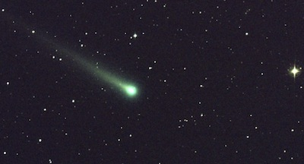Comet ISON shines beautifully in this five-minute exposure taken at NASA's Marshall Space Flight Center on November 8, 2013 at 5:40 a.m. EST. Comet ISON was 97 million miles from earth at the time. As Comet ISON approached the sun, it became visible to the naked eye or with a good pair of binoculars. Image: Associated Press/NASA through FoxNews

The Comet ISON Show—To Be Or Not To Be?
Because sun-grazers like Comet ISON closely approach the fiery heat of our sun, they can put on a great one-time show, so long as they survive to sizzle for us at a time and place when we can watch. Much of their ice melts as they graze the sun, producing a magnificent tail of dust and gas visible from earth. Discovered on September 21, 2012, by astronomers at Russia’s International Scientific Optical Network observatory, the comet C/2012 S2 (ISON) was already streaking toward our sun and gathering speed. Its path brought it to within 730,000 miles of the sun at a speed of 828,000 miles per hour as it swung around it on November 28.¹
As observations accumulated in the months of Comet ISON’s approach, predictions as to the comet’s imminent fate ranged across the board. Some expected ISON to be “a once-in-a-civilization’s-lifetime event.” It has been wistfully dubbed the “Comet of the Century” in hopes it would rival the spectacular Great Comet of 1680. Others feared that its size—smaller than originally thought—and unfortunate and unexpected faintness by summer’s end boded ill for its chances at surviving its approach to the sun with enough sputtering ice to produce the greatest show on earth.
Commenting hopefully before the Thanksgiving Day of the Comet, NASA’s Jim Green said, “On Friday, we’ll all be delighted to see its beautiful face as it then comes around the sun. Then between Thanksgiving and Christmas, it will fly over the North Pole—a very nice holiday comet. ISON is very special. What makes it different is where it comes from—the further reaches of the sun’s gravity.”²
Comet ISON is a newcomer to our solar system. Its orbital path has brought it into the solar system for a close encounter with our sun. Scientists hope to study the materials vaporized off of it to learn more about the composition of the matter in space. And of course everyone would like to see ISON put on a great show after it swings around the sun. The show will only go on, however, if the comet survives its perilous trip around the sun.
“The surface is going to be vaporizing furiously, and that's going to release a lot of interesting material that hopefully we can study,” commented U.S. Naval Research Laboratory astrophysicist Karl Battams as the ISON approached. “At any moment it could fall apart, it could fizzle out, big chunks could break off.”³
Initially, many Thanksgiving Day observers feared the comet had disintegrated during the solar slingshot. The nucleus seemed shrunken and the trail of debris increased. But after several hours the classic comet appearance showed up in images being captured at several observatories. Longtime Sky & Telescope comet writer John Bortle summed up the impressions of many when he noted the comet’s “huge and ongoing dust release in a broad range of particle sizes” was “a very hopeful sign for visual observers in days to come.”⁴ Only time will tell how much of the comet survived and what sort of show it will be putting on.

Comet ISON’s Observable Journey
Comet ISON’s approach was followed from vantage points terrestrial and celestial—even the Mars Reconnaissance Orbiter and the Mercury-orbiting Messenger—as telescopes and cameras were directed at ISON from every available angle. “Every spacecraft that has a camera, we're turning on it,” said NASA’s John Grunsfeld as NASA prepared for the big event. Would it have its tail ripped off by a storm of electrically charged particles in a coronal mass ejection anticipated to interact with it just a day before perihelion?⁵ Would its swing around the sun reduce it to an insignificant rock⁶ flying around in space? “Comets tend to be delicate,” said Adam Block of the University of Arizona’s Mount Lemmon Sky-Center as ISON approached, “so it may actually break up.” But the many observational platforms did indeed, as Block said, make it possible to “watch the whole thing unfold.”²
Whatever Comet ISON’s fate, by the second week of December the Maven spacecraft en route to Mars will have its cameras in position to check it out whether earth-bound eyes are getting a great show or not. “Whether we’ll see a comet, comet bits or the last wisps of comet vapor,” says Nick Schneider, who manages Maven’s camera, “whatever happens, it’s bound to be interesting.”¹
Once Comet ISON burns out its beauty in evaporating dust, water, and carbon dioxide, any remaining unspectacular rocky remnant of its nucleus may continue on its long orbital path, but it will not approach earth. Some secular cosmologists today suppose that water from comets like this supplied up to 40% of the water on earth. “At one time secular scientists thought that water had existed on earth from the time that the earth formed billions of years ago. But theories today suggest that the early earth lost much of its water, so much of the earth’s water had to come from somewhere else,” astronomer Dr. Danny Faulkner of Answers in Genesis explains. “Since comets contain so much water, evolutionary scientists think that much of earth’s water came from impacts of comets with earth.”⁷

Comet ISON’s Unobservable Origins
Now that Comet ISON has passed its perihelion, tomorrow (Sunday, December 1st) will likely offer the first post-perihelion opportunity for folks to catch a glimpse of it from their backyards. You can find out where to look for the best chance of seeing the comet yourself and safety precautions to avoid endangering your vision as you try to get your own once-in-a-lifetime look at “Latest Updates on Comet ISON” in Sky and Telescope. The dramatic effect of the sun on Comet ISON should point our attention to the fact that comets present a major problem for evolutionary cosmologists and all who insist the universe is billions of years old. Comets simply cannot survive for millions of years.
Modern technology has allowed us to observe this sun-grazer during most of its journey from the time it was first observed in September 2012 beyond Jupiter’s orbit, more than 6 AU (astronomical units, the average distance between earth and the sun) away, until now. But reported in most media reports about ISON are authoritative pronouncements not only about its observable journey but also about its unobservable origins.
NASA’s Jim Green noted that ISON is special because of the time and distance it traveled to get to our solar system. But did ISON really travel a million years or more to reach our sun from the Oort cloud at the furthest reaches of our sun’s gravitational field? Actually the Oort cloud, like Peter Pan’s Neverland, has never been observed. The Oort cloud was imagined to provide a birthplace for new comets, since comets like ISON could not exist in a billions-of-years-old universe without some renewable source. The Oort cloud is thus a convenient fiction, but a fiction nonetheless.
The Oort cloud was hypothesized as a birthplace for long-period comets like ISON, for if the solar system were really as old as currently conventional cosmology claims, such comets would have fizzled long ago. The ne’er-been-observed Oort cloud is supposed to be located at the outer reaches of our sun’s gravitational influence.
Concerning the claims about the Oort cloud, Dr. Faulkner says:
This sun-grazer comet has an orbit that's virtually parabolic, as near as we can tell. That means that its orbital path extends very far out from the sun, which, if the Oort cloud exists, would be in the region of the Oort cloud. However, more than 25 years ago the late Carl Sagan observed that there is no direct evidence that the Oort cloud exists. The situation hasn't changed since then.

Killing Comets
“Astronomers think that a comet has a small nucleus only a few miles across. The nucleus is made of various ices (frozen water, but other frozen substances, such as carbon dioxide and ammonia) with small bits of solid dark material that we call dust,” Dr. Faulkner explains. “For years astronomers have called these dirty snow balls, but now some astronomers have taken to calling them icy dirtballs. When the nucleus passes very close to the sun once each orbit, the sun’s heat evaporates much of the ice and frees the dust to form the comet’s head and tail. The sun’s radiation causes the gas and dust to glow.”
Comets like ISON, in reality, are evidence for a young universe. As Dr. Faulkner recently explained, a number of things happen to efficiently kill comets like this:
As a sun-grazer, Comet ISON will lose a massive amount of material as it passes close to the sun. This will cause the comet to brighten tremendously, but it comes at a cost: after enough orbits Comet ISON eventually will lose so much matter that it won’t brighten anymore.
In addition to gradually wearing out, two more catastrophic loss mechanisms can ravage comets. First, as comets pass close to the major planets (especially the gas giant Jupiter), the gravity of those planets can alter comet orbits. When this happens, half the time the comet orbit decreases in size and orbital period, which causes the comet to wear out even faster. But the other half of the time comets have their orbits increased. Sometimes the increase can lead to ejection from the solar system, never to return. Astronomers have observed comet ejection a number of times.
Second, comets occasionally collide with planets, thus abruptly ending their existence. We observed this for the first time in 1994 when Comet Shoemaker-Levi IX slammed into Jupiter.

No New Comets
Scientists have observed the demise of comets, and indeed whenever over the centuries humans have observed a comet blazing away they have been observing its death, if only by degrees. Eventually, comets run out of ice and die. So where could new comets come from? That’s the problem evolutionists have. Dr. Faulkner explains:
With these efficient loss mechanisms, it is clear that we should not see any comets at all, if the solar system is billions of years old. So, for more than 60 years many astronomers have offered two hypothetical sources to replace older comets as they die.
There are two types of comets: long-period comets and short-period comets. As the names suggest, the two groups generally differ by the lengths of their orbital periods (200 years is the dividing line), though there are other more fundamental differences. Long-period comets supposedly come from the Oort cloud, a hypothetical spherical cloud of comet nuclei orbiting very far from the sun. The gravity of an occasional passing star is supposed to rob the comet nuclei of energy so that they fall into the inner solar system where we can see them. Short-period comets supposedly come from the Kuiper belt, a flatter distribution of comets just beyond the orbit of Neptune. Gravitational tugs from the outer planets are thought to bring these comets into the inner solar system.
We’ve never seen the Oort cloud, and we likely never will. So there’s zero observational evidence that the Oort cloud exists. Astronomers have found many objects beyond the orbit of Neptune, about where the Kuiper belt is supposed to be. But it isn’t clear that this actually is the Kuiper belt, because these objects have a different composition than comets.
Evolutionary scientists have to assume that both the Kuiper belt and Oort cloud exist because otherwise comets—and the universe—are much younger than the supposed billions of years. But if the solar system is only thousands of years old, as God’s Word clearly teaches, there is no problem.

Evidence for a Young Universe
“Creationist astronomers think that just a few thousand years ago God created comets pretty much as they exist today.” Dr. Faulkner says. “Evolutionary astronomers think that comets, along with the solar system, are billions of years old, far too old for there to be comets today. To explain comets today, evolutionists must believe that comets that we see were stored in the Oort cloud and Kuiper belt until very recently.”
So while technology continues to show us how comets die, it fails to reveal the origin of comets in a billions-of-years-old universe. Imagination may look far away and see solutions like an Oort cloud to solve the long-age problem, but science and technology never have. Just because the Oort cloud gets mentioned as if it is an observed place in the media and even in some of my favorite science fiction novels, doesn’t make it real. The Word of God, however, provides an eyewitness account of God’s creation of the universe about 6,000 years ago. And what astronomers actually observe is, not surprisingly, perfectly consistent with what we would expect from reading God’s Word.

For more information:
Be sure to follow Dr. Danny Faulkner’s blog for Answers in Genesis ongoing perspective on Comet ISON’s appearance in the coming days.
- Dr. Faulkner’s blog: Comet ISON Was Here (Finis)
- Dr. Faulkner’s blog: Comet Ison Is Here (Part 1)
- Get Answers: Comet Ison
- Feedback: Assuming the Origin of Comets
- Comet Ison—Fire in the Sky
- Kuiper Belt Objects: Solution to Short-Period Comets?
- Primordial Wellspring: Where Did Earth Get Its Water?
- Universe by Design: Introduction
- More Problems for the ‘Oort Comet Cloud’

And Don’t Miss . . .
- This past week we discussed the many differences—and reasons for them—between animals and humans, examined some not-so-primordial-looking slime, and we hope you, like us, enjoyed our many blessings and gave thanks to our great God.
- Next week, we’ll see what some crocodiles use those nasty teeth to eat and discuss just how old the super-salty water under Chesapeake Bay’s impact crater may be. And who knows what else will be in the News?

For more information: Get Answers

Remember, if you see a news story that might merit some attention, let us know about it! (Note: if the story originates from the Associated Press, FOX News, MSNBC, the New York Times, or another major national media outlet, we will most likely have already heard about it.) And thanks to all of our readers who have submitted great news tips to us. If you didn’t catch all the latest News to Know, why not take a look to see what you’ve missed?
(Please note that links will take you directly to the source. Answers in Genesis is not responsible for content on the websites to which we refer. For more information, please see our Privacy Policy.)

Footnotes
- www.foxnews.com/science/2013/11/24/will-icy-comet-ison-survive-close-encounter-with-sunBack (1) Back (2)
- www.washingtonpost.com/national/health-science/comet-ison-if-it-survives-trip-around-the-sun-could-bring-spectacular-sky-show/2013/11/24/f544103a-53b6-11e3-a7f0-b790929232e1_story.htmlBack (1) Back (2)
- www.npr.org/2013/11/26/247180926/comet-fans-psyched-for-a-celestial-feast-on-thanksgiving-dayBack
- http://www.skyandtelescope.com/community/skyblog/observingblog/Comet-ISON-Updates-193909261.html Back
- www.nbcnews.com/science/comet-ison-solar-probe-sights-storm-coming-2D11663523Back
- Extinct comets that have lost their volatile ice, dust, and frozen gases may still have a small rocky remnant of their nucleus resembling a small asteroid, but they no longer can produce the tail or coma that is the signature feature of a comet. Back
- Read more about the problems with this notion as well as its inconsistency with God’s eyewitness account of earth history in “Primordial Wellspring: Where Did Earth Get Its Water?” Back

(下面中文使用谷歌翻译。需要修正和编辑。)

第7周：第5部分
在彗星ISON的火热命运的眼睛，但不奥尔特起源
新闻知道
由伊丽莎白·米切尔博士
二〇一三年十一月三十○日
外行
•天文
•作家伊丽莎白 - 米切尔
•彗星
•新闻方知
华盛顿邮报：彗星ISON ，如果它生存绕太阳的行程，可能会带来壮观的天象节目
彗星ISON的命运燃料猜测它的起源。
由于感恩节在美国走近，伸缩的目光都集中在天空，看看会发生什么，因为彗星ISON达到最接近太阳。已经ISON曾透露自己的肉眼，但不能作为自由的希望。将其近日点，更接近太阳比水星的轨道，把它带到这样的神话伊卡洛斯谁，飞得太靠近太阳的命运，融化他的蜡翅膀？或将其太阳放牧过程中让它走出一条在美容和照亮我们的十二月初圣诞节的天空？
彗星ISON美丽闪耀在美国宇航局马歇尔太空飞行中心于5:40 AM EST采取2013年11月8日这5分钟的曝光。彗星ISON是从地球97000000英里的时间。由于彗星ISON接近太阳，它成为可见肉眼或具有良好的双筒望远镜。图片：美联社/美国航天局通过FoxNews
彗星ISON显示，要还是不要呢？
因为太阳像食草动物彗星ISON密切接近我们的太阳的火热热，他们可以把一个伟大的一次演出，只要他们求生存，以嘶嘶声，我们的时间和地点时，我们可以看。他们的大部分冰融化，因为它们吃草太阳，产生的尘埃和气体从地球上可见的一个宏伟的尾巴。发现于2012年9月21日，天文学家在俄罗斯国际科学光学观测台网，彗星C/2012 S2 （ ISON ）已经向我们的太阳和采集速度裸奔。它的路径把它带到730000英里太阳内的828,000英里每小时的速度，因为它转过身它在十一月28.1
由于观测的彗星ISON的做法月累计，预测为彗星的命运即将全线不等。一些预期ISON是“一次在-A- civilization's千载难逢的事件。 ”这已经望眼欲穿戏称为“彗星的世纪” ，希望将对手的1680壮观的大彗星。其他人担心它的大小小于在夏季结束原本以为和大家预料不到的模糊在其生存的方法来太阳有足够的溅镀冰，产生地球上最伟大的表演预示着生病的机会。
彗星的感恩节之前，希望谈到，美国航空航天局的吉姆·格林说， “上周五，我们都会高兴地看到它的美丽的脸，因为它然后是绕太阳。然后，感恩节和圣诞节之间，它会飞越北极，一个非常漂亮的度假彗星。 ISON是非常特殊的。所不同的是它从何而来，在太阳的引力进一步达到。 “ 2
彗星ISON是初来乍到我们的太阳系。其轨道路径已经将其纳入与我们的太阳近距离接触了太阳系。科学家希望，研究蒸发掉它的材料，以了解更多有关此事的空间组成。当然还有每个人都希望看到诠贸把一个伟大的演出摆动它围绕太阳之后。该节目将只去上，但是，如果这颗彗星幸存的危险围绕太阳之旅。
“表面将被蒸发得飞快，而这会释放出大量的，希望我们可以学习有趣的材料，”评论美国海军研究实验室的天体物理学家卡尔· Battams作为诠贸接近。 “在任何时候都有可能散架，它可能不了了之，大口吃可能折断。 ” 3
最初，许多感恩节观察家担心彗星太阳能弹弓时已经解体。细胞核似乎缩小和碎片的踪迹增加。但几个小时后的经典外观彗星出现了在被捕获在几个观测图像。长期天空和望远镜彗星作家约翰Bortle总结了许多的印象时，他指出，彗星的“巨大和持续的粉尘释放各种粒径”是“一个非常有希望的迹象目视观测的日子。 ” 4只时间会告诉我们怎样的大部分彗星存活和什么样展示它在投入上。

彗星ISON的可观察之旅
彗星ISON的做法之后从有利位置的地面和天体，就连火星勘测轨道飞行器和水星变轨信使如望远镜和照相机从各个角度提供冲着诠贸。 “有一个摄像头的每个航天器，我们打开它，” NASA的约翰·格伦斯菲尔德说，美国航空航天局准备的大事件。难道有它的尾巴扯掉了风暴的日冕物质抛射预期的带电粒子与它的近日点之前，短短一天的互动？ 5会围绕太阳摆动将其降低到微不足道rock6在太空中飞来飞去？ “彗星往往是微妙的，说：”亚利桑那州莱蒙山天空中心的大学作为诠贸走近亚当座， “所以它实际上可能会分手。 ”但许多观测平台做确实如座说，使人们有可能“看整个事情展开。 ” 2
无论彗星ISON的命运，由十二月的Maven飞船的第二个星期途中火星将拥有摄像头的位置，以检查它地球上的眼睛是否得到一个伟大的演出与否。 “无论我们将看到一颗彗星，彗星比特彗星或蒸气的最后几缕， ”尼克·施奈德，谁管理Maven的摄像头，说： “无论发生什么事情，它一定很有趣。 ” 1
一旦彗星ISON烧坏它的美丽在蒸发灰尘，水和二氧化碳，其原子核的任何剩余引人注意的岩石遗迹可能继续其漫长的轨道路径，但不会接近地球。一些世俗的宇宙学家现在假设从这样的彗星水供给到水的40 ％，在地球上。 “有一次，世俗的科学家认为水已经存在地球上从地球形成的数十亿年前的时间。但今天理论认为，早期的地球失去了它的水，这么大的地球上的水必须来自其他地方， “答案在创世纪的天文学家丹尼·福克纳博士解释说。 “由于彗星含有这么多的水，进化的科学家认为很多地球上的水来自彗星与地球的影响。 ” 7

彗星ISON的不可观测的起源
现在，彗星ISON已经走过了它的近日点，明天（周日， 12月1日）将有可能提供给乡亲的第一篇文章，近日点的机会，从他们的后院捕捉到了她一眼。你可以找到在哪里寻找看到自己的彗星和安全预防措施，以避免危及你的视力当你试图让自己的一次在一个千载难逢的外观在天“最新更新的彗星ISON ”的最佳机会，望远镜。在彗星ISON太阳的戏剧性效果应该指向我们注意的是，彗星是一个重大问题，进化的宇宙学家和所有谁坚持宇宙是数十亿年的历史。彗星根本无法数百万年生存。
现代技术使我们能够从它最早是在2012年9月观测到木星轨道以外，超过6 AU （天文单位，地球和太阳之间的平均距离）远的时间内其大部分旅程观察这个阳光格拉茨，直到现在。但报道中关于诠贸大多数媒体的报道是权威公告，不仅关于其观察的旅程，但也是关于它的不可观察的起源。
NASA的吉姆·格林指出，诠贸是因为时间和距离它前往到达我们的太阳系特殊。但并ISON真的出差万年以上，从奥尔特云中达到我们的太阳在我们的太阳的引力场的最远到达？其实，奥尔特云，像彼得潘的梦幻岛，从未被观察到。奥尔特云是想象提供了发源地新彗星，因为像ISON彗星不可能在数十亿， - 年 - 旧宇宙存在没有一些可再生能源。奥尔特云是这样一个方便的虚构，但虚构的仍然。
奥尔特云是假设作为发源地的长周期彗星状ISON ，因为如果太阳系真的一样古老的传统目前宇宙学主张，如彗星会告吹很久以前。该游手好闲，被观察到奥尔特云是应该位于我们的太阳的引力影响外游。
关于对奥尔特云的说法，福克纳博士说：
这阳光葛瑞泽彗星有一个轨道上的几乎抛物线，尽可能接近我们可以告诉。这意味着，它的轨道路径的太阳，而如果奥尔特云存在，将在奥尔特云的区域很远了延伸。然而，超过25年前已故的卡尔·萨根指出，没有直接证据证明奥尔特云的存在。的情况，因为当时并没有改变。
杀彗星
“天文学家认为，彗星有一个小的原子核只有几英里宽。原子核是由各种冰（冻水，但是其他的冷冻物质，如二氧化碳和氨）与固体暗物质小位，我们称之为灰尘， “福克纳博士解释说。 “多年来，天文学家们称，这些肮脏的雪球，但现在一些天文学家已经采取措施来调用它们冰冷dirtballs 。当原子核过得非常接近太阳一次，每个轨道，太阳的热量蒸发掉大部分冰和释放灰尘，形成彗星的头部和尾部。太阳的辐射会导致气体和尘埃发光。 “
像ISON彗星，在现实中，有证据证明一个年轻的宇宙。正如福克纳博士最近解释，一些事情的发生，有效地杀死这样的彗星：
作为一个阳光格拉茨，彗星ISON将失去物质的巨量当它通过接近太阳。这将导致彗星照亮巨大，但它是有代价的：经过足够的轨道彗星ISON最终会失去这么多的事情，它不会亮了。
除了逐渐磨损，两个灾难性损失的机制可以蹂躏彗星。首先，彗星经过接近大行星（尤其是天然气巨头木星） ，这些行星的重力可以改变彗星的轨道。当此情况发生时，有一半时间在大小和轨道周期，这将导致彗星磨损得更快彗星轨道下降。但时间彗星的另一半有它们的轨道增加。有时候，增加可导致弹射从太阳系，再也没有回来。天文学家已经观测到彗星喷出的次数。
第二，彗星偶尔与行星发生碰撞，从而突然结束他们的存在。我们观察到这是第一次在1994年，当彗星苏梅克 - 列维九撞上木星。
无新彗星
科学家们观察到彗星的灭亡，而事实上，每当数百年来人类已经发现一颗彗星炽烈了，他们一直在观察它的死亡，如果仅靠度。最终，彗星用完冰和死亡。那么，可能的新彗星从何而来？这就是问题所在进化论者。福克纳博士解释说：
有了这些高效的损失机制，很显然，我们不应该看到任何彗星可言，如果太阳能系统是亿万年之久。因此，对于60岁以上的许多天文学家提出两个假设的来源，以取代他们死去旧的彗星。
有两种类型的彗星：长周期彗星和短周期彗星。正如名称所暗示的，这两个群体通常由它们的轨道周期（200年属分界线）的长度有所不同，但也有其他更根本的差异。长周期彗星据说来自奥尔特云，一个假想的球形云的彗星核，轨道离太阳很远的。一个偶尔经过的恒星重力应该抢能量的彗核，使他们落入太阳系内部，我们可以看到它们。短周期彗星据说来自柯伊伯带，彗星的平坦的分布只是超出海王星轨道。从外星球引力拖船被认为将这些彗星进入太阳系内部。
我们从来没有见过的奥尔特云，我们可能永远也不会。因此，有为零的观测证据证明奥尔特云的存在。天文学家已经发现了许多对象超出海王星轨道，在哪里柯伊伯带被认为是。但目前尚不清楚，这实际上是柯伊伯带，因为这些对象有不同的组成彗星。
进化科学家们假设，无论是柯伊伯带和奥尔特云的存在是因为其他彗星和宇宙，比假想的数十亿年年轻得多。但是，如果太阳系只有几千年历史，是神的话清楚地教导，是没有问题的。
对于一个年轻宇宙的证据
“创造论天文学家认为，仅仅几千年前神创造了彗星相当多，因为他们存在的今天。 ”福克纳博士说。 “进化的天文学家认为，彗星，随着太阳能系统，是亿万年之久，远远太老了有今天是彗星。到今天解释彗星，进化论者必须相信，彗星，我们看到存储在奥尔特云和柯伊伯带，直到最近。 “
因此，尽管技术不断向我们展示了彗星怎么死的，它不能揭示彗星的起源在一百亿， - 年 - 旧宇宙。想象力可以看得很远，能看到它的奥尔特云解决方案，解决了长期年龄问题，但科技永远不会有。只是因为奥尔特云被提及，就好像它是在媒体上观察到的地方，甚至在一些我最喜欢的科幻小说，并不能使它真实的。神的话语，然而，提供了神创造宇宙的约6000年前的目击记录。和天文学家实际观测是，这并不奇怪，与我们所期望的阅读神的话语完全一致。
欲了解更多信息：
一定要按照医生丹尼·福克纳的博客答案在创世纪的彗星ISON的出现在未来的日子里持续的观点。
▪福克纳博士的博客：彗星ISON是在这里（菲尼斯）
▪福克纳博士的博客：彗星伊森在这里（第1部分）
▪获取答案：伊森彗星
▪反馈：假设彗星的起源
▪彗星伊森 - 火在天上
▪的柯伊伯带天体：解决方案，以短周期彗星？
▪原始源泉：在哪里地球获取它的水？
▪宇宙由设计：简介
▪为“奥尔特彗星云'更多问题
千万不要错过。 。 。
▪刚刚过去的这个星期，我们讨论了许多差异和原因，他们之间的动物和人类，分析了一些不那么原始的前瞻性煤泥，我们希望您和我们一样，享受我们的许多祝福，给感谢我们伟大的神。
▪下周，我们将看到一些鳄鱼使用那些讨厌的牙齿吃饭并讨论在切萨皮克湾的撞击坑的超咸的水是多么古老而定。谁知道还有什么会在新闻？
欲了解更多信息：获取答案
________________________________________
请记住，如果你看到有一个消息，可能会有些值得关注，让我们知道吧！ （注：如果故事从美联社，福克斯新闻， MSNBC ，纽约时报，或其他全国各大媒体插座起源，我们将最有可能已经听说过它），并感谢我们所有的读者是谁提交伟大的新闻线索给我们。如果你没赶上大家知道最新的新闻，为什么不来看看，看看你错过了什么？
（请注意，链接将直接带您到源。答案在创世纪是不负责给大家引用的网站内容。欲了解更多信息，请参阅我们的隐私权政策。 ）

脚注
1 。 www.foxnews.com/science/2013/11/24/will-icy-comet-ison-survive-close-encounter-with-sunBack （ 1 ）回复（ 2 ）
2 。 （ 1 ）回复（ 2 ）
3 。 www.npr.org/2013/11/26/247180926/comet-fans-psyched-for-a-celestial-feast-on-thanksgiving-dayBack
4 。 http://www.skyandtelescope.com/community/skyblog/observingblog/Comet-ISON-Updates-193909261.html返回
5 。 www.nbcnews.com/science/comet-ison-solar-probe-sights-storm-coming-2D11663523Back
6 。已失去挥发性的冰，尘埃和冰冻的气体灭绝的彗星可能仍然有其细胞核类似一个小小行星的一个小岩石遗迹，但他们不再能产生尾或昏迷是彗星的标志性特征。后面
7 。了解更多有关这个概念的问题，以及其矛盾与地球历史的上帝的目击者账户“原始源泉：在哪里地球获取它的水”回

